A 3.65mW, Amplifier based Up-Conversion Mixer for Zigbee Application
Abhishek Pandey, Deepak Prasad, Vijay Nath (Member IEEE)
VLSI Design Group, Department of ECE, B.I.T. Mesra, Ranchi-835215(JH), India
a.p.bitmesra@gmail.com, prasaddeepak007@gmail.com, vijaynath@bitmesra.ac.in.
Abstract—This paper demonstrates a component of radio frequency transmitter called up-conversion Mixer with high conversion gain and ameliorate linearity. The novelty of given circuit architecture is that CMOS transconductance amplifier is used to imporve the overall conversion gain. For changing to an unbalanced base-band signal (UBBBS) to differential balanced signal(DBS), a passive balun circuit has been used. The circuit operates at frequency 2.4 GHz, and the local oscillator frequency is 2.3 GHz. The conversion gain and IIP3 of proposed circuit has been achieved 21.4 dB and 4.24 dBm respectively. The proposed circuit is designed & simulated using Cadence Analog & Digital System Design Tools with PDK UMC90nm CMOS Technology. This circuit is operational on rail to rail power supply of ±1.8 V.

Keywords—Mixer, Conversion Gain (CG), Local Oscillator (LOSC), Radio-frequency (RF), Input Intercept Point (IIP), Unbalanced Base-Band Signal (UBBBS), Differential Balanced Signal(DBS).

- INTRODUCTION

With exploration and development of CMOS technology [13], it could have low cost, small size and low voltage circuitry promising to integrate whole system on single chip. The challenges are continuous and imply attention in exploration of RF Architectures [1-3]. The RF-mixer is critical component in RF system, because of its ability for frequency conversion. Basically the frequency conversion can be done in two ways:
- Up-Conversion Mixer (UCM)
- Down Conversion Mixer (DCM)
In Up-conversion Mixer is a mixer used in the transmitter circuitry. It multiplies the Low frequency message signal with the local oscillator signal to convert low frequency message signal to high frequency message signal [4, 5].
Receiver circuitry is required down conversion mixer. It multiplies a high frequency signal with a local oscillator signal to obtain low frequency signal (IF signal) [5].
In ideal situation the output of the Mixer is exact replica of input signal. But in reality, due to the non-linearity of the mixer some distortion occurs at the output. That’s why linearity is one of the major parameter of Mixer design. The Mixer converts the frequency of the signal with some gain, this is called conversion gain. In design of Mixer attention should be given in the leakage of local oscillator to the output port [6, 7].

A good Mixer should have the following qualities:
- Large conversion gain
- Good Isolation
- Small Noise figure
- High Linearity

Since these parameters depend upon each other. Therefore, it is tedious task to development a suitable mixer topology, which can obtained a high conversion gain, and high linearity, low power, and noise figure, at the same time [1-4]. Zigbee IEEE 802.15.4 illustrate three frequency bands for operation: the 868-MHz, 915-MHz, and 2.4-GHz ISM bands in which the 2.4-GHz band is the most commonly used unlicensed band [1]. This standard is applicable in industrial, home automation, consumer electronics, and personal healthcare appliances [8].
The active mixer has leads to a better conversion gain and low noise figure. But the linearity and power consumption is not better [9]. Since linearity and conversion gain are both opposes the enhancement of each other, therefore for proper value of conversion gains and IIP3, a novel architecture of mixer has been chosen. The two transconductance amplifier has been used for boosting the conversion gain and derivative superposition theorem is used to enhance the linearity of the mixer.
This paper is constructed in following manners:- The insight of the basic of Gilbert cell mixer design and operation is demonstrated in Section 2. A summarized analysis of proposed mixer topology is described in Section 3. Simulation results and discussion demonstrated in Section 4. This consists with all the important data such as: conversion gain, noise figure, linearity and 1 dB compression point. Finally, the conclusion is enunciated in Section 5.

- GILBERT-CELL MIXER DESIGN

For constructing the active mixer, the Gilbert mixer cell is most commonly used topology [10-12]. Gilbert mixer has several salient features that is, enough conversion gain with proper load. A very good port-to-port isolation and low noise figure is leaded by Double-Balanced Gilbert cell topology. It operates on the concept of translinear configuration. The drawbacks of this type of mixers have limited linearity and frequency, which depends on matching. The input transistors of these mixers should be in saturation region. The schematic diagram of Gilbert cell mixer has been depicted in Figure 1.
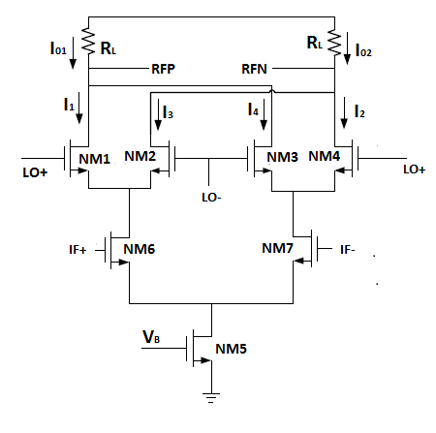
Fig. 1 Schematic diagram of the Gilbert Mixer

I_{OUT} is tail current of transistor NM5. For governing the total current the tail current I_{OUT} should be in saturation region. Transistors NM6 and NM7 are differential pair, which operate in saturation region and change the input voltage to current. The linearity and gain of Gilbert cell mainly depends on these NM6 and NM7 transistors. Two pairs of switches are NM1, NM2, and NM3, NM4 which operate in a saturation region. Mainly this transistor mixed the signal current from transconductors NM6 and NM7 [4] with the local oscillator (LOSC) signal current.

The Gilbert mixer output current can be expressed as follows [3]:
(1)
The transconductance of NM6 and NM7 is g_{m:}
(2)
The Voltage conversion gain of Gilbert mixer demonstrated as
(3)
Where is the Load resistance of the Gilbert-cell mixer

- TRANSCONDUCTANCE AMPLIFIER BASED UP CONVERSION MIXER

The transconductance amplifier based up-conversion mixer is shown in Figure 2. The transconductance pair transistor M1 and M2 are used to convert the IF signal voltage to current. The transistors M3, M4 and M5, M6 behave as two pair of ideal switch, which is biased in saturation region. These transistors enhanced the current, supplied by transconductance pairs M1 and M2. To connect these four transistors to M1 and M2, the derivative superposition method is implied. The transistors M1 and M2 are connected to parallel with transistors M7, M8 and M9, M10. The transistors (M7 to M10) are functioned in weak inversion region. The W/L ratio of these transistors is demonstrated as:
(4)

If the aspect ratio (W/L ratio) of transistors M7 and M8 decreases, then resistance of these transistors is improved. With proper selection of W/L of transistors M7-M10 comes in weak inversion region. The parameter depends on [9]. The IIP3 is determined by the third-order coefficient of transconductance. If will be decreases, then the linearity will be increases. For improve the circuit linearity a source degeneration spiral inductor is used. The inductance is selected at the resonant frequency. The blocking capacitors C_{BL} behaves as to isolate the input and output port from the DC sources.
The load resistors (R_{L}) connected on the top of LO switch transistors which is optimized to achieve a minimum power loss and better gain.

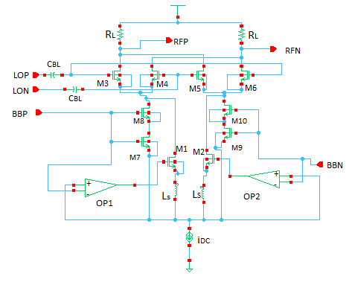
Fig. 2 Schematic diagram of the Proposed Up-Conversion mixer circuit with transconductance amplifier

Fig. 3 Test bench used for Mixer design

SIMULATION RESULTS

The proposed circuit is simulated using Cadence analog and digital system design tools with PDK UMC 90nm CMOS technology. The passive balun is used for the simulation of mixer circuit, which is depicted in Fig 3.
The Radiofrequency (RF) of mixer is designed at 2.4 GHz and the local oscillator is selected to operate at 2.3 GHz. The baseband signal is choose at 100 MHz. The proposed circuit converts 100 MHz Baseband to 2.4 GHz Radio Frequency (RF) signal.
To find the transient response of the circuit transient simulation techniques are required and the A.C. signals (RF and LO signals) are must applied to the mixer. The voltage against time (transient response) is presented in Fig 4.
The Fig 5 has presented the conversion gain of Mixer, which is plotted against frequency is achieved 21.4 dB. The 1 dB compression point and IIP3 of mixer are found -5.61 dBm and 4.24 dBm as shown in Figs 6 and 7 respectively. The noise figure of proposed mixer circuit produces 13 dB, which is shown in Fig 8. The performance summary of the proposed Mixer have been compared to other recent paper, is summarized in Table 1.

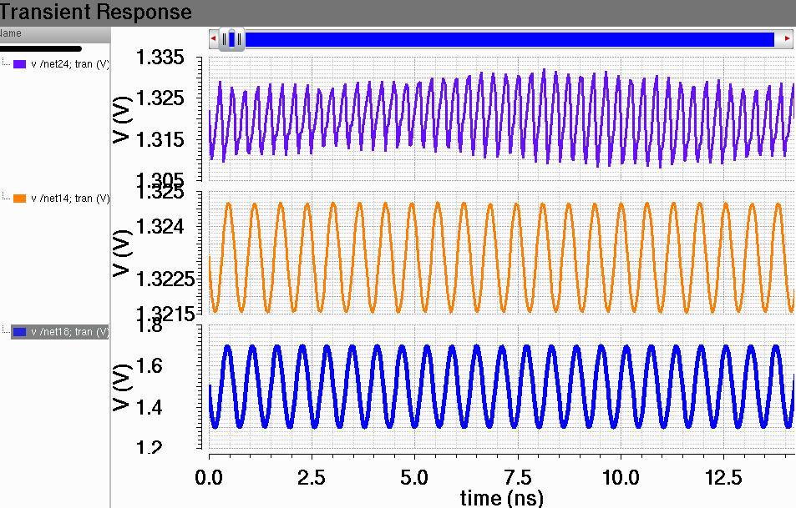
Fig. 4 Transient response of transconductance amplifier based up-conversion Mixer
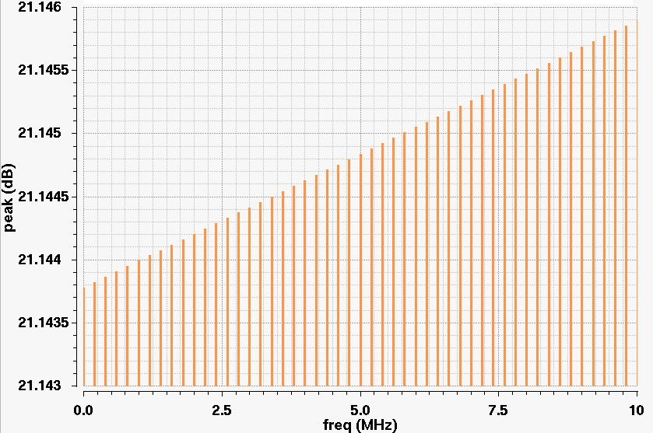

Fig.5 Voltage Conversion Gain versus IF frequency of transconductance amplifier based up-conversion Mixer

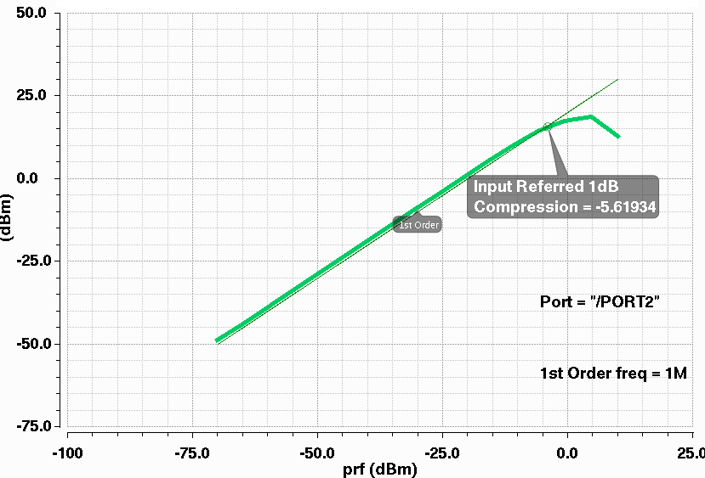

Fig.6. 1dB compression point of transconductance amplifier based up-conversion Mixer

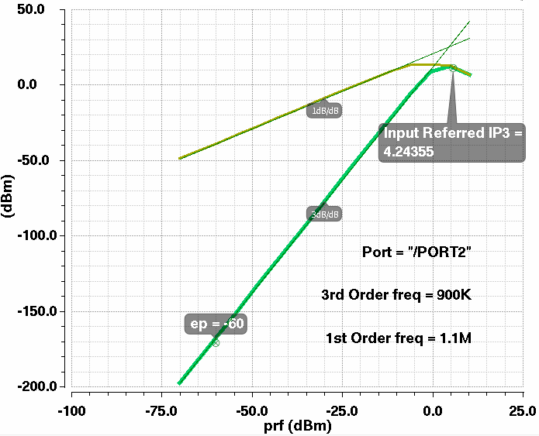

Fig.7 IIP3 of transconductance amplifier based up-conversion Mixer

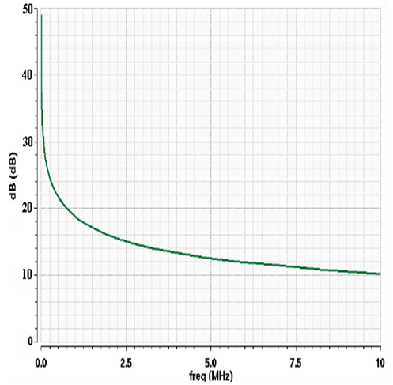
Fig. 8 Noise Figure of transconductance amplifier based up-conversion Mixer

CONCLUSION
The circuit is proposed to demonstrate the challenge of high
conversion gain and low noise figure with good linearity of the mixer for Zigbee band application. In this paper two transconductance amplifier with super derivative technique is used. It illustrates high forward gain, low noise figure and linearity with power consumption of 3.65 mW. The circuit is compared with the newly designed mixers. So it is best suited for applying in energy efficient low-power Zigbee transmitter front-end.

REFERENCES

- B.Razzavi, “Mixer Design Chapter 6,” in RF Micoelectronics 2nd edition.
- Yuan-Hao Shu, and Jeng-Rern Yang. “Low voltage, high linearity CMOS up-conversion mixer for LTE applications,” in Proc. IMFEDK –IEEE, 2013, pp-44-45.
- Xiaopeng Sun et.al. , “A 1.8-2.6GHz RF CMOS Up-Conversion Mixer for Wideband Applications,” in Proc. IMWS-IEEE MTT-S International, 2012, pp-1-4.
- Wu Chenjian and Li Zhiqun, “A 0.18μm CMOS Up-Conversion Mixer for Wireless Sensor Networks Application,” in Proc.WCSP IEEE, 2011, pp- 1-4.
- S.A.Z Murad et.al., “ A Design of 5.2 GHz CMOS Up-conversion Mixer with IF Input Active Balun,” in Proc. ISWTA IEEE, 2011, pp- 1-4.
- S.A.Z Murad et.al. , “High Linearity 5.2GHz CMOS up-conversion Mixer Using Super Derivative Superposition Method” in Proc. TENCON IEEE, 2010, pp-1509-1512.
- A. Saberkari et.al. ,“A low voltage highly linear CMOS up-conversion mixer based on current conveyor,” IEICE Electronics Express, vol.6, pp. 930-935, 2009.
- G.Sapone and G. Palmisano, “A 1.5V 0.25 μm CMOS up converter for 3-5 GHz low power WPANs,” Microwave & Optical Technology Letter, vol. 49, no. 9, pp. 2209-2212, Sept. 2007.,
- S. H-L. Tu and S.C-H. Chen, “A 5.26-GHz CMOS up-conversion mixer for IEEE 802.11a WLAN”, in Proc. of 4th IEEE International Conference on Circuits and Systems for Communications (ICCSC), 2008, pp. 820-823.
- Aparin, V et al. , “Modified Derivative superposition method for linearizing FET low –noise amplifiers,” IEEE Microwave Theory and Techniques, vol. 53, pp. 571-581, Feb. 2005.
- Ghulam Mehdi, “Highly Linear Mixer for On-Chip RF Test in 130nm CMOS” Master thesis performed at division of Electronic Devices at Linköping Institute of Technology.
- Shengchang Gao. "A High-Linearity Low-Noise Figure Active Mixer in 0.18 um CMOS", 2009 5th International Conference on Wireless communication Networking and Mobile computing, 09/2009.
- Vijay Nath http://www.ide.iitkgp.ernet.in/Pedagogy_view/example.jsp?USER_ID=210

Table .1
Cross platform comparative performance

Parameter | [2] | [3] | [4] | [5] | [6] | This work
Technology | 0.18µm | 0.13 µm | 0.18 µm | 0.18 µm | 0.18 µm | 90nm
Power Supply(V) | 1.2 | 1.2 | 1.8 | 1.8 | 1.8 | 1.8
IF Freq(MHz) | 100 | 10-400 | 1 | 100 | 100 | 100
LO Freq(GHz) | 1.8 | 1.8-2.6 | 2.419 | 5.1 | 5.1 | 2.3
RF Freq(GHz) | 1.9 | 1.810 | 2.42 | 5.2 | 5.2 | 2.4
Conversion Gain (dB) | 5 | 1.1 | 16.2 | 6 | 6 | 21.4
Input 1dB compression Point (dBm) |  |  | -20.7 |  |  | -5.61
IIP3(dBm) | 14.68 | 6.45 |  | 8 | 15.7 | 4.26
Noise Figure(dB) |  |  | 18.6 | 26 | 24 | 13
Power Consumption (mW) | 9.45 | 10 |  | 8.6 | 7.5 | 3.65

