TENDER FOR
Supply and Installation of Chairs

at

BIT MESRA, Lalpur Campus, Ranchi

Tender No.: Fur/21-22/01 Tender date: 22/03/2022

Last Date of submission: 24/03/2022 ,
Office of the Registrar
Birla Institute of Technology, Mesra

Page 1 of 5
Birla Institute of Technology, Mesra, Ranchi invites tender for supply and installation of Furnitures.

Tender Reference No. | Fur/21-22/01
Last Date and Time for receipt of Tender | 24/03/2022 1500 Hrs
Address for Communication | As Stated below in the Instructions to the bidders.
Contact Telephone | Numbers0651-2275444;4889  R.P Singh, Deputy Registrar (Purchase & MM)
For Details Contact | dr.purchase@bitmesra.ac.in

INSTRUCTIONS TO BIDDERS

All interested vendors are requested to send their sealed quotation for supply of the below items under single bid systems for supply of chairs with compliance with technical specification and price bid.

NOTE: The bid documents are not transferable, and the firm’s seal and signature of the authorized official must appear on all papers and envelopes submitted.

The envelop should be sealed, signed, marked envelop superscribed with the Tender Reference No. and Tender notice detail as appended hereunder.
TENDER FOR RATE CONTRACT OF CHAIR.
TENDER REF. NO: Fur/21-22/01 LAST DATE FOR SUBMISSION: 24/03/2022 1500 Hrs
.

The Deputy Registrar (Purchase Section) Birla Institute of Technology, Mesra Ranchi - 835215.

From: M/s Contact No: E-mail ID:

EMD: Rs One Lac. The EMD of the unsuccessful bidder’s will be refunded only after finalization of the tendering process. No interest will be payable on the earnest money. lf any bidder withdraws his bid at any point of time during the tendering process, the EMD of the bidder concerned will stand forfeited. BIT Mesra reserves the right to cancel the tender at any time/ stage or relax/amend/withdraw any of the terms and conditions contained in the Tender Document without assigning any reason thereof. Any inquiry after submission of the bid shall not be entertained. Before submission of the bid, enquiry can be made over through email at dr.purchase@bitmesra.ac.in. In case of withdrawal of bids, the EMD of the bidder concerned will stand forfeited.

Eligibility Criteria
- The firm should be OEM (Original Equipment Manufacturer)/ Dealer must be in this business for last 5 years or more. Annual Turnover of the OEM should be more than Rs 30 Crore &above. The Bidder should submit the turnover proof for last year (proof to be attached).
- The OEM should possess following prevalent Certifications related to quality & safety possessed by most of reputed brands of furniture manufacturers & relevant ISO certification, ISO 9001:2015 & BIFMA.
- The manufacturer should agree to undertake comprehensive warranty for all the items supplied of and Fixed by it and it shall also agree for post warranty services and maintenance.
- The first response time for service should be within 24 working hours (excluding Sundays/ holidays).
- Detailed address to be submitted.
- The manufacturer should have in-house Quality Control Facility. (Supporting documents about Quality Control facilities). Documents to be submitted.
- Permanent account number/ GST number: (Documentary evidence should be attach)
- Firm incorporation certificate. (Documentary evidence should be attached).
- Firm should have repair support service in Ranchi.

Terms & conditions

Delivery date etc.:
specified.
Time taken for delivery, installation and commissioning should be separately

- Bid Submission: The bids can be sent to us by Hand/ Speed post/ Courier so as to reach the marked address by due date and time. Late bids will not be accepted. The price bids of only those firms will only be opened who are found to be technically qualified after evaluation. The Institute reserves the right to cancel/reject any or all bids without assigning any reason thereof.
- Bid document: The vendor should read the Tender documents carefully before quoting. It shall be
deemed that the vendor has gone through the documents carefully and has understood its implication. Any lack of information shall not relieve the bidder of its responsibility to fulfill its obligations under the Bid.
- Price: Prices quoted should be on F.O.R., BIT Mesra, Ranchi on Door Delivery basis.
- Dealers: Dealership certificate/ authorization certificate from OEM if the bidder is a dealer.
- Validity of Quotation: Quotations should be valid for three months.
- Declaration: The bidder should attach a self-declaration stating that he is not debarred/ blacklisted or banned from any University/ Central Government / PSU / State Govt of India / any other Govt. agencies or any Institute of National / International importance.
- Copy of PAN must be submitted of Firm.
- Bank Details: Banker’s details of quoting Firm/ Vendor should be clearly mentioned as attached
- Warranty/ Guarantee/ AMC: The supplier should provide warranty details, minimum warranty period five years. If within a period of five years after commission, any accessory / consumable/ spare part is proved to be defective then such product shall be replaced by the manufacturer / supplier. Such replacement shall be sole obligation of manufacturer / supplier, including payment of charges for freight delivery, duty and transportation, if any.
- Delivery: Unless otherwise stated delivery of goods at BIT, Mesra, will have to be maximum within six
(6) weeks from the date of issue of the Purchase Order. All aspects of safe delivery shall be the exclusive responsibility of the OEM / Bidder.
- Bid Currencies: The quoted price should be in Indian Rupees.
- Conditional tenders: Conditional tenders shall not be accepted.

- Late and delayed Tenders: Late and delayed tender will not be considered. In case any unscheduled holiday occurs on prescribed closing/opening date the next working day shall be the prescribed date of closing/opening.
- Rejection of Tender: The tenders are liable to be rejected if the conditions mentioned in the tender documents are not complied with. The tender should be complete in all respects and duly signed wherever required. Incomplete and unsigned offer will not be accepted.
- Liquidated Damage: If a firm accepts an order and fails to execute the order in full as per the terms and conditions stipulated therein, it will be open to this Institute to recover liquidated damages from the firm at the rate of 0.5% to 1% per week of the order value subject to a maximum of 10% of the order value. It will also be open to this Institute alternatively, to arrange procurement of the required stores from any other source at the risk and expense of the firm, which accepted the order but failed to execute the order according to stipulated agreed upon.
- Payment Terms: -100% payments will be released after receiving of stores in good order and condition and successful installation and commissioning duly certified by the concern authority.
- Termination for default: Default is said to have occurred: -
- If the supplier fails to deliver any or all of the services within the time period(s) specified in the purchase order or any extension thereof granted by BIT, Mesra.
- If the supplier fails to perform any other obligation(s) stated in the Purchase Order.
- If the vendor, in either of the above circumstances, does not take remedial steps within a period of 30 days after receipt of the default notice from BIT Mesra (or takes longer period in-spite of what BIT Mesra may authorize in writing). BIT Mesra may terminate the contract / purchase order in completely or in part. In addition to above, BIT Mesra may at its discretion also take the following actions: BIT Mesra may procure, upon such terms and in such manner, as it deems appropriate, goods similar to the undelivered items/products and the defaulting supplier shall be liable to compensate BIT Mesra for any extra expenditure involved towards goods and services to complete the scope of.
- Acceptance and rejection of bids: The Institute may accept or reject any or all the bids in part of in full without assigning any reason and doesn’t bind himself to accept the lower bid, without thereby incurring any liability to the affected Bidder or bidders. The institute at its discretion may change the quantity / upgrade the criteria / drop any item or thereof at any time before placing the Purchase Order.

Blacklisting of Supplier: Furnishing of wrong/ambiguous information in the compliance statement may lead to rejection of bid and further black listing of the bidder, if prima-facie it appears that the information in the compliance statement was given with a malafied/fraudulent intent.
- Waivers: The Institute may waive off any minor informality non-conformity or irregularity in a bid which does not constitute a material deviation, provided such a waiver does not prejudice or affect the relative ranking of any Bidder.
- Bid responsiveness: A responsive bid is one in which the bid is substantively responsible i.e. the bid which conforms to all the terms and conditions of the bidding documents without material deviations. Deviations from or objections or reservations to critical provisions such as those concerning Performance Security, Warranty, Force Majeure, Limitation of liability, Applicable law, and Taxes & Duties will be deemed to be a material deviation. The Purchaser's determination of a bid's responsiveness is to be based on the contents of the bid itself without recourse to extrinsic evidence.
- No Canvassing: Any effort by a Bidder to influence the Purchaser in its decisions on bid evaluation, bid comparison or contract award may result in rejection of the Bidder's bid.
- Rejection of Bid: If a bid is not substantially responsive, it will be rejected by the Purchaser and may not subsequently be made responsive by the Bidder by correction of the non-conformity.

- Award of Purchase Order: The Purchaser will award the Order to the successful Bidder whose bid has been determined to be substantially responsive, provided further that the Bidder is determined to be qualified to perform the Contract satisfactorily.
- Insurance: For delivery of goods at site, the insurance shall be obtained by the Supplier in an amount equal to 110% of the value of the goods from "warehouse to warehouse" (final destinations) on "All Risks" basis including War Risks and Strikes.
- Packaging: The packaging should be such to prevent their damage, rough handling during transit and exposure to extreme temperatures etc or deterioration during transit to the final destination as indicated in the Purchase order. Packing case size and weights shall take into consideration, where appropriate, the remoteness of the Goods' final destination and the absence of heavy handling facilities at all points in transit.
- Tax liabilities: Suppliers shall be entirely responsible for all duties, taxes, license fees, octroi, road permits, GST etc., incurred until delivery of the Goods to the Purchaser as per the Purchase order.
- The terms & conditions as mentioned below would be binding to all the parties. Repeat orders can be made on the same price which is finalized.
- The manufacturers should send the document of registration of companies with a copy of product license, Income Tax, PAN No. and recent authorization certificate of the manufacturer in case
of authorized dealer.
- The rates of the products shall be FOR Destination (FOR BIT Mesra, on Door Delivery basis) and the rates offered at the time of entering into Contract will be final, it will include delivery, installation, proper furniture fixing at site.
- Payment shall be released to the Firm on successfully delivery, Installation of the furniture.
- In case bidder wants to submit the bid in online mode he can do so by sending password protected file to dr.purchase@bitmesra.ac.in.

Bank Details (B.I.T. Mesra) for EMD, UCO. Bank, Mesra

- Name of Account Holder –BIRLA INSTITUTE OF TECHNOLOGY
- ACCOUNT NO- 01670200000002
- IFSC Code- UCBA0000167
4. Bank Name - UCO Bank
5. Branch Name- Mesra
6. Bank Address - B.I.T. Main Bld. Mesra, Ranchi-835215
PAN No.: AAATB3286H
GST No.: 20AAATB3286H1Z4

Alternatively Demand Draft may be deposited in name of BIRLA INSTITUTE OF TECHNOLOGY, payable at MESRA , RANCHI.
Registrar

Technical Datasheet:
- Supplying and placing of Training Room Chair
- Upholstery/Frame: 12 mm hot pressed ply in seat and back with Polyurethane moulded foam of 40mm and fabric upholstered with PVC lipping all around. The HR polyurethane foam shall be moulded with density= 45±2 kg/m3 and hardness load 16.± 2 kgf as. per IS:7888 for 25% compression. Seat size : not less than 480 mm (w) x 440 mm (D), The seat shall be made up of 12 ± 1mm. thick hot-pressed plywood and upholstered with fabric upholstery covers and moulded Polyurethane foam. Back size : 480 mm (w) x 460 mm (H), The seat shall be made up of 12 ± 1mm. thick hot-pressed plywood and upholstered with fabric upholstery covers and moulded Polyurethane foam. Arms/Desk let: 350(w) writing pad is made PU/18mm thick pre-laminated particle board with 2 mm thick PVC edge band all around and desklet should rest on both armrest fixed with well durable hing. and Polyurethane arms. Base : The understructure is made of M.S having 25 mm diameter of 1.6 mm wall thickness.The base frame is epoxy power coated up to 60micron.A under storage made of MS material is provided below the seat having 401mm (L) X 361mm (W) X 220mm (D). The product must be from a Manufacturer having ISO 9001,ISO 14001 .BIFMA COMPLIANT, WARRANTY-5 YEARS.
- The mechanism for closing and opening desklet should be as shown in the figure.
- Quantity 1140 Pcs.

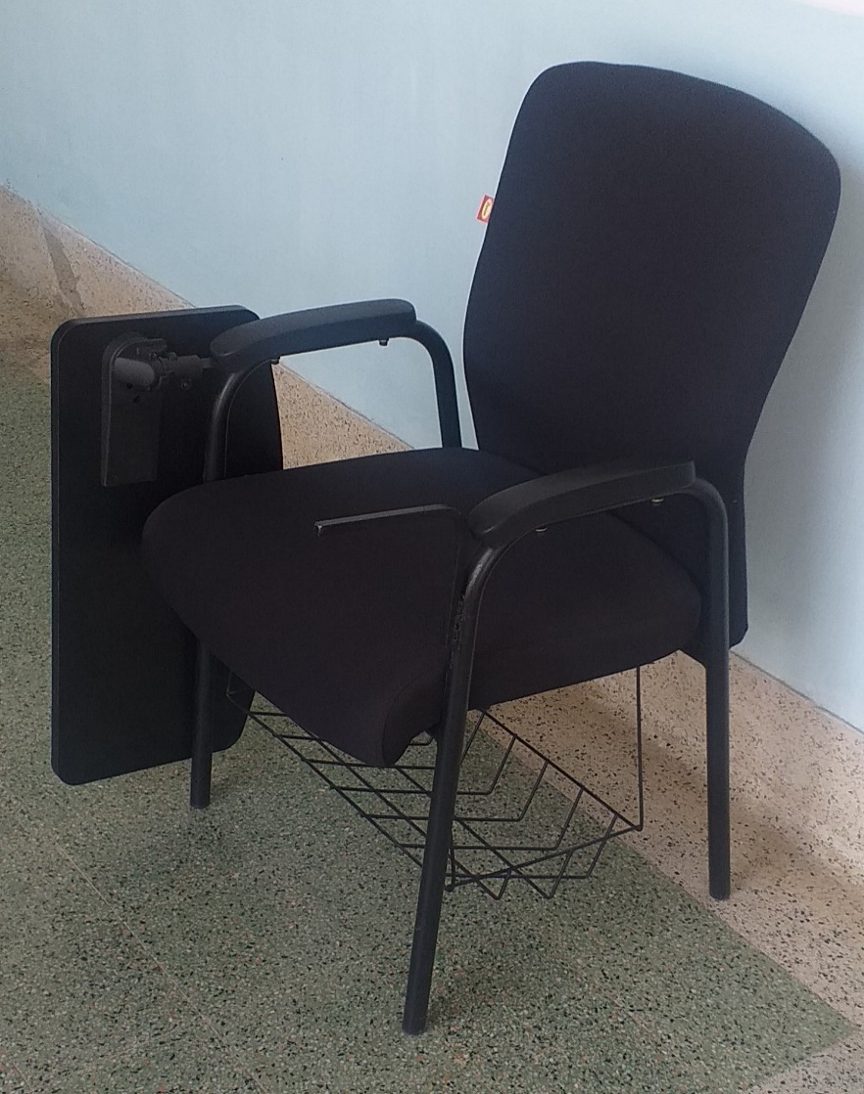

Note:-Suggested Modifications as follow:-1. Left armrest rod –to make with smooth curvature finish & also smaller length. 2. Storage rack below- Stronger 3.Two Colours- Black & Coffee/ dark Brown.

Price bid

- The price quoted shall remain fixed during the contract period and shall not vary on any account.
All lots and items must be listed and priced separately in the Price bid. If a Price bid shows items listed but not priced, their prices shall be assumed to be included in the prices of other items. Lots or items not listed in the Price bid shall be assumed to be not included in the bid.
- Arithmetical errors: The arithmetical errors will be rectified as follows. If there is a discrepancy
between the unit price and the total price that is obtained by multiplying the unit price and quantity, the unit price shall prevail and the total price shall be corrected. If there is a discrepancy between the figures and words. The amount in words will prevail. If the supplier does not accept the correction of errors, its bid will be rejected.
- The prices should be FOR BIT Mesra
Registrar

X

