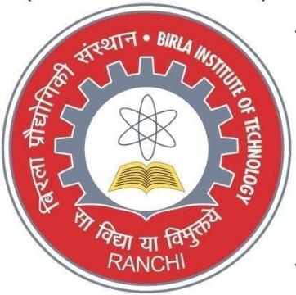
RFQ from Insurance Companies

for

General Insurance of Assets, Vehicles, Buildings

at

BIT MESRA, Ranchi

RFQ date: 28th September 2020

Last Date & Time of submission: 18th October 2020 (03.00 PM)

Bid Opening Date & Time: 19th October 2019 (03.30 PM)

BIRLA INSTITUTE OF TECHNOLOGY

Mesra, Ranchi 835215

RFQ Notice for General Insurance of Assets, Vehicles, Buildings

Background: -

We have taken General Insurance Policy for Assets, Vehicles & Buildings of BIT Mesra, BIT Polytechnic, BIT Lalpur, BIT Noida, BIT Jaipur, BIT Kolkata, BIT Deoghar & BIT Patna.

The period of existing policy is mentioned in the Annexure attached with this RFQ document; we would like to continue the said policy without break for a further period of 1 year.

The details of Assets, Vehicles & Buildings are below:

BIRLA INSTITUTE OF TECHNOLOGY ,MESRA ,RANCHI
 | QUOTATION FORMAT
Name of Firm / Company :
Full Address :
Mail ID :
Contact Person :
Contact No :
Pan No / GST No. :
Sl. No | General Insurance -Items | Located at | Sum Insured | Due Date | Actual Paid | Actual Paid | Premium Proposed
 |  |  | ( Rs. In Lacs ) |  | in 2018-19 | in 2019-20
1 | Money Insurance | Polytechnic |  | 14.02.21 | 6302 | 6302
 | Cash in Transit | Mesra | 108.00
 | Money in Safe |  | 10.00
 | Cash in Transit |  | 1.50
2 | Auditorium | BIT,Mesra | 1000.00 | 08.01.21 | 21240 | 51920
3 | Institute -Assets - Fire | BIT,Mesra | 44781.83 | 30.03.21 | 1002441 | 2113700
 | Institute -Assets - Burglary | BIT,Mesra | 2860.65 | 30.03.21 | 5138 | 3362
4 | Institute - Assets - Fire | BIT, Patna | 7563.81 | 21.08.21 | 259683 | 446264
 | Institute -Assets - Burglary | BIT,Patan | 2136.95 | 21.08.21 | 14815 | 9436
5 | Fidulity Guarantee | BIT, Mesra | 10.00 | 10.07.21 | 5848 | 5848
6 | Institute -Assets -Fire | BIT, Kolkata | 1700.00 | 15.07.21 | 60187 | 100300
7 | Institute -Assets - Fire | BIT, Deoghar | 5010.86 | 02.09.21 | NIL | 266076
 | Institute - Assets -Burglary | BIT, Deoghar | 1599.80 | 02.09.21 | NIL | 7059
8 | Money Insurance | BIT,Mesra |  |  | 4150 | 6787
 | Cash in Transist |  | 400.00 | 07.04.21
 | Money In Safe |  | 15.00 | 07.04.21
 | Cash in transit |  | 5.00 | 07.04.21
9 | Vehicles |  |  |  | 937637 | 983271
 | ( As per list attached )
 |  |  |  |  | 2317441 | 4000325
Note: Figures of Assets of BIT, Mesra based on January ,2020

but at the time of renewal figures will be

of January / February,2020 i.e. Amount will increase.

Other Centres Assets figures will also
change

at the time of renewal at various dates.

Vehicle Policy are being renewed throughout the year

based on date of renewal.

Important Note: Price Bid to be submitted Separately & not to be clubbed with any other policy. Sealed Bids should be submitted in Envelopes Superscripted as “General Insurance Policy for Assets, Buildings & Vehicles”.

The institute may accept bids through E- Mail also, provided the Price Bid is submitted by a Password Protected file on or before the due date and time of submission of bids

specified in this document at registrar@bitmesra.ac.in & utpal.baul@bitmesra.ac.in

