PABX: +91 651 2275444/2275896, Extn: 4663, Fax: 0651 2275401, Email: dr.purchase@bitmesra.ac.in
Website: www.bitmesra.ac.in

SHORT TIME TENDER

Ref: 24-25/G/PE/00039 DATE: 10/07/2024

To,

M/s. ..............................................

Dear Sir,

Subject: Request for Quotation for Procurement Steel Cot, Steel Table & Chair for Hostels at BIT Mesra

You are requested to submit the most competitive rates(s) for the following item(s) as per the details given below (Sealed Quotations may be sent by hand or by post):

Last date and time for submissions of complete Quotations by ( Password protected)  Email to dr.purchase@bitmesra.ac.in, purchase7@bitmesra.ac.in sealed quotations  can be submitted to the under-mentioned address. | 16/07/2024 15:00 Hrs.  ( If all LTE Vendors submit the quotation prior to the submission date, the quotations will be opened prior to the last date of submission.)

FURNITURE FOR HOSTEL NO. 9
INDENT NUMBER - 24-25/IC/000140
Sl NO | Description Of Work | Unit | Qty. | Rate | Amount
1 | STEEL COT  Size: 2005x900x60mm head and leg Bow Height 750mm & 630mm Made Up of 32mm x 16 gauge Round pipe Supported With 03 Nos x 19mm R- Vertical pipe 7 the provision of Mosquito Net Holder Bed Top made of 18 Gauge CRC Sheet size of Bed Top 2005x900x60mm Bended by machine Supported With 2 Nos 3mm sheet Angle below the Top & on the Four Sides of the Top 6 Nos R/b pressed on the Top complete3 with powder coating and installation Approx Weight 50 Kg. | Nos. | 62.00
2 | STEEL TABLE  Size- 900x600 mm Frame made of 1" x 16 Gauge Sq. Pipe Frame size- 2-9" x 1¿-8" x2¿-6" fitted with waterproof & termite resistance top of 19mm plywood and 0.8mm sunmica of century make (both) with bush in all legs. | Nos. | 62.00
3 | PLASTIC CHAIR WITH ARM  Make: Supreme  Model: Turbo  Colour: Reddish Brown | Nos. | 62.00
 | TOTAL
 | GST@18%
 | TRANSPORTATION
 | INSTALLATION CHARGES (If any)
 | GRAND TOTAL
 | WARRANTY
 | DELIVERY SCHEDULE

- Bed /Cot

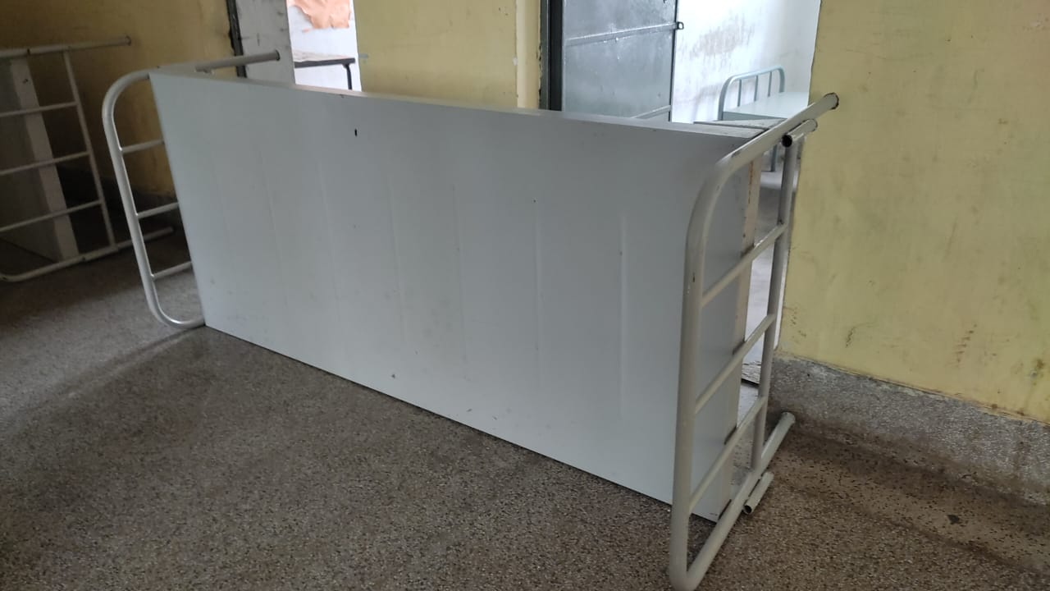
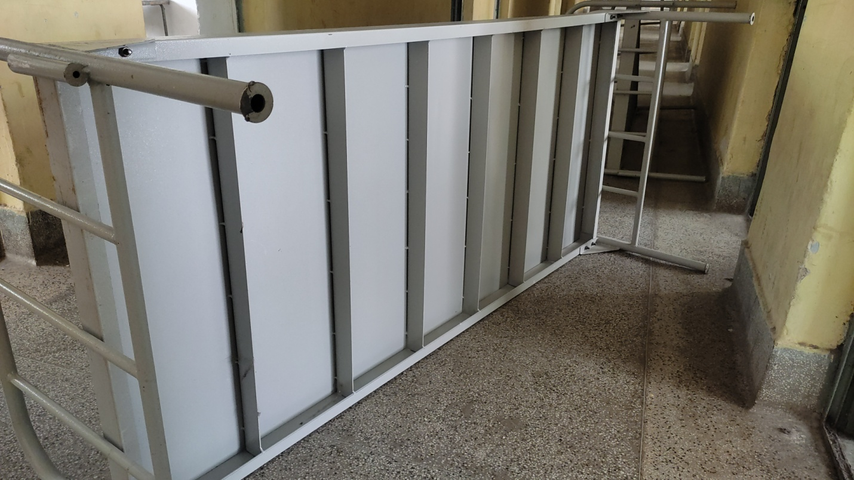
2. Table

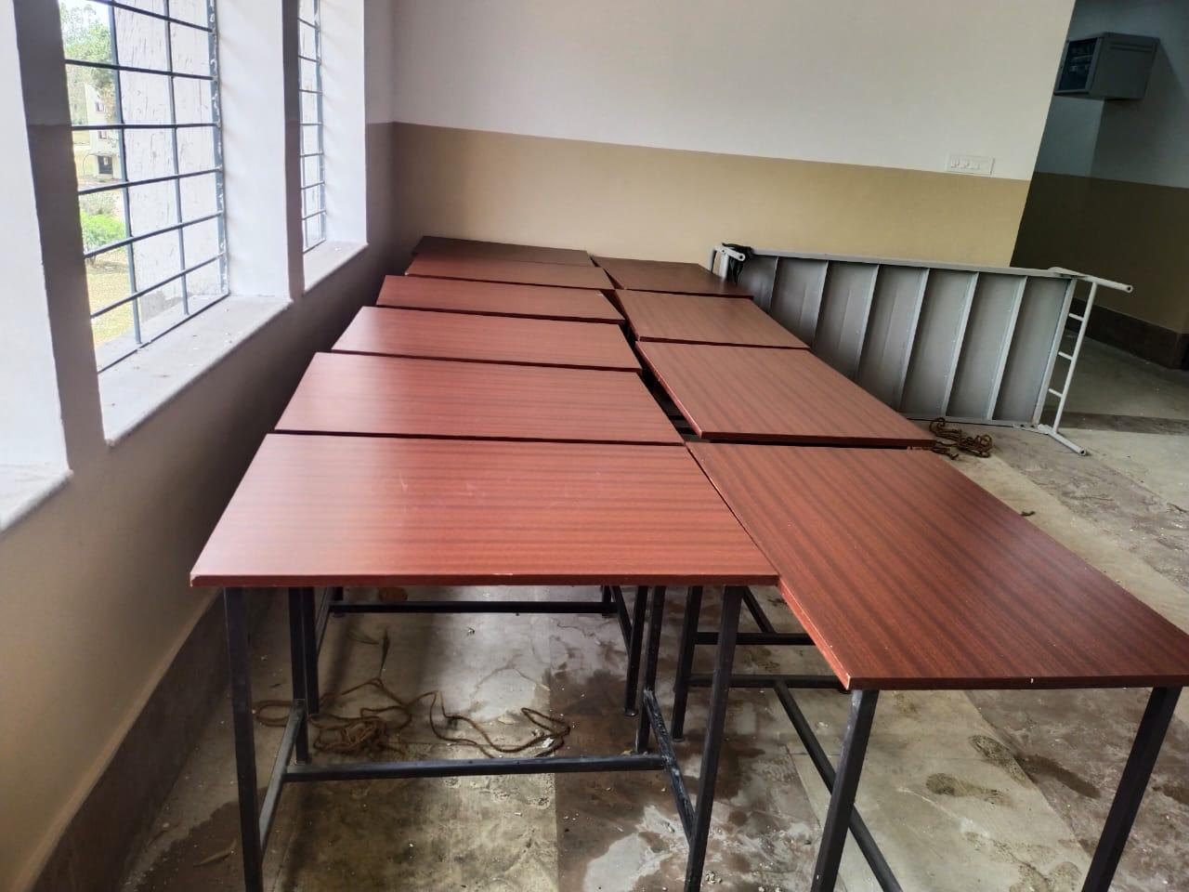

- Chair

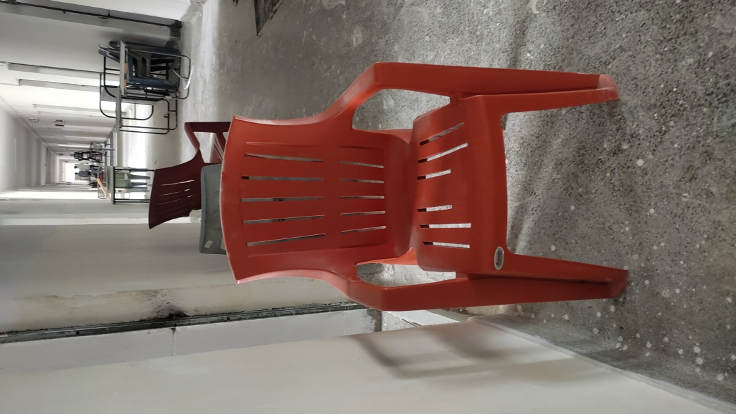

Sealed Quotation may be submitted superscribed with reference number as appended hereunder:-
Quotation for the Supply of Steel Cot, Steel Table & Chair for Hostel at BIT Mesra

Ref. No. 24-25/G/PE/00039

To,
Dy. Registrar (Purchase)
Birla Institute of Technology From : M/s----------------------------------------
Mesra , Ranchi -835215 Address : ----------------------------------------
Jharkhand Contact No. -------------------------------------
Email ID

Terms & Conditions:
- Original bills in triplicate along with the warranty card will have to be issued by the party to whom the order is issued.
- HSN code of the material should be mentioned in the quotation.
- All entries in the quotation should be typed or computer-printed without any ambiguity and should be free from correction etc. Handwritten offers will be rejected.
- Late and delayed tenders will not be considered. In case any unscheduled holiday occurs on the prescribed closing date the next working day shall be the prescribed date of closing.
- The quotation should be submitted with descriptive literature & drawing. The make of the items offered should be clearly specified.
- Material should be confirmed to our specifications. The deviations if any should be clearly indicated in the quotations.
- Successful bidder has to furnish the OEM test certificates along with the materials (if applicable).
- Rate /Price: The offered price shall be on FOR BIT Mesra on a Door Delivery basis. 9. No Advance payment will be considered at any circumstances.
- If offered Price Term is other than the FOR-Destination term, approximate Freight & forwarding charges along with the applicable Insurance charges may be mentioned.
- GST and PAN certificates should be furnished along with quotations.
- Road Permit: The supplier shall arrange Road Permit on his own for transportation material to BIT Mesra and any additional tax liability on this account shall be borne and paid by the supplier.
- Purchaser will not pay separately for transit insurance/taxes (if any) and the supplier will be responsible until the stores arrive in good condition at the destination.
- Warranty: The period of warranty should be clearly mentioned and also the parts covered under it. Warranty will be applicable from the date of successful installation.
- Service Facility: Supplier must mention about the service set up in India & confirm effective after-sales service.
- BIT Mesra is not bound to accept the lowest or any quotation for whatsoever reason and reserves its right to accept or reject in whole or in part any or all the quotations received without assigning any reason.
- Applicable taxes shall be quoted separately for all items and levies payable by the supplier under the contract shall be included in the unit price.
- Each bidder shall submit only one quotation and a sealed quotation to be submitted/delivered at the address. (Alternatively, it can be email (Password protected) at purchase7@bitmesra.ac.in or dr.purchase@bitmesra.ac.in) or deliver by hand.
- Training clause ( if any )to be mentioned.
- Delivery period should be mentioned clearly in the quotation. If a firm accepts an order and fails to execute the order in full as per the terms and conditions stipulated therein, it will be open to this Institute to recover liquidated damages from the firm at the rate of 0.5% to 1% per week of the order value subject to a maximum of 10% of the order value.
- Conditional tenders will not be considered.
- Authorized dealership certificate should be submitted in case the principal manufacturing company is not quoting directly.
- Copy of Purchase Orders for similar equipment supplied to any other organization desired.
- Annual turnover of the company for the last 3 years / CA Certificate to be provided.
- Declaration required by the vendor that the price quoted is the lowest that I have supplied to any other organization.

-Sd-

DR (Purchase )
BIT Mesra, Ranchi-835215

