Institution’s Innovation Council – BIT Mesra

Greetings from IIC-BIT Mesra. Trust you are doing well and are safe.

BIT Mesra has always had strong ties with entrepreneurship, leaving its mark across all industries. Maintaining the streak of entrepreneurial excellence, the Institution’s Innovation Council (IIC) of BIT Mesra, in collaboration with the Entrepreneurship Development Cell and Finance Club, is thrilled to present its 'BIT-NISHAN-2021' (NISHAN stands for Neoteric-Indigenous-Scientific-Harmonious-Ambitious-Novel) an innovation contest to be held on 23rd and 24th October 2021. The key motto behind this event is "No Idea should go unnoticed just because of lack of resources and support".

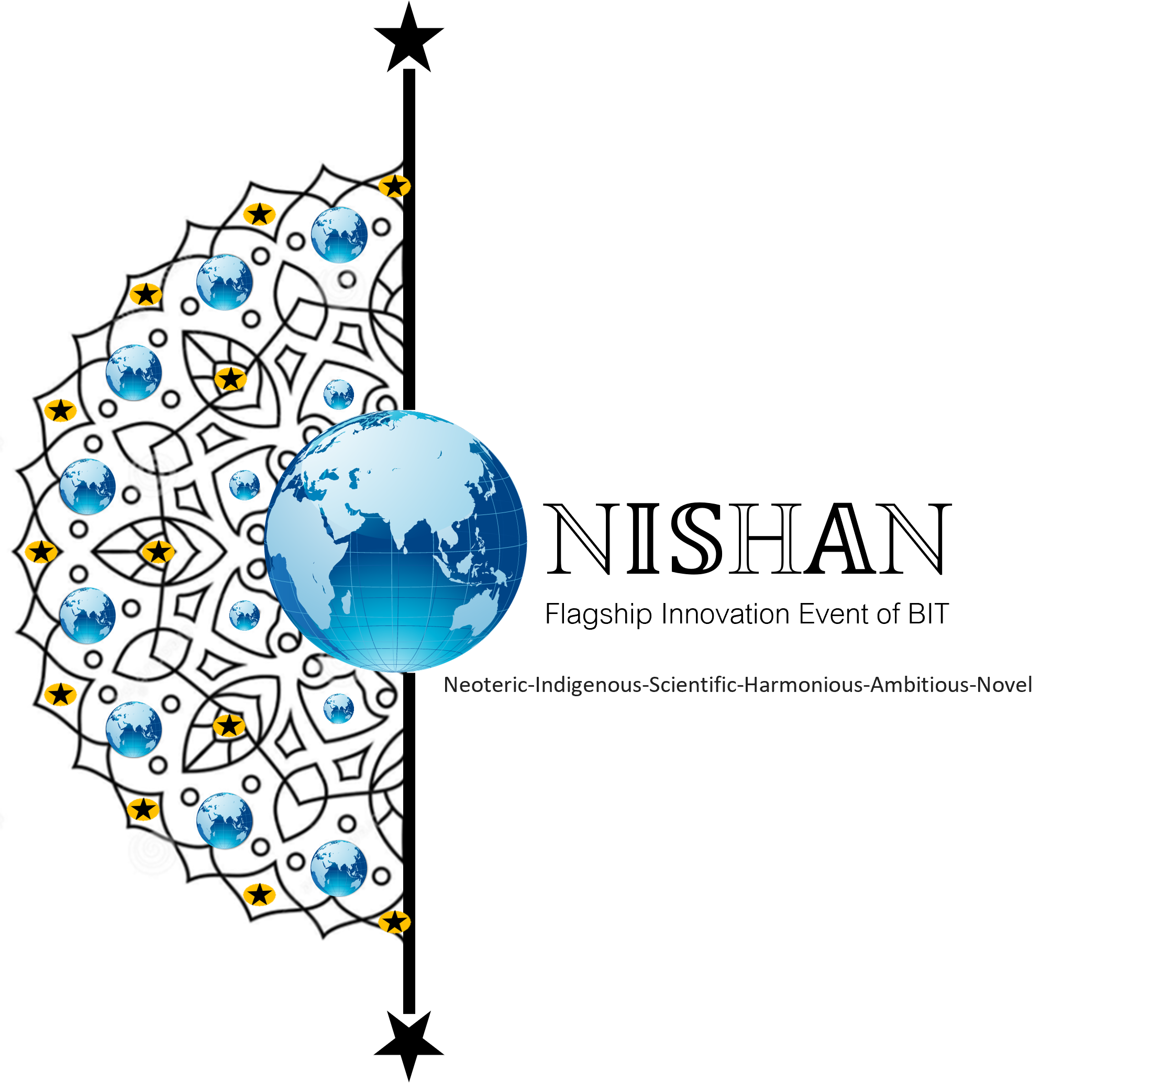
BIT - NISHAN aims to identify and support engineering talents, entrepreneurial ideas and startup thought process from enthusiastic BIT students. The institute and the event organizing body will help the selected startup idea with their immediate monetary and mentorship requirements.

Key takeaways from NISHAN:
• Top performing teams will get Immediate Monetary Support (up to INR 2 Lakh).
• Mentorship & Infrastructural backing.
We invite all budding startups and teams having bright ideas from BIT Mesra and its other off campuses to register for the event and make the best use of this golden opportunity to kickstart their journey on this high-growth trajectory!

Registration

Registration Start date: 18th September 2021
Registration End date: 10th October 2021.
Event Date: 23rd & 24th October 2021.

Student Teams can Register at: https://bit.ly/BIT-NISHAN-Registration
Teaser Video and further details about the event can be seen in the attachments.

BIT NISHAN Video link : https://drive.google.com/file/d/107Qxfzk0mIJ7B7Vmk2N3kw-e-17R7VRR/view

