BIRLA INSTITUTE OF TECHNOLOGY MESRA

Heartiest Congratulations

to

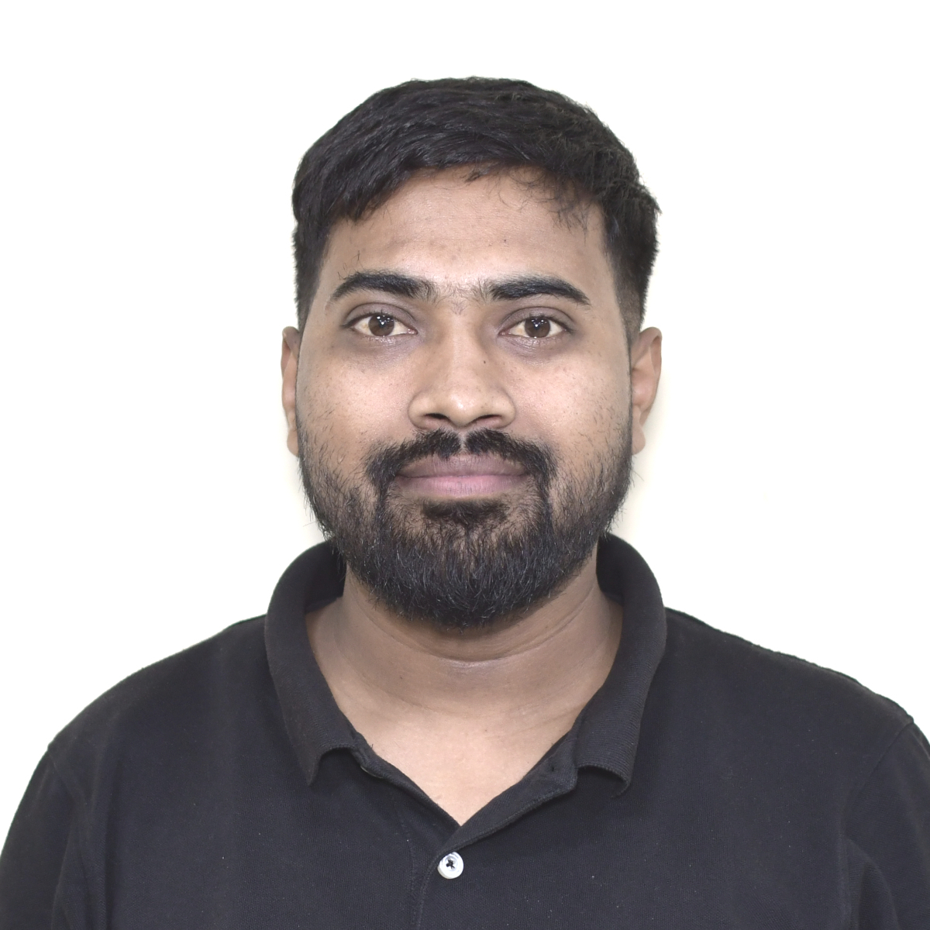

**Suresh Pratap,** Research Scholar, Production and Industrial Engineering,

Birla Institute Of Technology, Mesra ,Ranchi, Jharkhand-835215.

He has received Financial Assistance from ANRF (Formerly SERB) ITS scheme for participating in "The 7th International Conference on Material Strength and Applied Mechanics (MSAM 2024) from 29 July 2024 to 01 August 2024), Hosted by Széchenyi István University, Gyor, Hungary.

Grant No : ITS/2024/002652

