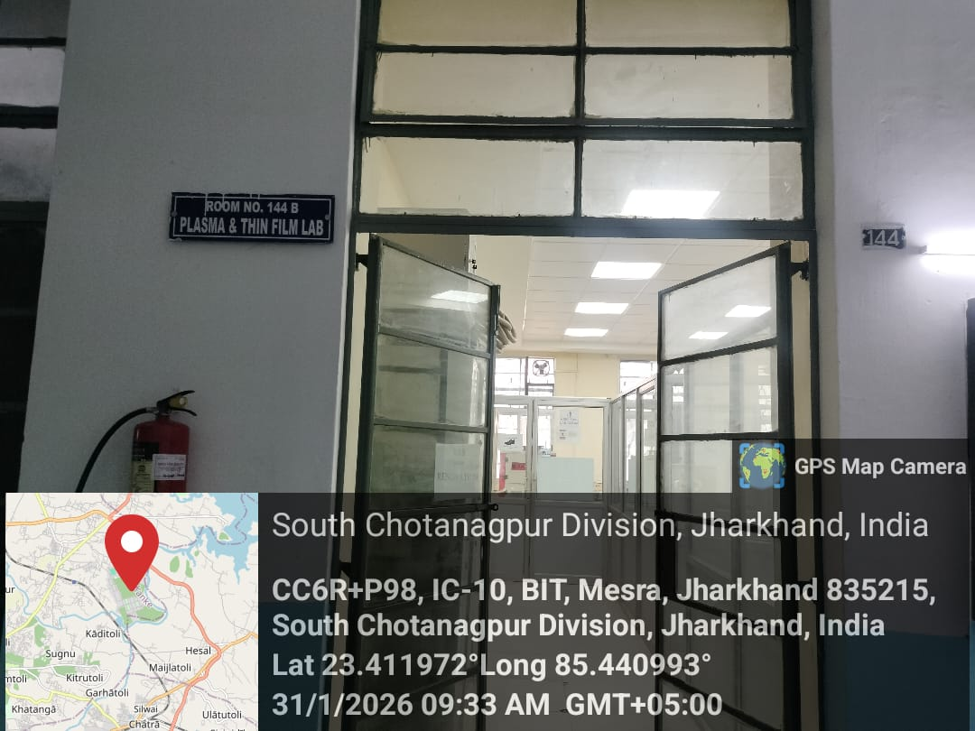
Plasma and Thin Film Laboratory

Dr. S. K. Mukherjee
Prof-in-Charge
Plasma and Thin Film Lab
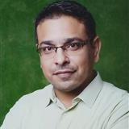

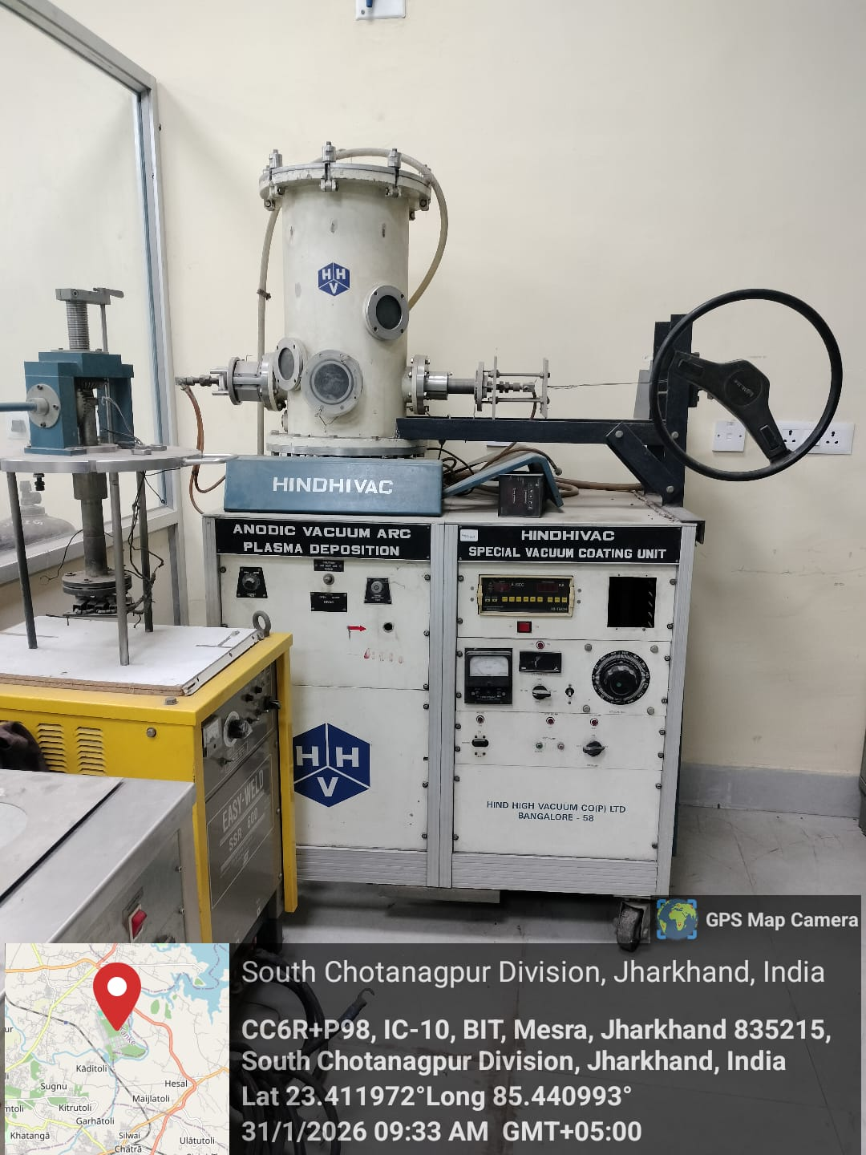

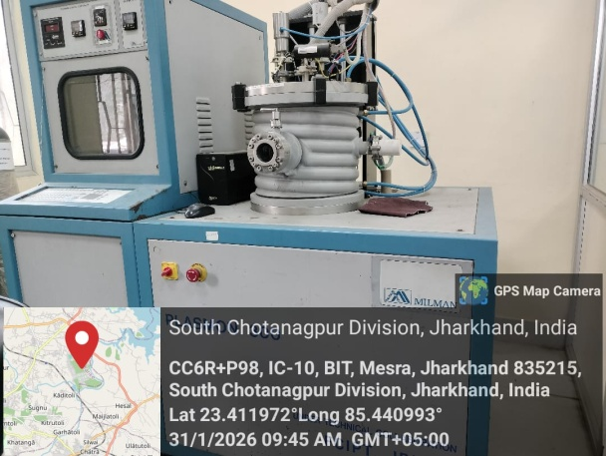
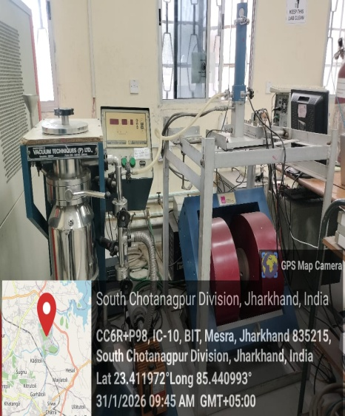
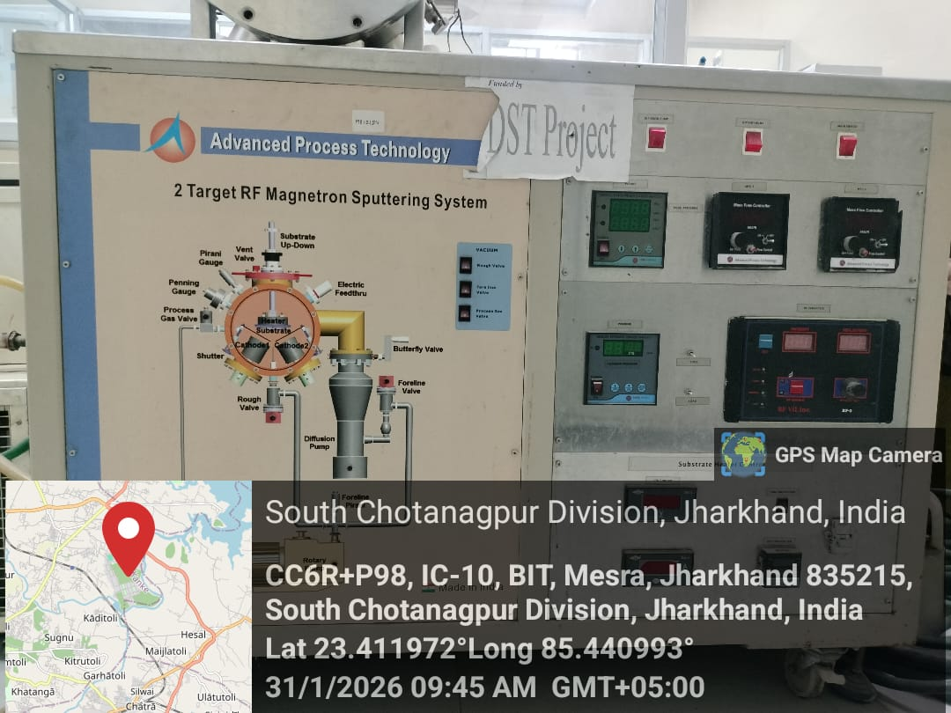
Anodic Vacuum Arc Plasma Thin Film
Prof- In-Charge Dr. S. K. Mukherjee
Plasma Nitriding
Prof- In-Charge Dr. S. K. Mukherjee
Cryogenic Setup
Prof- In-Charge Prof. S. Keshri
2 Target RF Magnetron Sputtering Setup
Prof- In-Charge: Prof. S. Keshri

