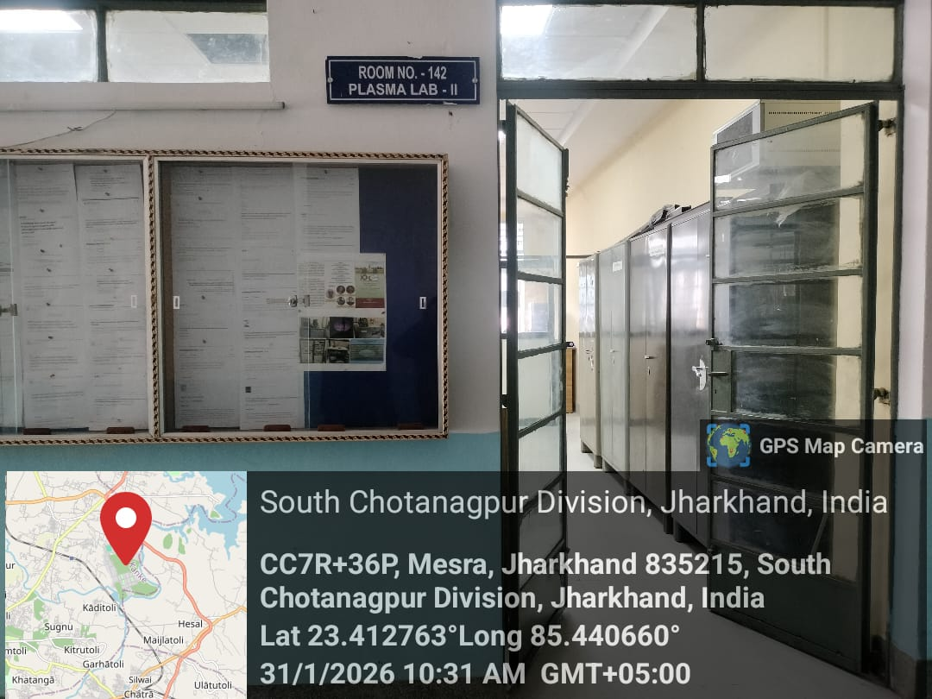
Plasma Lab- II

Prof. S. K. Sinha
Prof- In-charge Plasma Lab-II
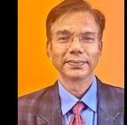

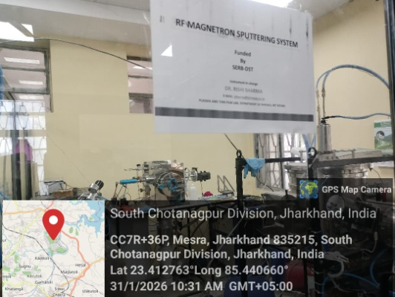

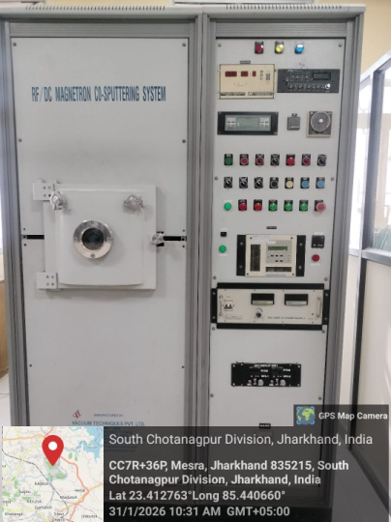
RF/DC Magnetron Co-sputtering Setup
Prof- In-Charge Dr. S. K. Mukherjee
RF Magnetron Sputtering Setup
Prof- In-Charge Dr. Rishi Sharma
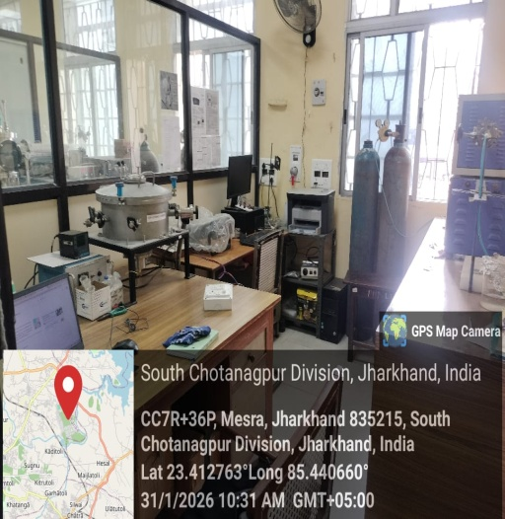
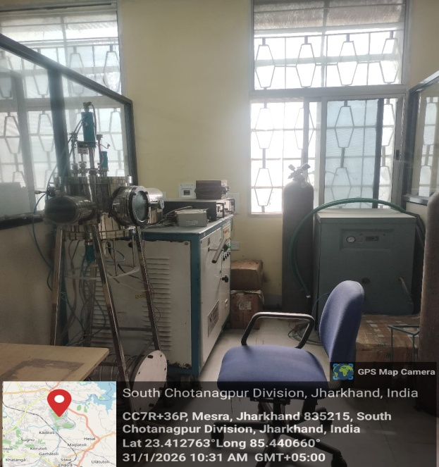

DC Magnetron Sputtering Setup
Prof- In-Charge Dr. S. K. Mukherjee
Semiconductor Nanomaterials for Optoelectronics and Sensing Lab
Prof- In-Charge Dr. D. K. Singh
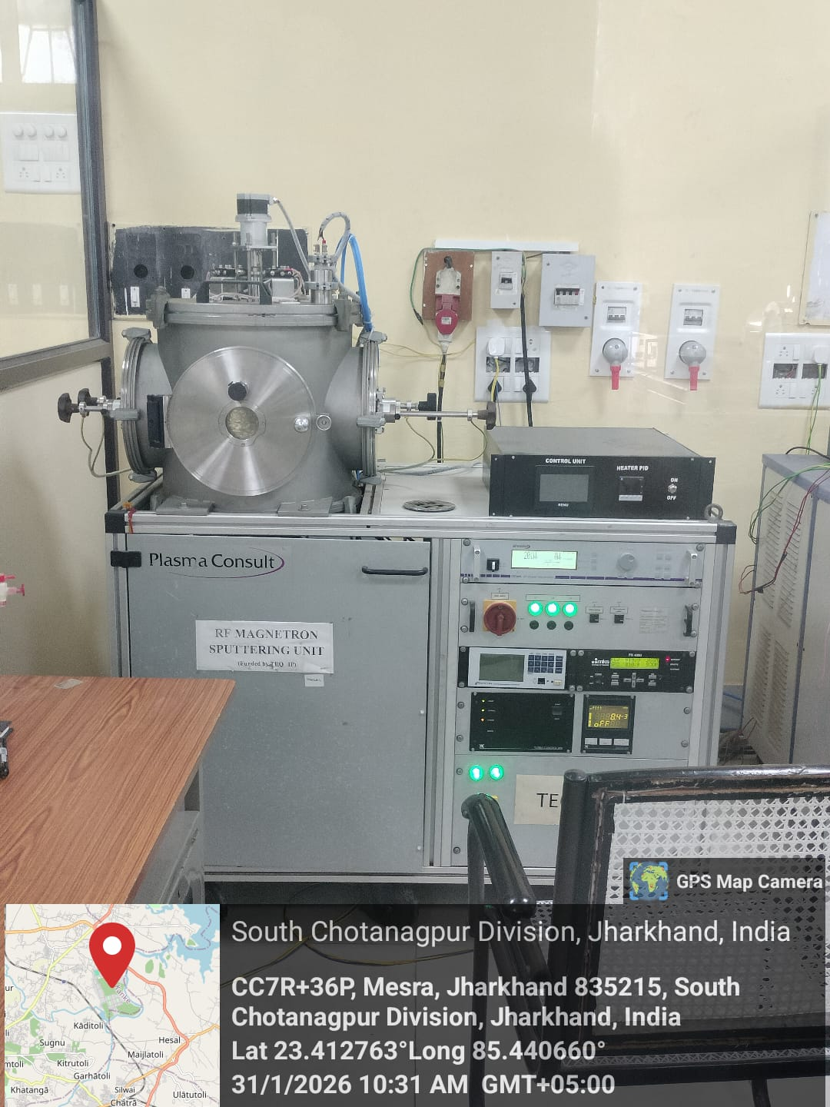

RF Magnetron Sputtering Setup
Prof- In-Charge Dr. S. K. Mukherjee
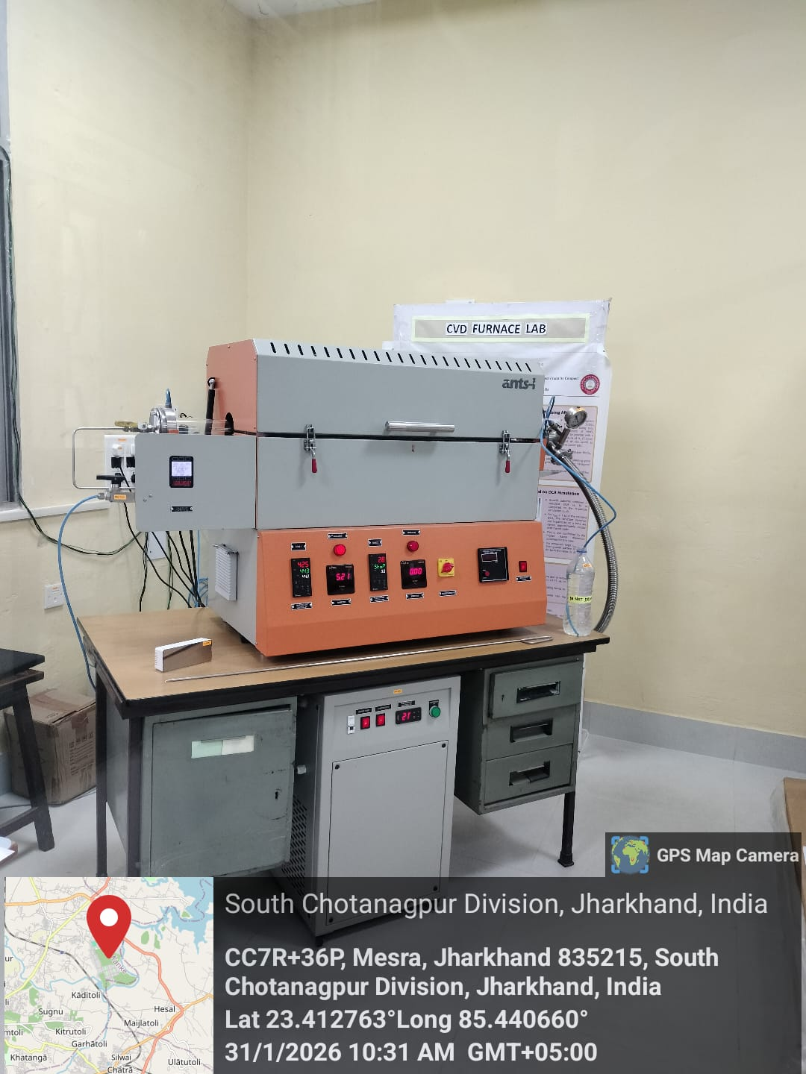
CVD Furnace Setup
Prof- In-Charge Dr. A. Roy
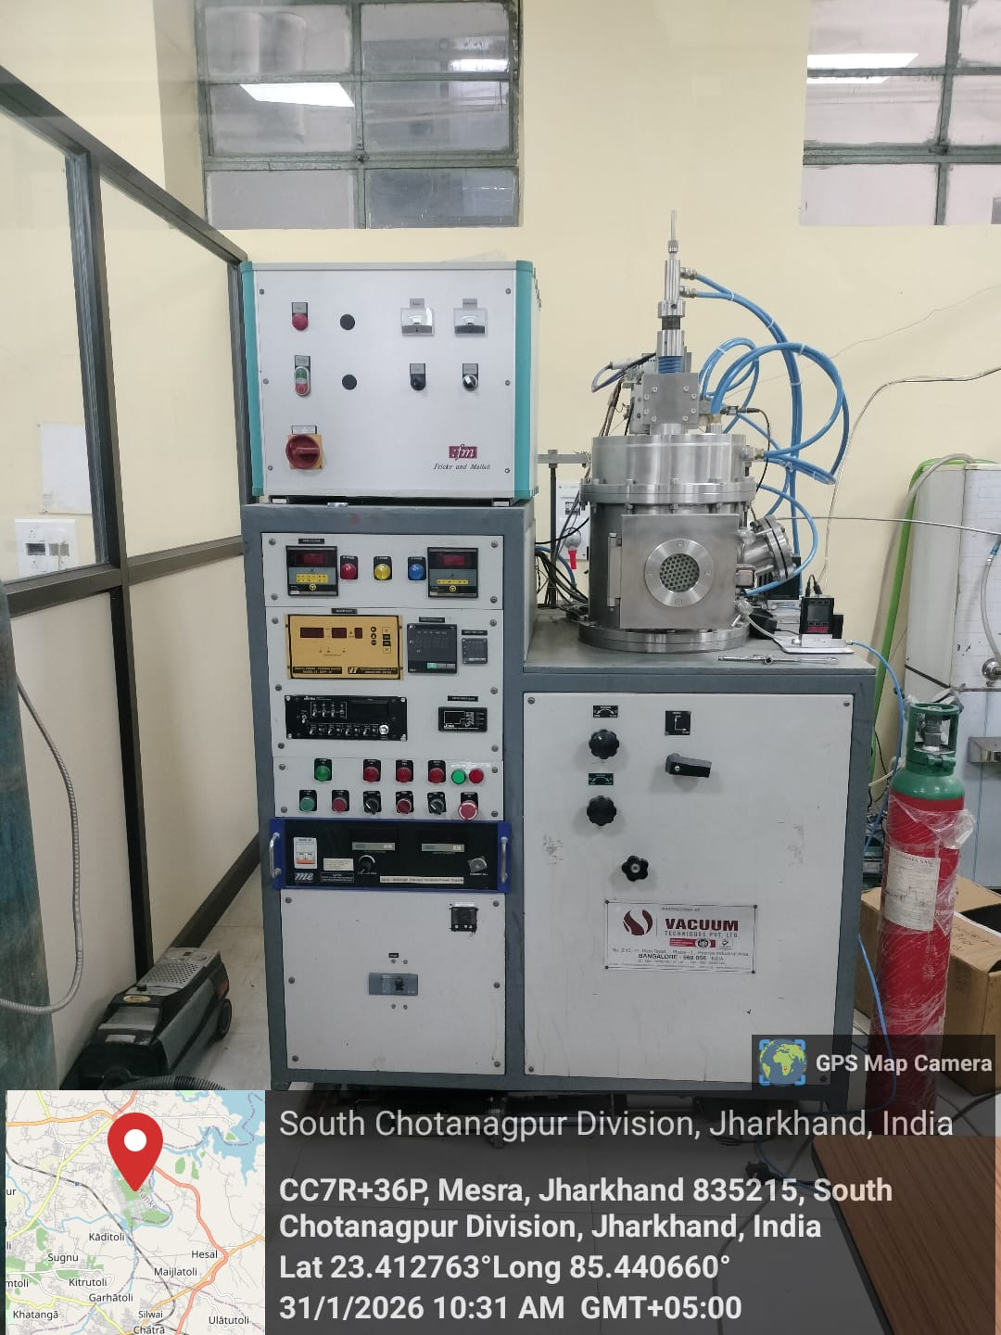

Microwave PECVD Setup
Prof- In-Charge Dr. Rishi Sharma

