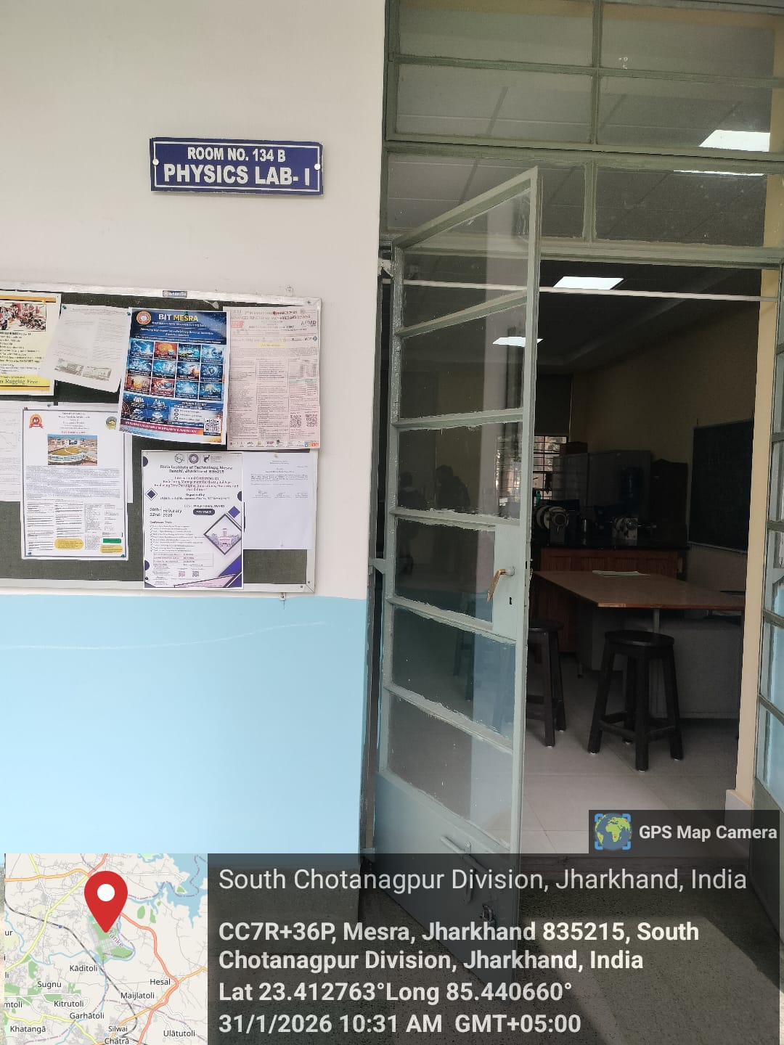
Physics Lab–I

Dr. R. K. Dewanjee
Prof- In-charge Physics Lab-I
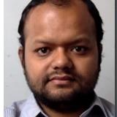

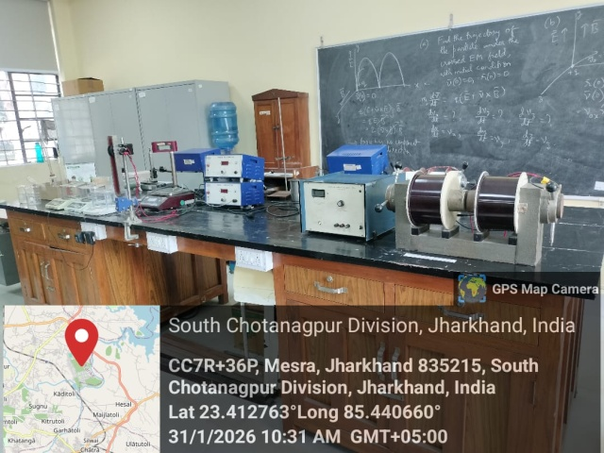

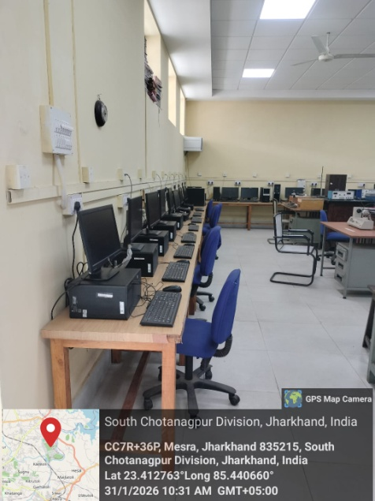
UG/PG Physics Experiments
UG/PG Physics Experiments
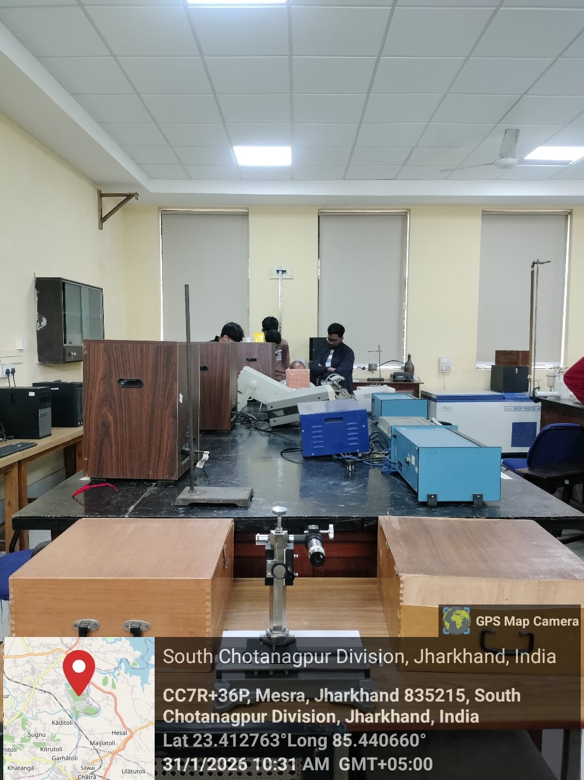
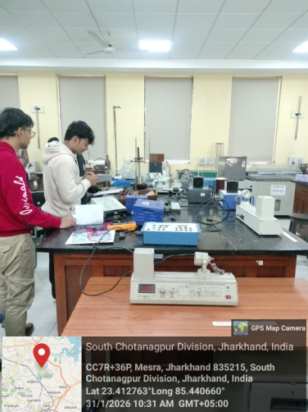

UG/PG Physics Experiments
UG/PG Physics Experiments

