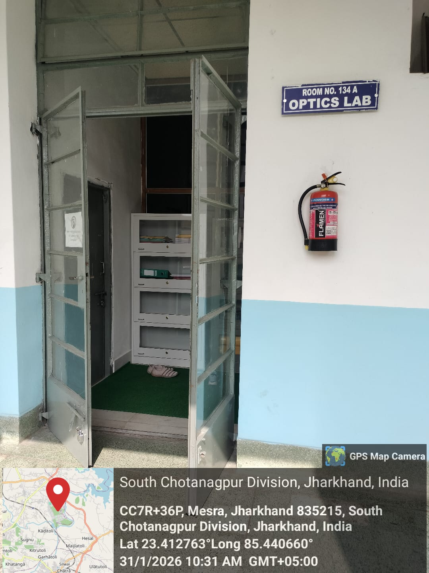
Optics Laboratory

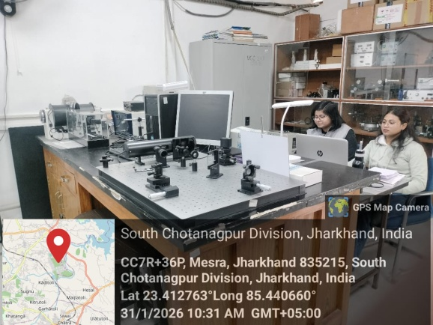
Dr. R. K. Sinha
Prof –in-Charge : Optics Laboratory
[Type a quote from the document or the summary of an interesting point. You can position the text box anywhere in the document. Use the Text Box Tools tab to change the formatting of the pull quote text box.]
[Type a quote from the document or the summary of an interesting point. You can position the text box anywhere in the document. Use the Text Box Tools tab to change the formatting of the pull quote text box.]
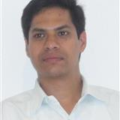

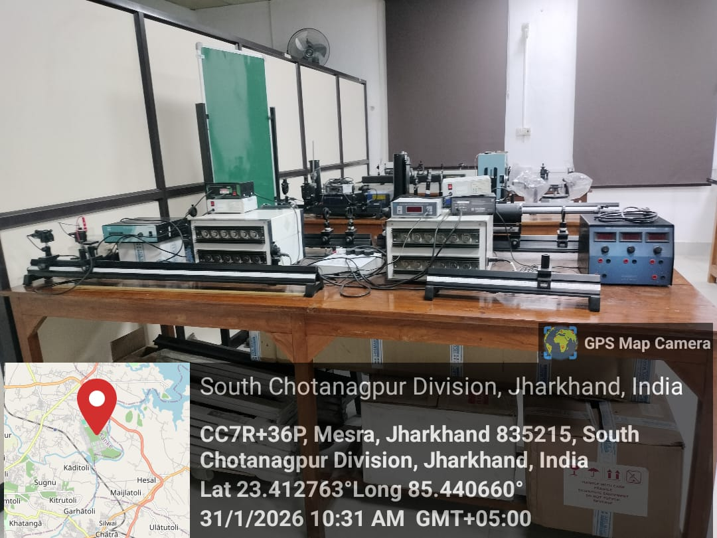
UG/PG Physics Experiments
UG/PG Physics Experiments
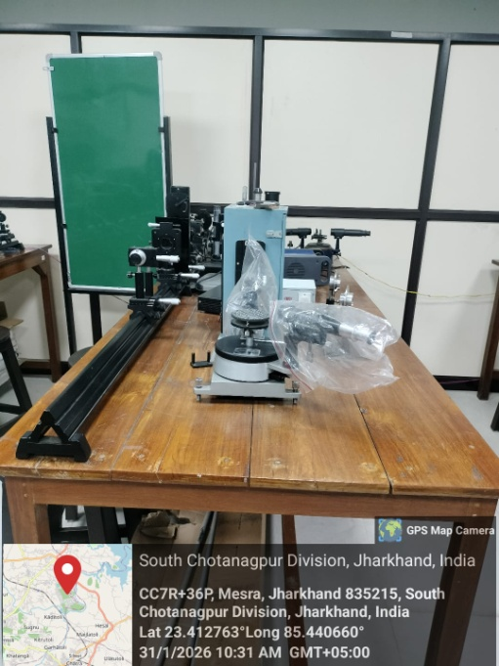
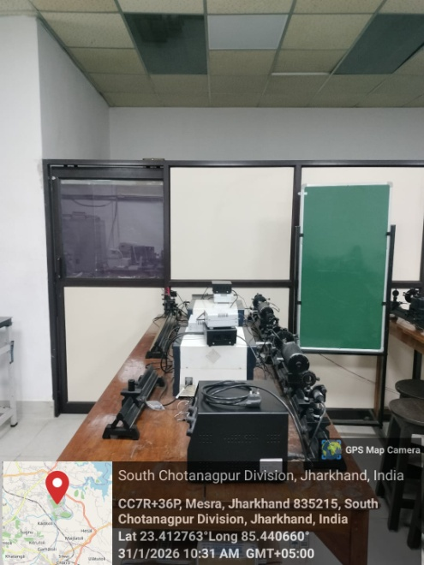

UG/PG Physics Experiments
UG/PG Physics Experiments
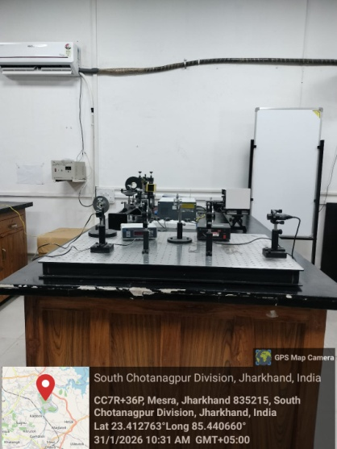
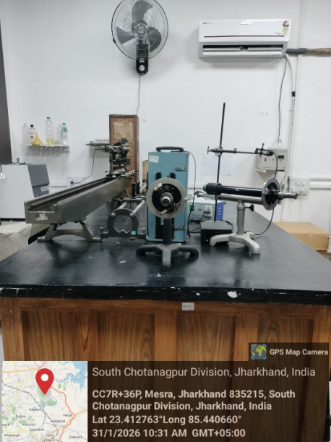

UG/PG Physics Experiments
UG/PG Physics Experiments
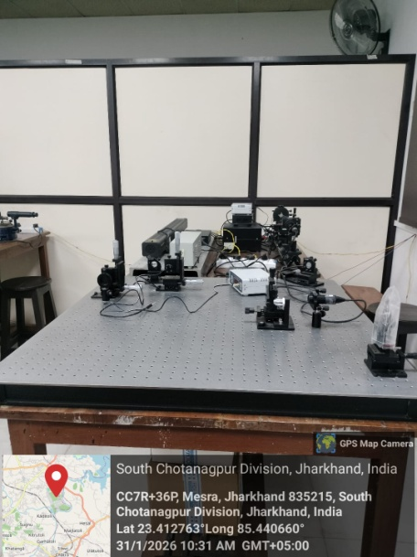

UG/PG Physics Experiments

