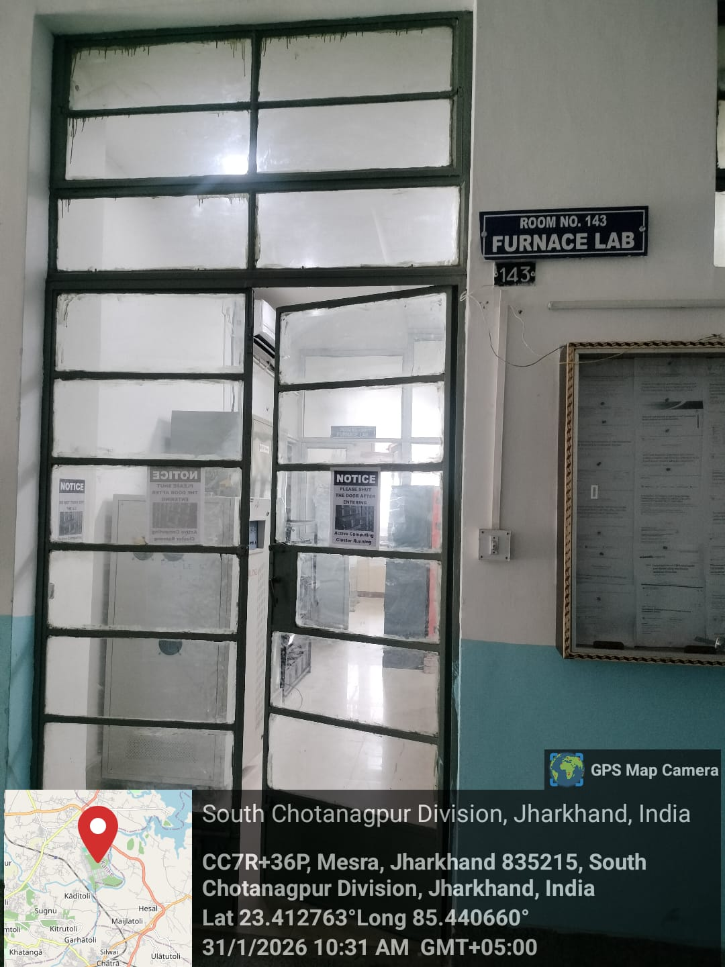
Furnace Laboratory

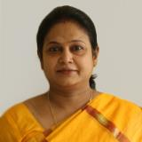
Dr. Ela Rout
Prof. In Charge Furnace Laboratory

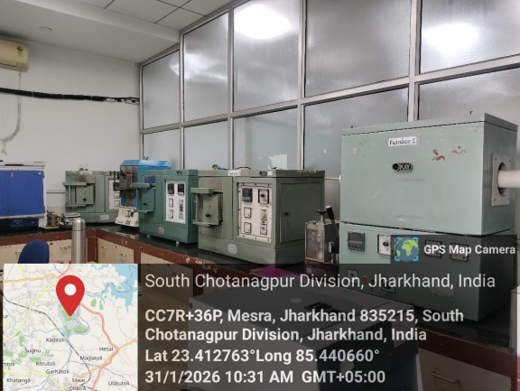

Furnaces
Prof. In Charge: Dr. Ela Rout

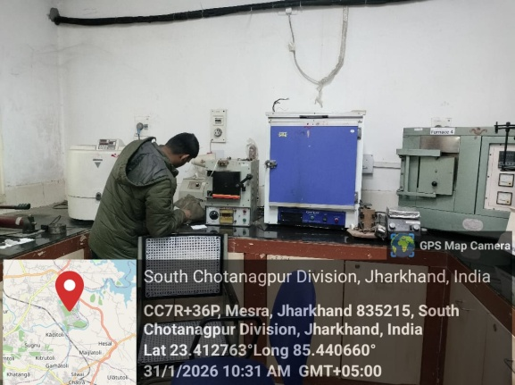
Furnaces
Prof. In Charge: Dr. Ela Rout
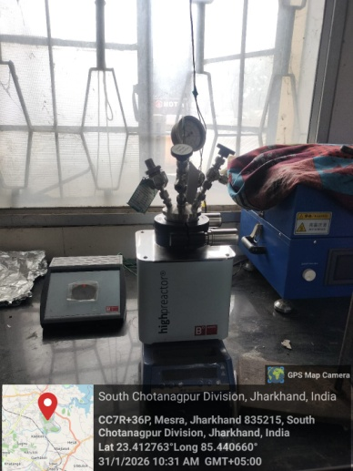

Hydrothermal Setup
Prof. In Charge: Dr. S. K. Mukherjee

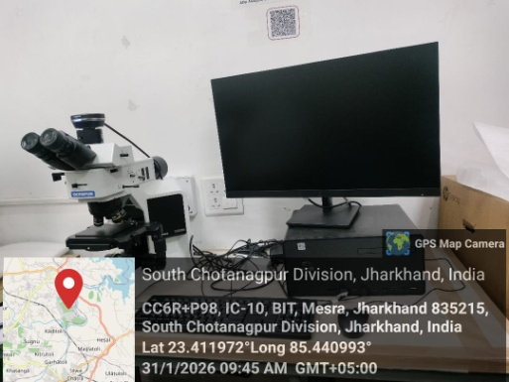

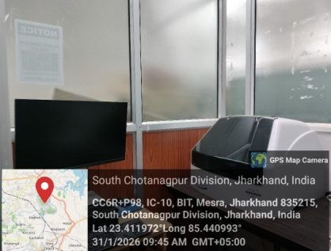
Surface Profilometer Setup
Prof. In Charge: Dr. S. K. Mukherjee
Optical Microscope Setup
Prof. In Charge: Dr. A. Roy
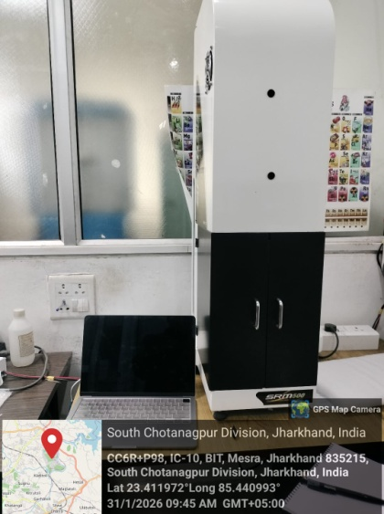

Spectral response measurement system
Prof- In-Charge Dr. Rishi Sharma

