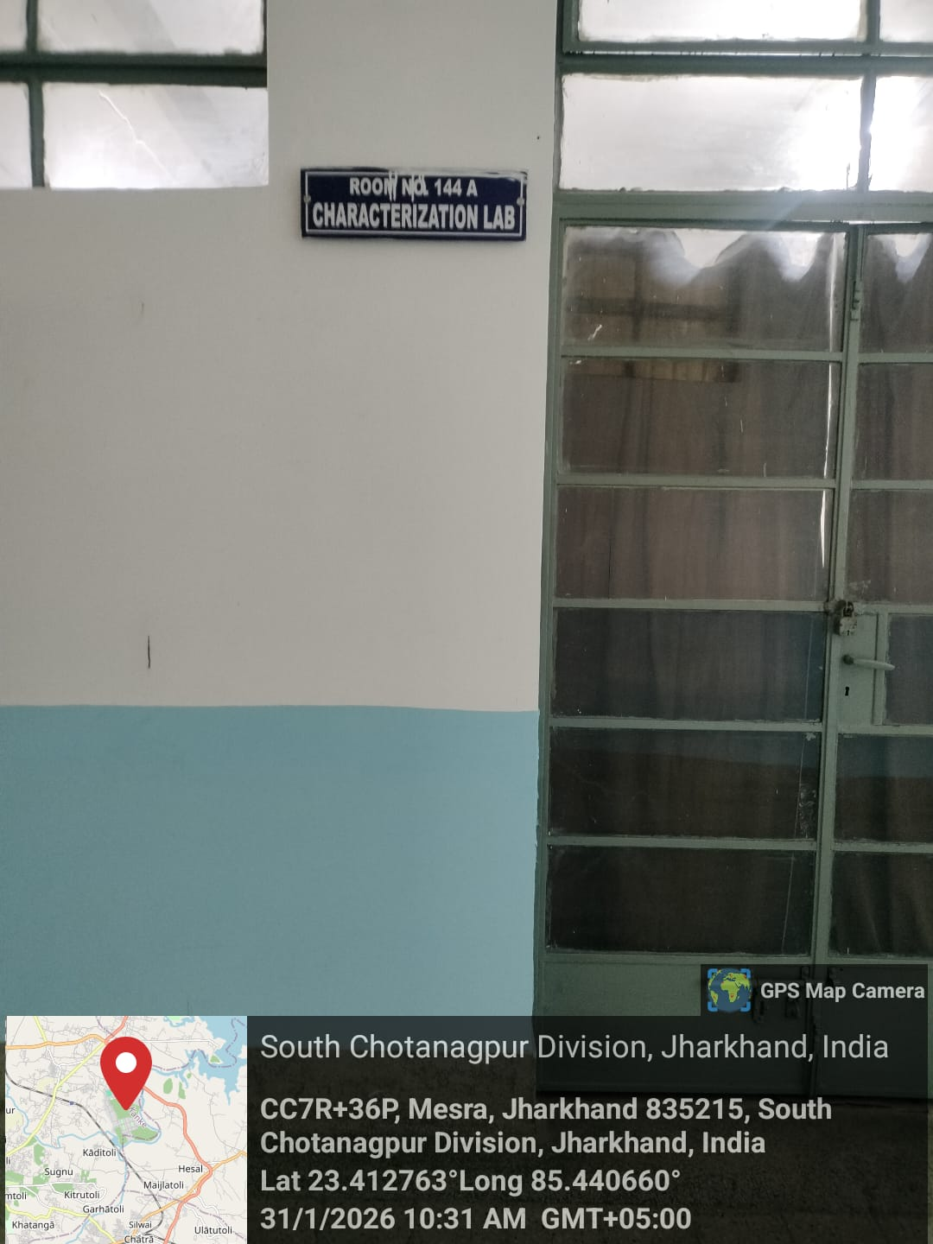
Characterization Laboratory


Dr. Ela Rout
Prof-In-Charge: Characterization Lab

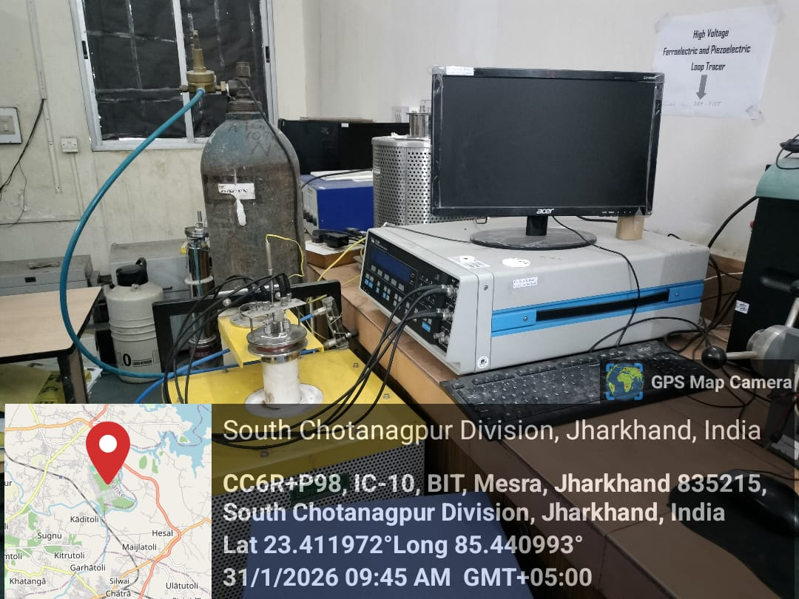

High Voltage Ferroelectric and Piezoelectric Loop tracer
Prof. In Charge: Dr. Ela Rout
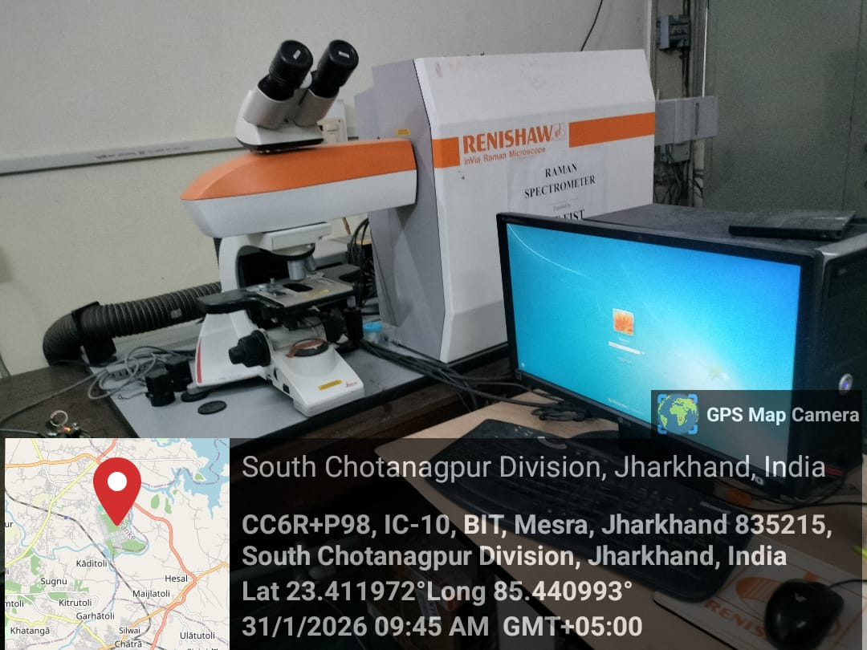

Raman Spectroscopy Setup
Prof. In Charge: Dr. D. K. Singh

