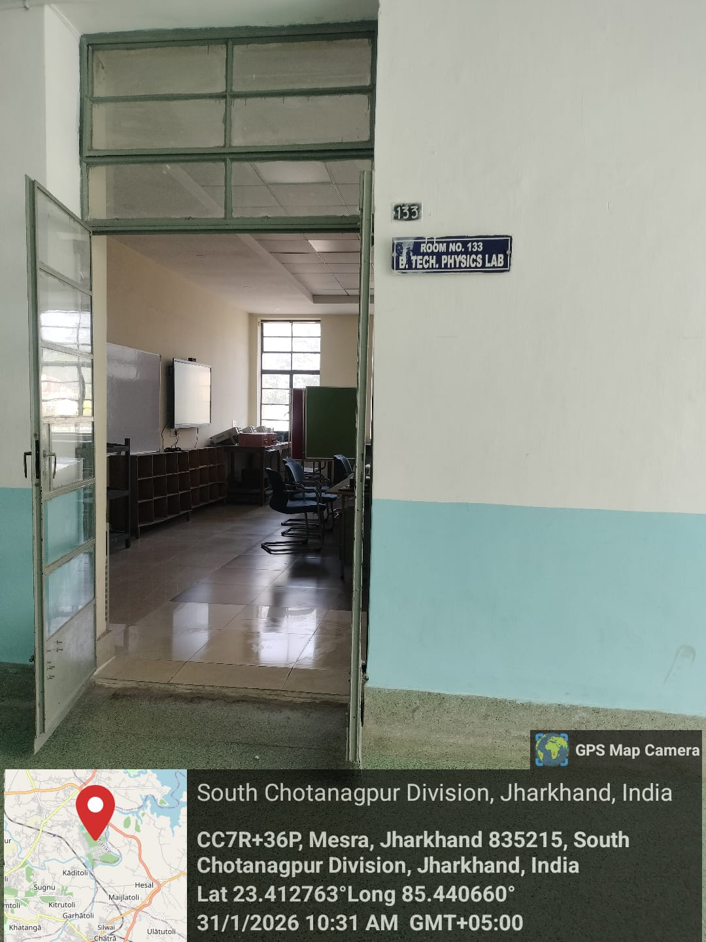
B. Tech Physics Laboratory

Dr. Nishi Srivastava
Prof. In Charge

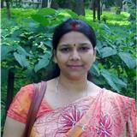

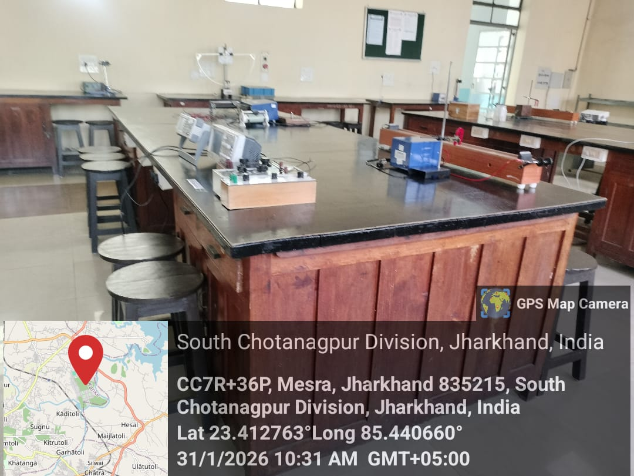

B. Tech Physics Lab Experiments

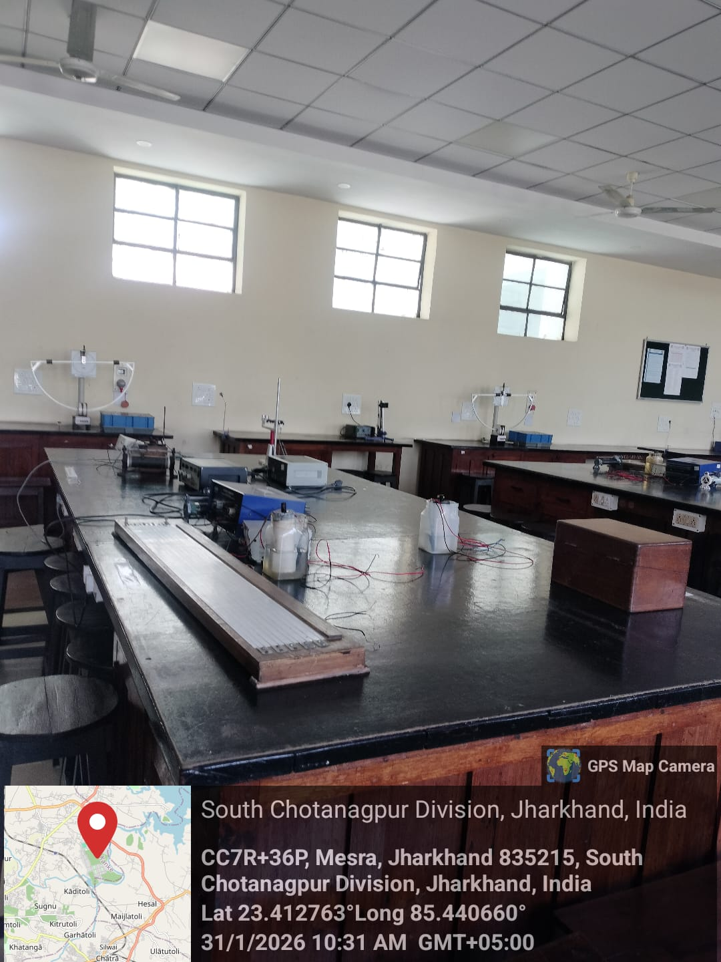

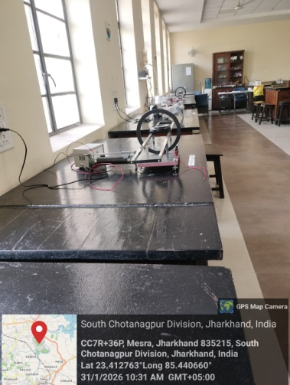
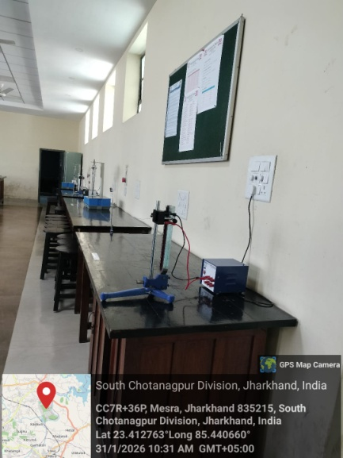
B. Tech Physics Lab Experiments

B. Tech Physics Lab Experiments
B. Tech Physics Lab Experiments
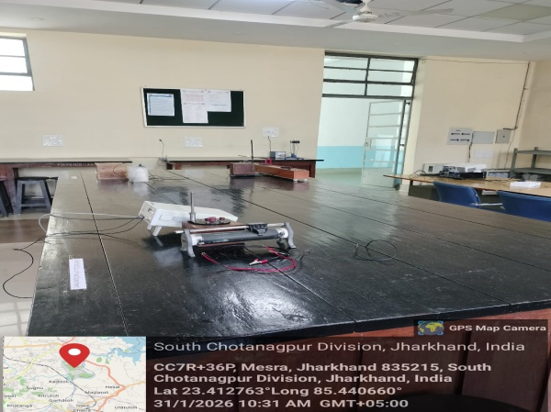

B. Tech Physics Lab Experiments

