Physics Laboratory – II
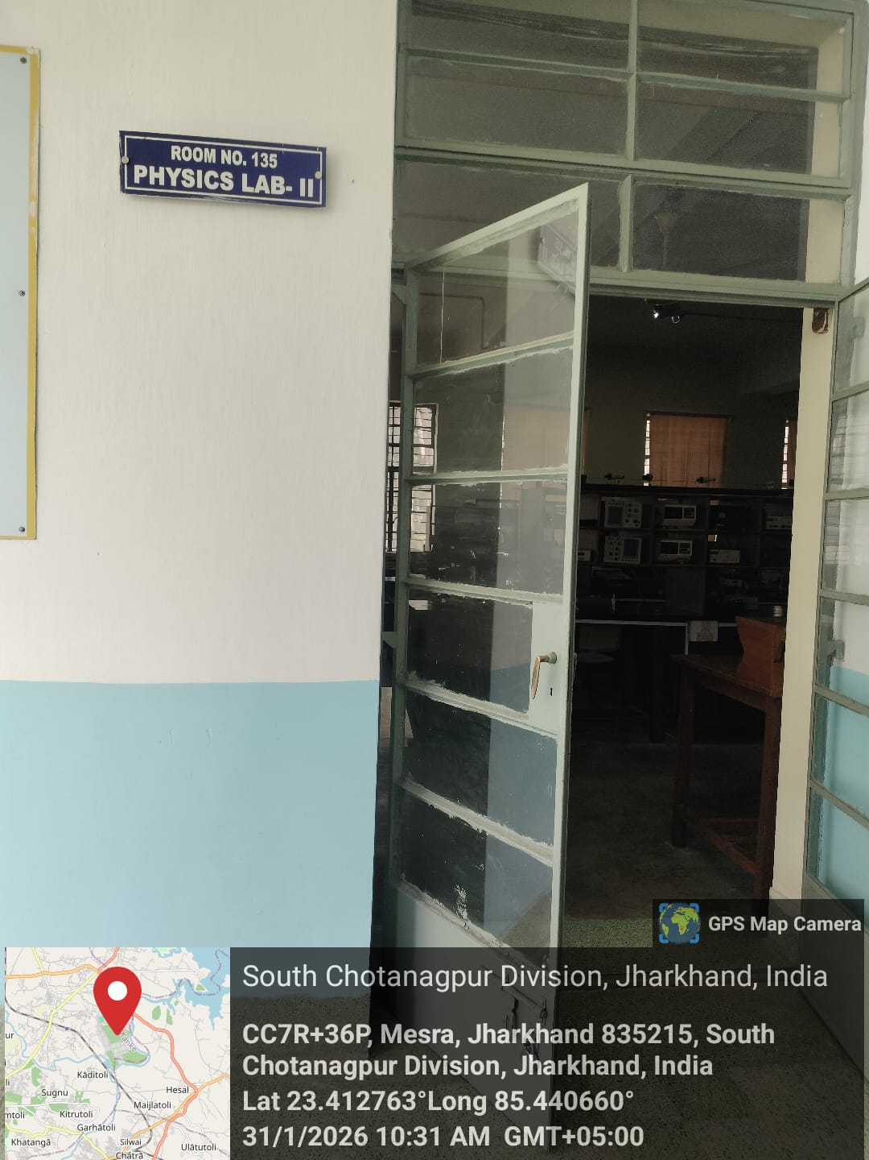
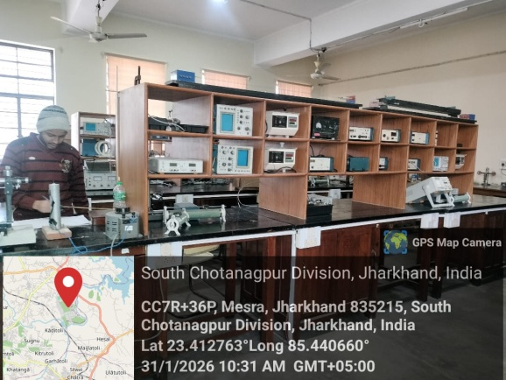
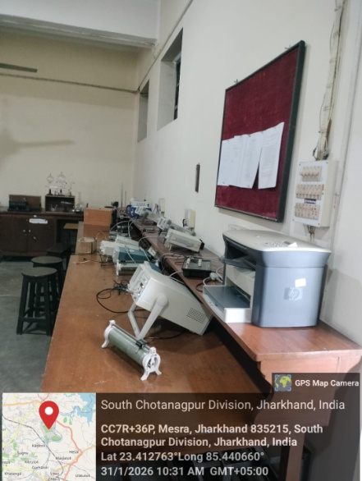
Dr. Anupam Roy
Prof- In-charge Physics Lab-II
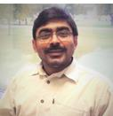

UG/PG Physics Experiments
UG/PG Physics Experiments
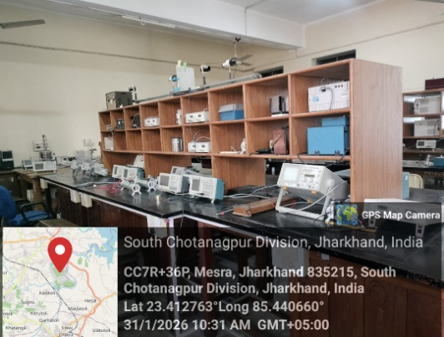

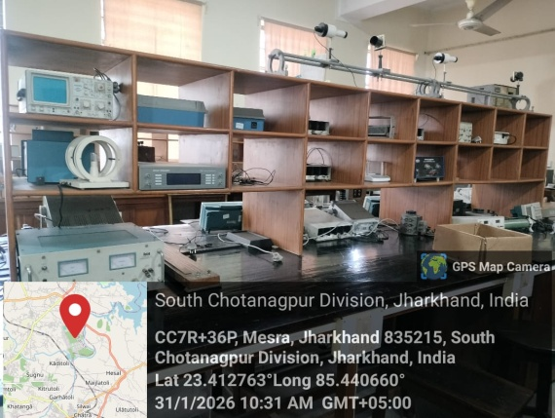

UG/PG Physics Experiments
UG/PG Physics Experiments
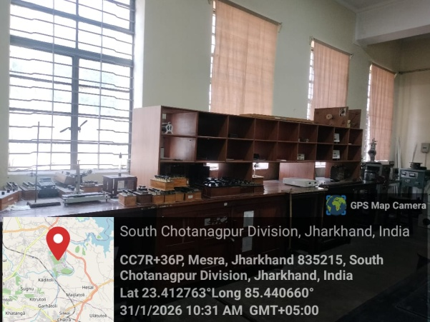

UG/PG Physics Experiments

