Birla Institute of Technology MESRA, NOIDA
Campus

Report on Business Plan Competition

21st March 2023
Session – Report

Coordinator
Dr. Vibha Kaw Raina

Date: 15th March 2023
Time: 3:00 to 5:00pm

Birla Institute of Technology MESRA, NOIDA Campus

Objectives of the competition:
- To encourage the students from different Institutes/Colleges/Universities to develop a business concept, undertake research to determine feasibility and write a business plan to document their work and plans.
- To motivate students to come forward with their ideas.
- To build their commercial skills by bringing them together with business talent.
- To attract venture capital; and
- To identify service providers who are willing to support entrepreneurial activities.
PREAMBLE
The Entrepreneurship and Innovation cell at Birla Institute of Technology, MESRA, NOIDA Campus organised the National level intercollegiate Business Plan Competition: “Theme Social and Environmental problems” on 15th March 2023 at 3:00pm. It was a virtual competition for 80 minutes with approximately 50 participants. The participants included students from different colleges from different states.
The competition was held in two rounds: Submission round and Final Round. It was conducted in parallel sessions with ten groups each comprising of two to three students. Every participant was given 10 minutes for the presentation and 5 minutes for Q/A session. The winners were awarded with cash prizes.
1st Prize - Rs. Three Thousand
2nd Prize - Rs. Two thousand
3rd Prize - Rs. One thousand
Consolation #1 - Rs. Five hundred
Consolation #2 - Rs. Five hundred
The participants were from School of Management sciences Lucknow, Lovely Professional University, Amity University, Patna, IMS Engineering College Ghaziabad, Sharda University, IMSUC Ghaziabad, BIT MESRA Ranchi, BIT NOIDA. The competition was judged by Dr. Lokesh Jindal Professor JNU, Dr. Pooja Kansra Professor Lovely Professional University, Dr. Arun Mittal Assistant Professor BIT NOIDA Campus, Dr. Monika Bisht Assistant Professor BIT NOIDA Campus. The judgement was based on innovativeness, uniqueness, viability of the business plan and the potential of the idea to solve the problem.

Birla Institute of Technology MESRA, NOIDA Campus

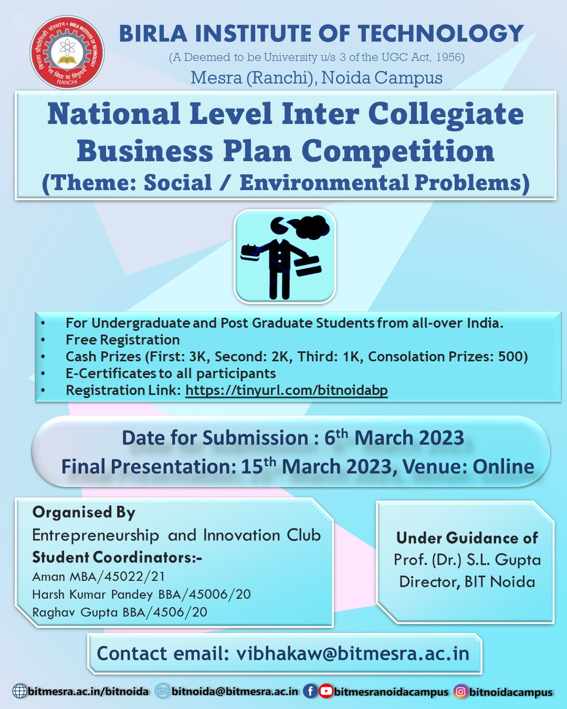

Birla Institute of Technology MESRA, NOIDA Campus
Student Registration form
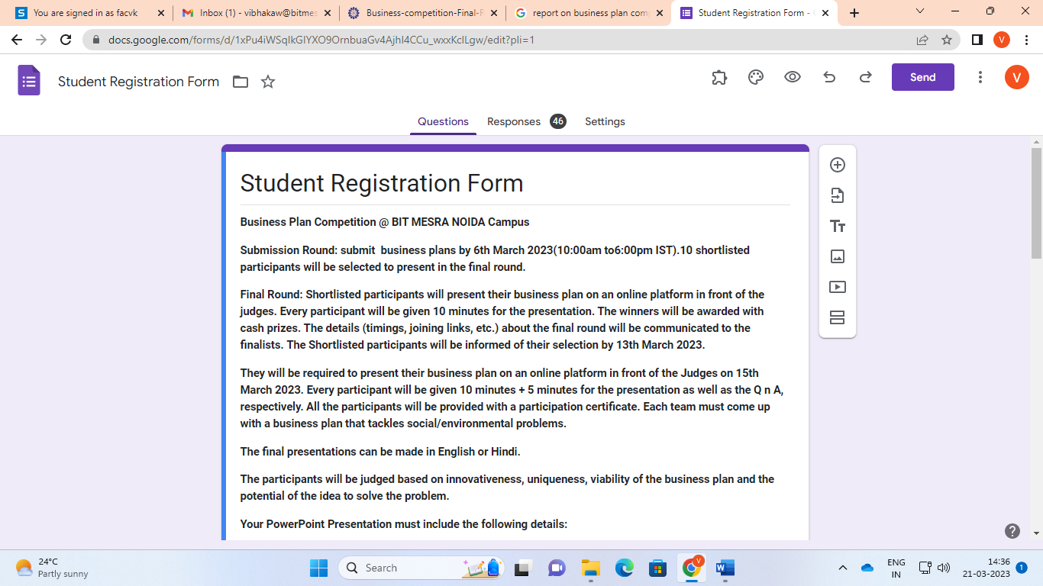

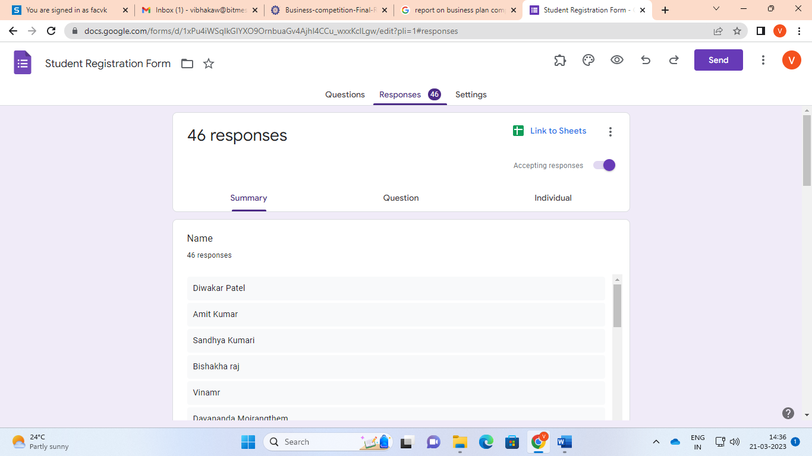

Birla Institute of Technology MESRA, NOIDA Campus
Email Address Of the participating Students
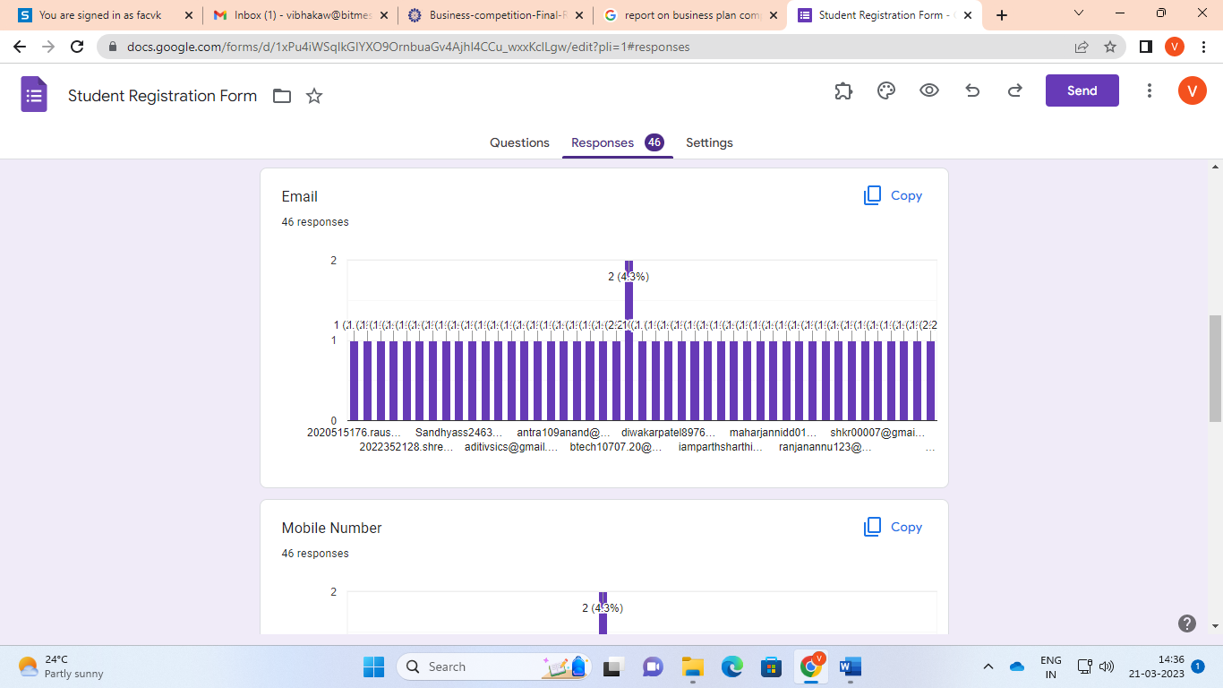

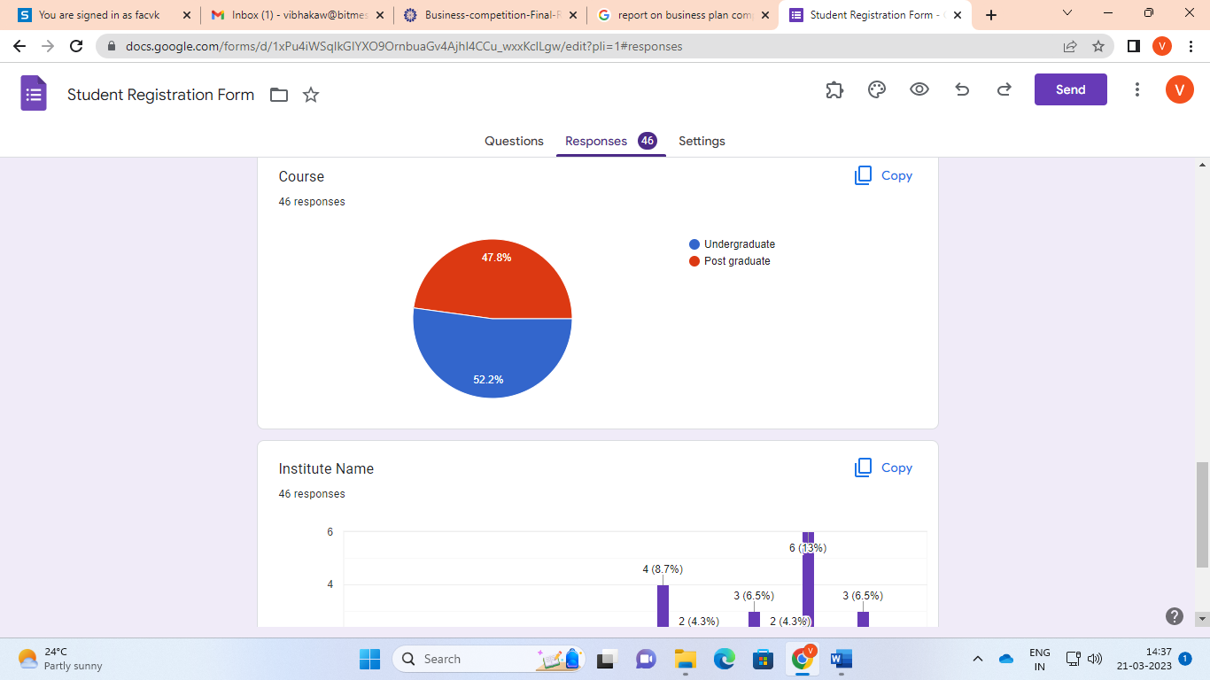

Birla Institute of Technology MESRA, NOIDA Campus

Session1: Judges Dr. Lokesh Mittal and Dr. Arun Mittal
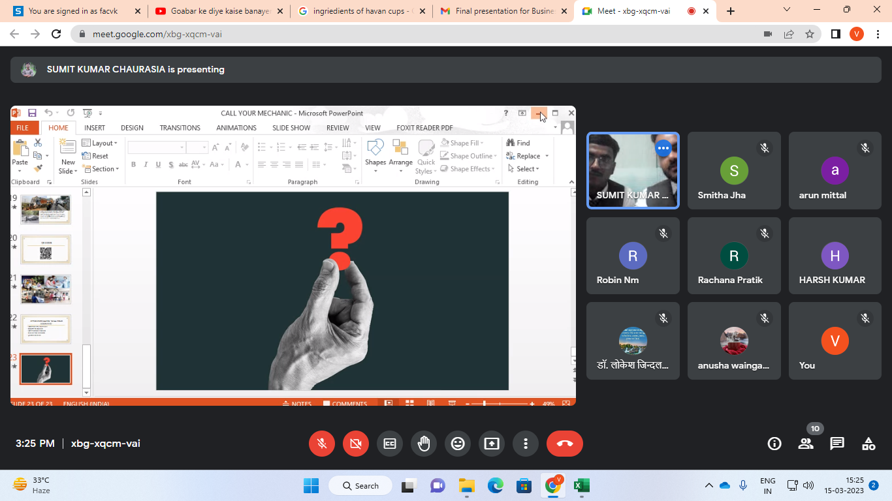

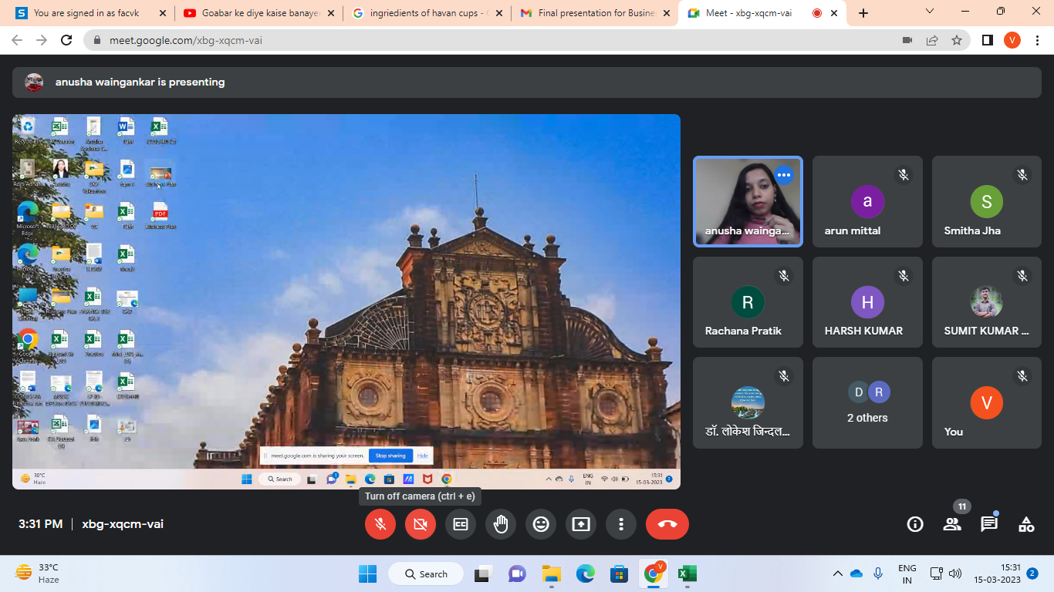

Birla Institute of Technology MESRA, NOIDA Campus

Session2: Judges Dr. Pooja Kansra and Dr.Monika Bishtt
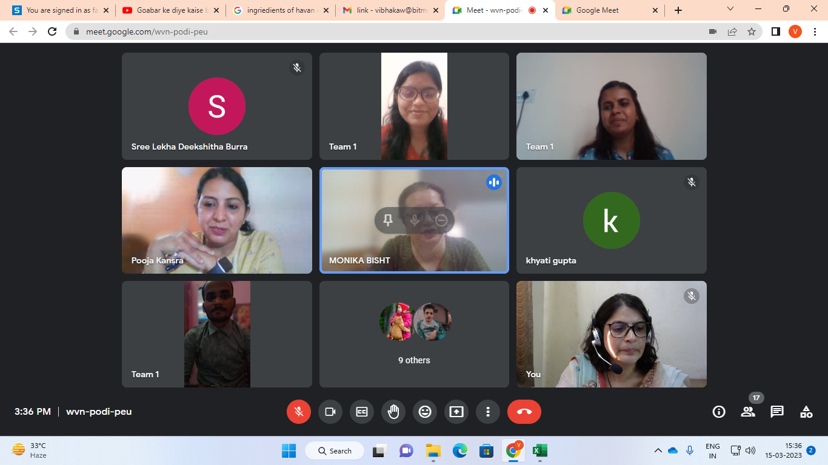

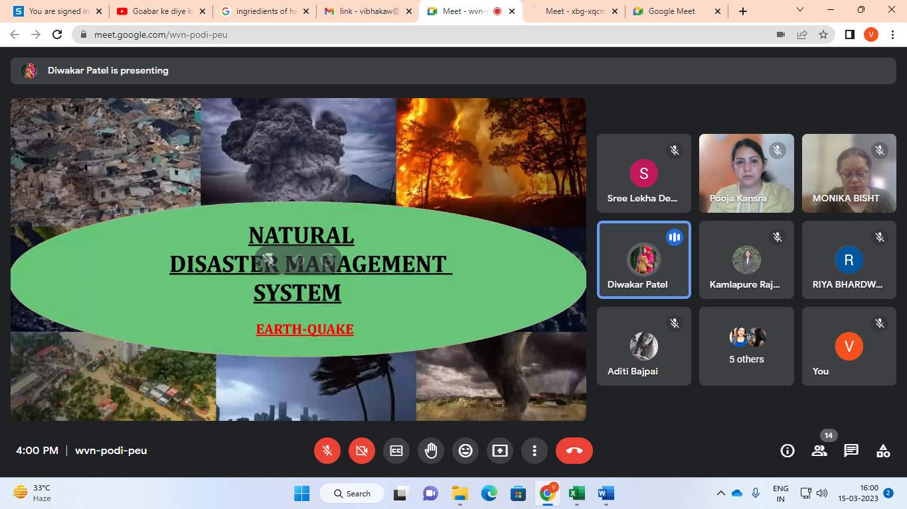

Birla Institute of Technology MESRA, NOIDA Campus

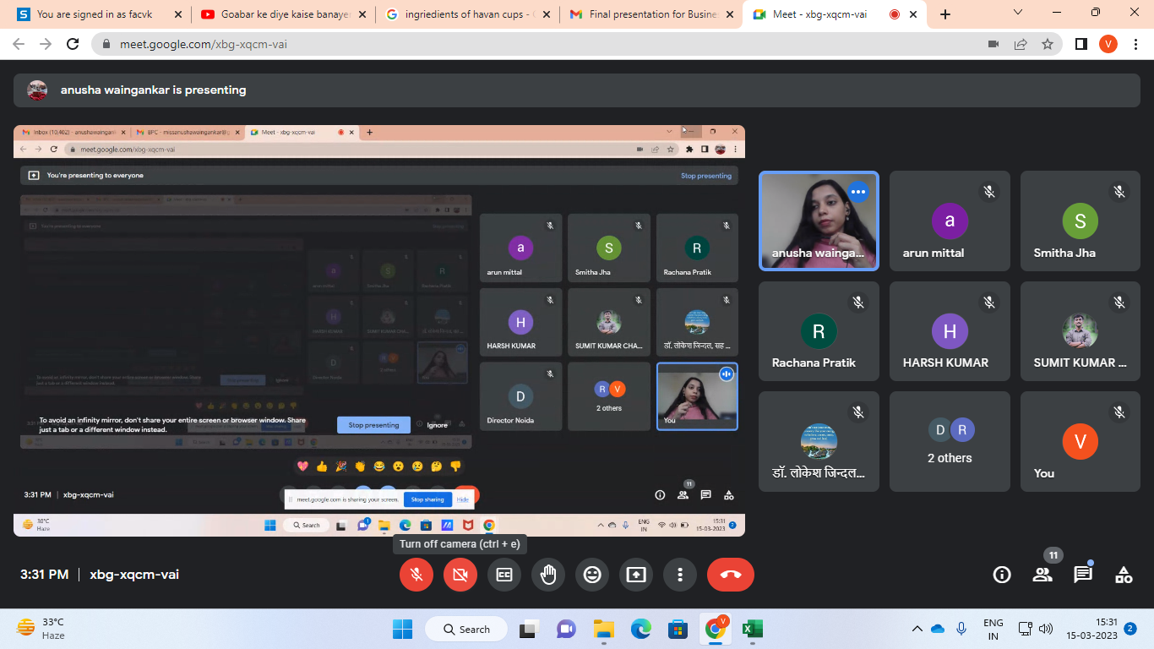

Winners of the competition

S.No | Position | Name of the student | INSTITUTE
1. | First Prize | Diwakar Patel, Vinay Maurya, Shivanshu | IMS Engineering College Ghaziabad
2. | Second Prize | Aditi Bajpai, Shruti singh | BIT NOIDA
3. | Third Prize | Ridhi Mishra, Atul Kumar Mishra, Nayab samer | School of Management Science Lucknow
4. | Consolation Prize | Khyati Gupta, Kajal Singh | BIT NOIDA
5. | Consolation Prize | Pranit | BIT MESRA,Ranchi

The participants were felicitated with the award prize and participation certificate on prize distribution ceremony held on 17th March 2023 at 3:00pm in Auditorium BIT NOIDA Campus. The student coordinators Raghav Gupta, Harsh Pandey, Riya Bhardwaj, and the organizer Dr. Vibha Kaw Raina were also felicitated with the appreciation certificate.

Birla Institute of Technology MESRA, NOIDA Campus

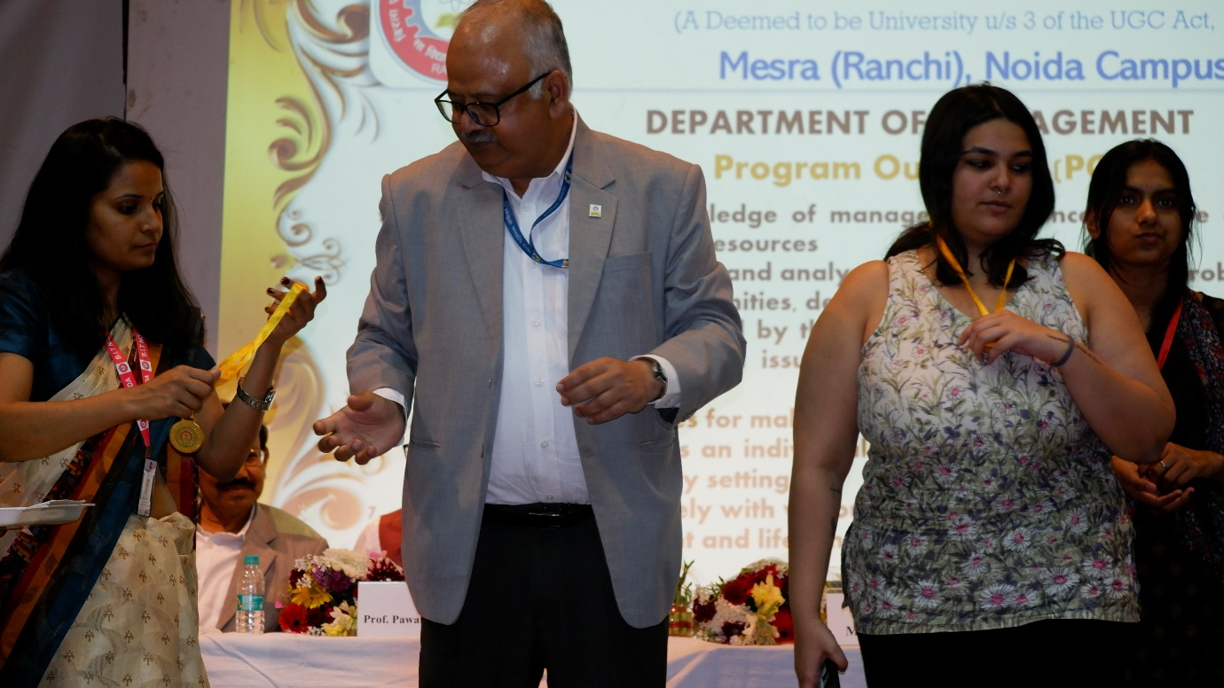

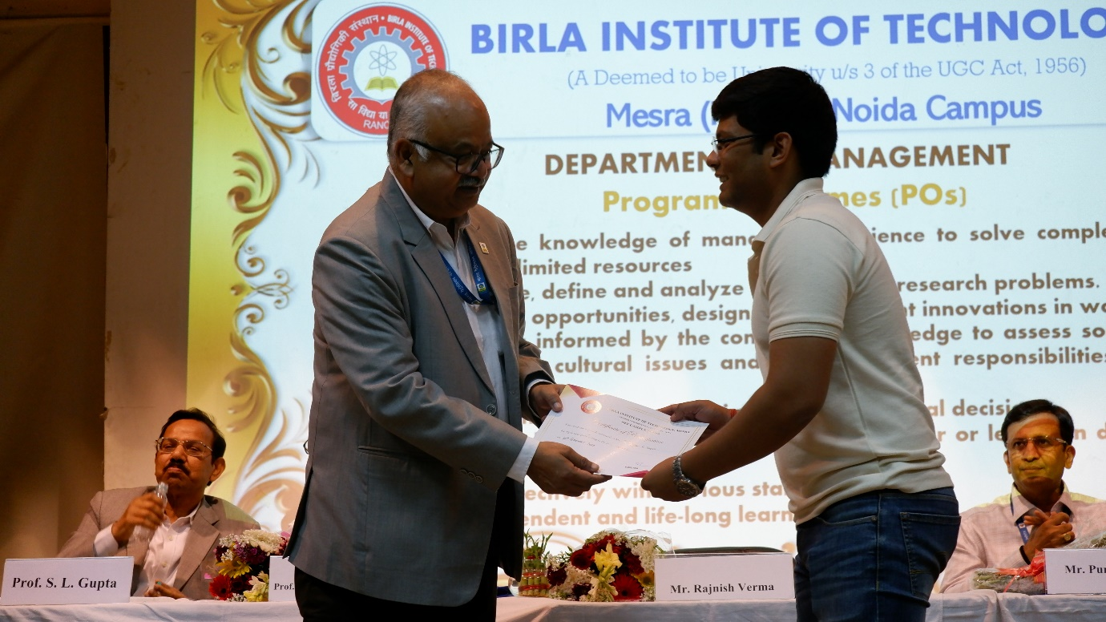

Birla Institute of Technology MESRA, NOIDA Campus

The objective of the competition was achieved. Students showcased their ideas in several magnitudes by discussing & developing new ventures. Students learnt the ways of dealing with business uncertainties. They gained theoretical and practical knowledge from other participants & eminent panel of judges. Participants developed an overall understanding of current and future trends in business. The overall session benefitted the student and participants.
---------------------------------------------End of Report-------------------------------------------------------------

