COMPUTER SCIENCE AND ENGINEERING DEPARTMENT
(MCA STUDENTS PLACED TILL DATE:29-03-2023)

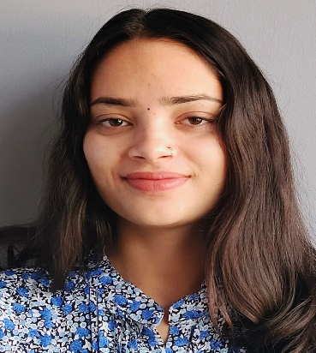
Name: Anjali Sahu
Roll Number: MCA/45042/21
Class: MCA (2021-2023)
Company Name: Threye Interactive

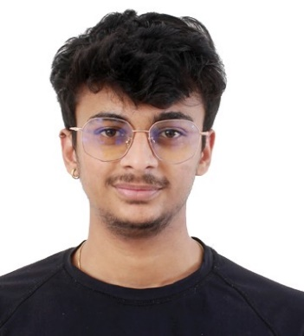
Name: Soumya Tiwari
Roll Number: MCA/45003/21
Class: MCA (2021-2023)
Company Name: Threye Interactive

Name: Pankaj Kannavedia
Roll Number: MCA/45013/21
Class: MCA (2021-2023)
Company Name: Threye Interactive

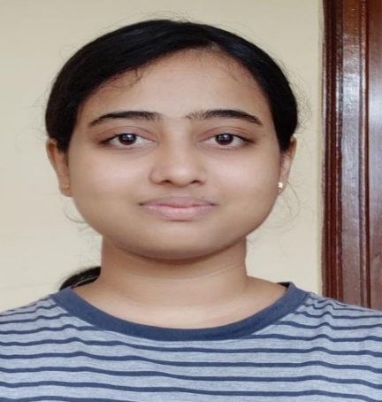
Name: Bharti Chourasiya
Roll Number: MCA/45043/21
Class: MCA (2021-2023)
Company Name: Cognizant

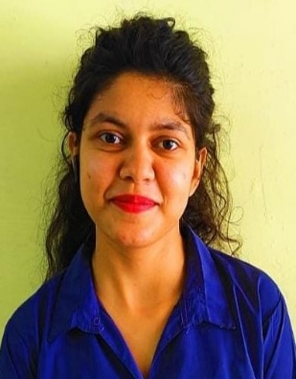
Name: Sanskriti Tiwari
Roll Number: MCA/45049/21
Class: MCA (2021-2023)
Company Name: Knoldus Inc.

Name: Aditya Khurana
Roll Number: MCA/45001/21
Class: MCA (2021-2023)
Company Name: Amdocs

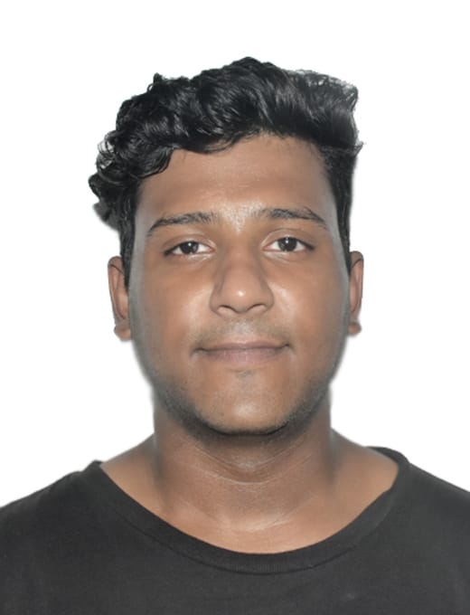
Name: Osman Rabbani
Roll Number: MCA/45045/21
Class: MCA (2021-2023)
Company Name: Jellyfish Technologies

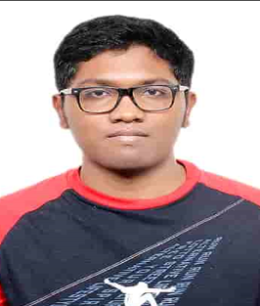
Name: Gladwin Tirkey
Roll Number: MCA/45002/21
Class: MCA (2021-2023)
Company Name: Jellyfish Technologies

Name: Nakul
Roll Number: MCA/45040/21
Class: MCA (2021-2023)
Company Name: Cognizant

Name: Sameer Jadhav
Roll Number: MCA/45021/21
Class: MCA (2021-2023)
Company Name: Cognizant

Name: Gopal Kumar Poddar
Roll Number: MCA/45026/21
Class: MCA (2021-2023)
Company Name: NexGen Solutions

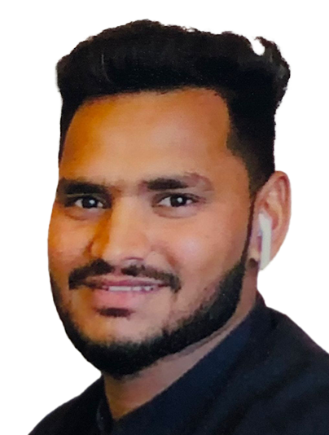
Name: Sandeep Jiyalal Yadav
Roll Number: MCA/45015/21
Class: MCA (2021-2023)
Company Name: PSS Technoservices pvt. Ltd.
( Self placed)

Name: Shashank Kumar Gupta
Roll Number: MCA/45032/21
Class: MCA (2021-2023)
Company Name: REBRAND GURUS
( Self placed)

