BIT Noida B.Sc. Animation and Multimedia course students won second prize at CMS Vatavaran Short Film Competition 2019

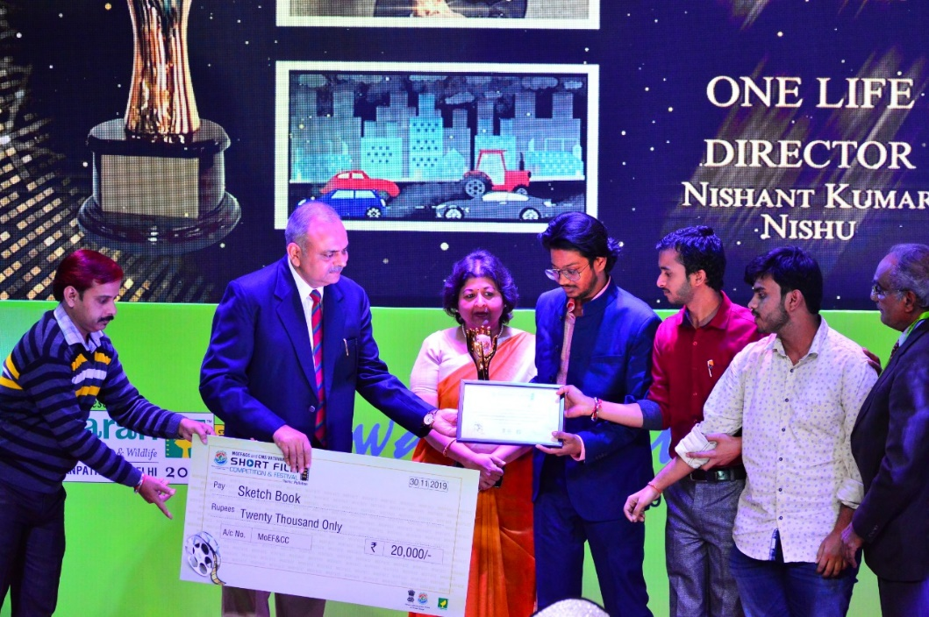

BIT Noida's B.Sc. Animation and Multimedia Course's students Nishant Kumar Nishu, Sarvesh Gupta, Gaurav Kumar and Kartikey won second prize at CMS Vatavaran short film competition 2019 in the category of college students and amateur film makers' films. Their film "One Life" was a 2D animation film on the theme of pollution. They got a cash prizes of Rs 20000/-, a certificate and a trophy. The event took place in New Delhi on 30th November 2019.

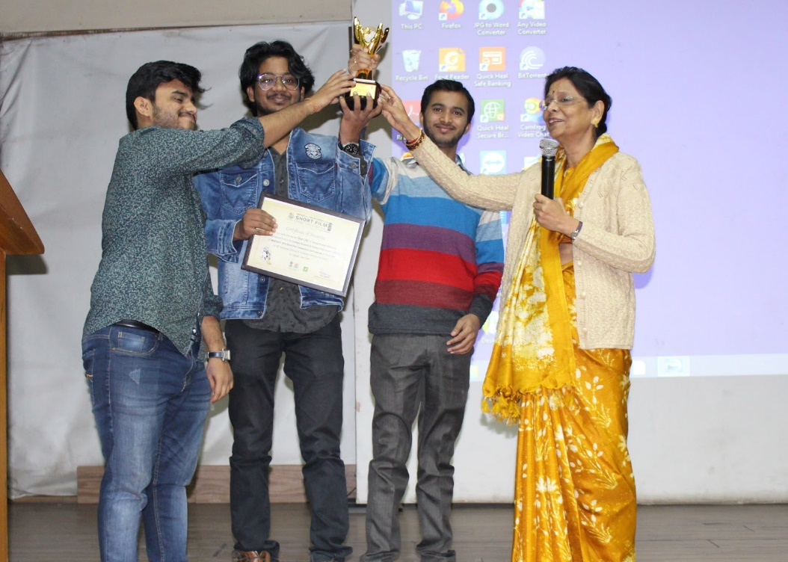

Director BIT Noida Prof. (Dr) Asha Prasad with winning film team Sarvesh, Nishant and Gaurav.

