MODULE IV
Introduction
The molecular spectroscopy is the study of the interaction of electromagnetic waves and matter. The scattering of sun’s rays by raindrops to produce a rainbow and appearance of a colorful spectrum when a narrow beam of sunlight is passed through a triangular glass prism are the simple examples where white light is separated into the visible spectrum of primary colors. This visible light is merely a part of the whole spectrum of electromagnetic radiation, extending from the radio waves to cosmic rays. All these apparently different forms of electromagnetic radiations travel at the same velocity but characteristically differ from each other in terms of frequencies and wavelength (Table 1).
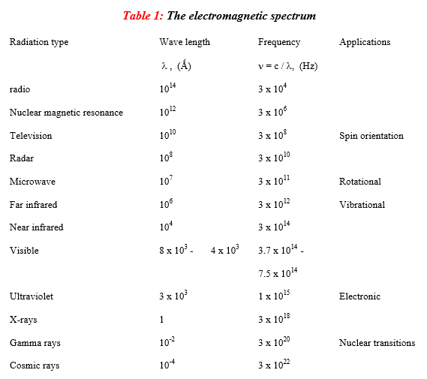
The propagation of these radiations involves both electric and magnetic forces which give rise to their common class name electromagnetic radiation. In spectroscopy, only the effects associated with electric component of electromagnetic wave are important. Therefore, the light wave traveling through space is represented by a sinusoidal trace (figure 1). In this diagram λ is the wavelength and distance A is known as the maximum amplitude of the wave. Although a wave is frequently characterized in terms of its wavelength λ, often the terms such as wavenumber , frequency (ν), cycles per second (cps) or hertz (Hz) are also used.
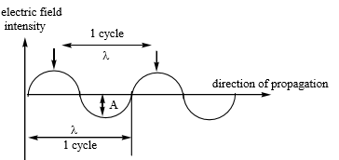
Figure 1: Wave like propagation of light ( λ = wavelength , A = amplitude)
The unit commonly used to describe the wavelength is centimeters (cm), the different units are used to express the wavelengths in different parts of the electromagnetic spectrum. For example, in the ultraviolet and visible region, the units use are angstrom (Ǻ) and nanometer (nm). In the infrared region, the commonly used unit is wavenumber (cm⁻¹), which gives the number of waves per centimeter. The four quantities wavelength, wavenumber, frequency and velocity can be related to each other by following relationships:
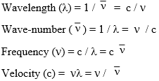
Emission and Absorption spectroscopy
When energy in the form of light, heat, or chemical agents is given to an element, the electrons of its atoms accept the energy and go to higher energy levels. However, these electrons have to emit energy in order to return to their ground state, since the excited state is unstable. The frequencies of light emitted in such a case constitute the emission spectrum (Figure 2). When an electron comes down from an excited state to the ground state, it emits a photon of energy. The energy of this photon depends on the difference between the energy levels of the excited state and ground state of that electron.
Figure 2: Concept of Emission spectrum
The intensity of the light emitted (at the specific frequency corresponding to the energy level difference) is proportional to concentration of the analyte. Spectroscopic studies based of this emitted light is known as emission spectroscopy.
Flame emission spectroscopy or Flame photometry is a common example of application of emission spectroscopy. However, Flame emission spectroscopy is limited only to alkali and alkaline earth elements as the ionization energy of only these elements are low enough to be thermally excited to yield a emission spectrum (Figure 3).
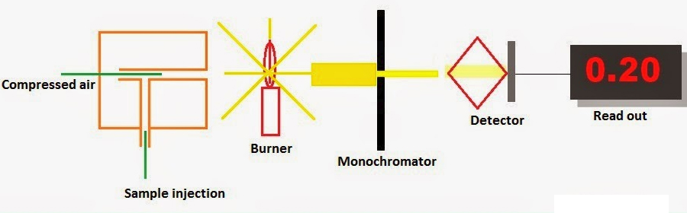
Figure 3: Flame emission spectroscopy or Flame photometry
Inductively Coupled Plasma –Atomic emission spectroscopy (ICP-AES) spectroscopy is a superior example that involves injection of the sample into the plasma, resulting in emission spectrum for all elements present and subsequently, their estimation (Figure 4).
Although each element emits energy at multiple wavelengths, in the ICP-AES technique it is most common to select a single wavelength (or a very few) for a given element. The intensity of the energy emitted at the chosen wavelength is proportional to the amount (concentration) of that element in the sample being analyzed. Thus, by determining which wavelengths are emitted by a sample and by determining their intensities, the analyst can qualitatively and quantitatively find the elements from the given sample relative to a reference standard.
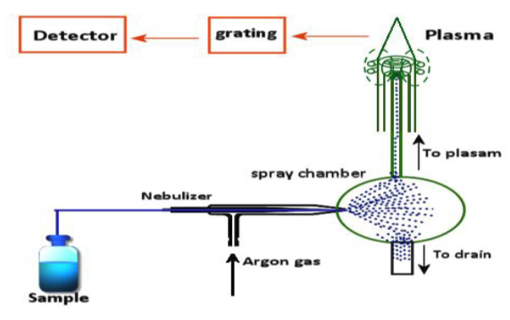
Figure 4: Inductively Coupled Plasma Atomic Emission Spectroscopy (ICP-AES)
Electrons of an element which are in the ground state may absorb incident energy in order to reach a higher energy state. The frequencies of light transmitted through this substance, with dark bands showing absorbed light, constitute the absorption spectrum of the substance.
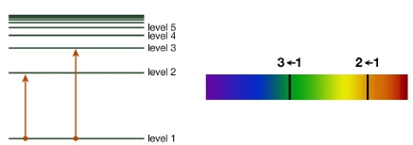
Figure 5: The concept of Absorption spectroscopy
The spectroscopic studies based on ‘absorbance’ of light at concerned frequency (corresponding to the energy gap) is called absorption spectroscopy (Figure 5).
All types of spectroscopy discussed heron are absorption spectroscopy.
Lambert – Beer’s law
Lambert's law stated that absorbance of a material sample is directly proportional to its thickness (path length). Much later, August Beer discovered another attenuation relation in 1852. Beer's law stated that absorbance is proportional to the concentrations of the attenuating species in the material sample.
Combination of these two laws resulted in Lambert – beer’s law, which states that absorbance of a monochromatic light passing through a medium is proportional to both thickness(l) of the medium as well as the concentration (c) of the absorbing species.
Mathematically,
Figure 6: Concept of Lambert-Beer’s Law
Limitations of Lambert – Beer’s law
The linearity of the Beer-Lambert law is limited by chemical and instrumental factors. Causes of nonlinearity include:
- deviations in absorptivity coefficients at high concentrations (>0.01M) due to electrostatic interactions between molecules in close proximity
- scattering of light due to particulates in the sample
- fluoresecence or phosphorescence of the sample
- changes in refractive index at high analyte concentration
- shifts in chemical equilibria as a function of concentration
- non-monochromatic radiation, deviations can be minimized by using a relatively flat part of the absorption spectrum such as the maximum of an absorption band
- stray light
UV – VIS Spectroscopy
This absorption spectroscopy uses electromagnetic radiations between 190 nm to 800 nm and is divided into the ultraviolet (UV, 190-400 nm) and visible (VIS, 400-800 nm) regions. Since the absorption of ultraviolet or visible radiation by a molecule leads transition among electronic energy levels of the molecule, it is also often called as electronic spectroscopy. The information provided by this spectroscopy when combined with the information provided by NMR and IR spectral data leads to valuable structural proposals. Nature of Electronic Transitions The total energy of a molecule is the sum of its electronic, its vibrational energy and its rotational energy. Energy absorbed in the UV region produces changes in the electronic energy of the molecule. As a molecule absorbs energy, an electron is promoted from an occupied molecular orbital (usually a non-bonding n or bonding π orbital) to an unoccupied molecular orbital (an antibonding π∗ or σ* orbital) of greater potential energy (figure 3). For most molecules, the lowest-energy occupied molecular orbitals are σ orbitals, which correspond to σ bonds. The π orbitals lie at relatively higher energy levels than σ orbitals and the non-bonding orbitals that hold unshared pairs of electrons lie even at higher energies. The antibonding orbitals (π* and σ * ) are orbitals of highest energy. The relative potential energies of these orbitals and vaious possible transitions have been depicted in figure 7.
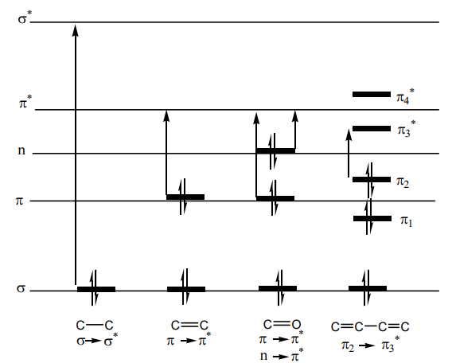
Figure 7: Relative energies of orbitals most commonly involved in electronic spectroscopy of organic molecules
The saturated aliphatic hydrocarbons (alkanes) exhibit only σ → σ* transitions but depending on the functional groups the organic molecules may undergo several possible transitions which *∗can be placed in the increasing order of their energies viz. n → π* < n → σ * < π→ π* < σ → π* < σ → σ* . Since all these transitions require fixed amount of energy (quantized), an ultraviolet or visible spectrum of a compound would consist of one or more well defined peaks, each corresponding to the transfer of an electron from one electronic level to another. If the differences between electronic energy levels of two electronic states are well defined i.e. if the nuclei of the two atoms of a diatomic molecule are held in fixed position, the peaks accordingly should be sharp. However, vibrations and rotations of nuclei occur constantly and as a result each electronic state in a molecule is associated with a large number of vibrational and rotational states. At room temperature, the molecules in the ground state will be in the zero vibrational level (Gυ_{o}). This is shown schematically in figure 8.
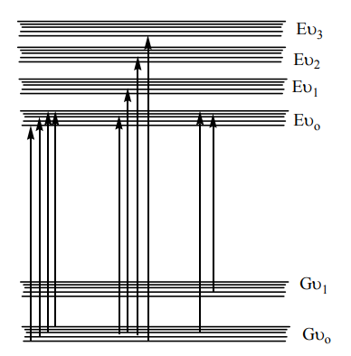
Figure 8: Energy level diagram showing excitation between different vibrational and rotational levels of two electronic states
The transition of an electron from one energy level to another is thus accompanied by simultaneous change in vibrational and rotational states and causes transitions between various vibrational and rotational levels of lower and higher energy electronic states. Therefore many radiations of closely placed frequencies are absorbed and a broad absorption band is obtained. When a molecule absorbs ultraviolet or visible light of a defined energy, an assumption is made that only one electron is excited form bonding orbital or non-bonding orbital to an anti-bonding orbital and all other electrons remain unaffected. The excited state thus produced is formed in a very short time i.e. of the order of 10-15 seconds. In accordance with Franck-Condon principle, during electronic excitation the atoms of the molecule do not move. The most probable transition would appear to involve the promotion of one electron from the highest occupied molecular orbital (HOMO) to the lowest unoccupied molecular orbital (LUMO), but in many cases several transitions can be observed, giving several absorption bands in the spectrum. We can have a general view of the possible transitions prevailing in organic compounds.
Alkanes can only undergo σ → σ* transitions. These are high-energy transitions and involve very short wavelength ultraviolet light (< 150 nm). These transitions usually fall out-side the generally available measurable range of UV-visible spectrophotometers (200-1000 nm). The σ → σ* transitions of methane and ethane are at 122 and 135 nm, respectively. In alkenes amongst the available σ → σ* and π → π* transitions, the π → π* transitions are of lowest energy and absorb radiations between 170-190 nm. In saturated aliphatic ketones the lowest energy transition involves the transfer of one electron of the nonbonding electrons of oxygen to the relatively low-lying π* anti-bonding orbital. This n → π* transition is of lowest energy (~280 nm) but is of low intensity as it is symmetry forbidden. Two other available transitions are n → π* and π → π*. The most intense band for these compounds is always due to π → π* transition. In conjugated dienes the π → π* orbitals of the two alkene groups combine to form new orbitals – two bonding orbitals named as π1 and π2 and two antibonding orbitals named as π₃* and π₄*. It is apparent that a new π → π* transition of low energy is available as a result of conjugation. Conjugated dienes as a result absorb at relatively longer wavelength than do isolated alkenes (see figure 10 ).
Spectral Measurements
The UV-Vis spectra are usually measured in very dilute solutions and the most important criterion in the choice of solvent is that the solvent must be transparent within the wavelength range being examined. Table 2 lists some common solvents with their lower wavelength cut off limits. Below these limits, the solvents show excessive absorbance and should not be used to determine UV spectrum of a sample.
Solvent Effects
Highly pure, non-polar solvents such as saturated hydrocarbons do not interact with solute molecules either in the ground or excited state and the absorption spectrum of a compound in these solvents is similar to the one in a pure gaseous state. However, polar solvents such as water, alcohols etc. may stabilize or destabilize the molecular orbitals of a molecule either in the ground state or in excited state and the spectrum of a compound in these solvents may significantly vary from the one recorded in a hydrocarbon solvent. (i) π → π* Transitions In case of π → π* transitions, the excited states are more polar than the ground state and the dipole-dipole interactions with solvent molecules lower the energy of the excited state more than that of the ground state. Therefore a polar solvent decreases the energy of π → π* transition and absorption maximum appears ~10-20 nm red shifted in going from hexane to ethanol solvent.

Table 2:
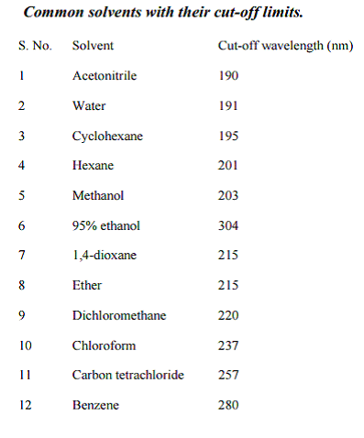
(ii) n→ π* Transitions In case of n → π* transitions, the polar solvents form hydrogen bonds with the ground state of polar molecules more readily than with their excited states. Therefore, in polar solvents the energies of electronic transitions are increased. For example, the figure 9 shows that the absorption maximum of acetone in hexane appears at 279 nm which in water is shifted to 264 nm, with a blue shift of 15nm.
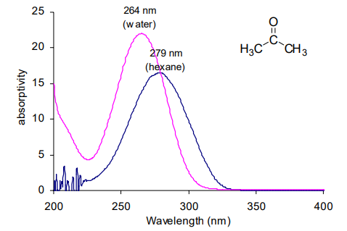
Figure 9 : UV-spectra of acetone in hexane and in water
Some important terms and definitions
(i) Chromophore: The energy of radiation being absorbed during excitation of electrons from ground state to excited state primarily depends on the nuclei that hold the electrons together in a bond. The group of atoms containing electrons responsible for the absorption is called chromophore. Most of the simple un-conjugated chromophores give rise to high energy transitions of little use. Some of these transitions have been listed in table 3.
Table 3:
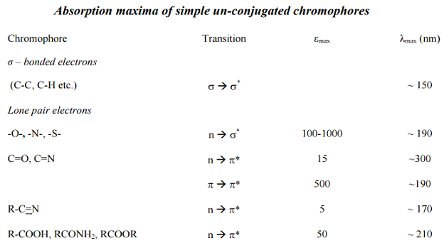
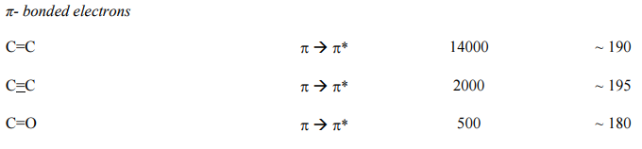
For example, alkanes contain only single bonds with only possible σ→σ* type electronic transitions. These transitions absorb radiations shorter than wavelengths that are experimentally accessible in usually available spectrophotometers. In saturated molecules with heteroatom bearing non-bonding pairs of electrons, n→σ* transitions become available. These are also high energy transitions. In unsaturated compounds, π→π* transitions become possible. Alkenes and alkynes absorb ~ 170 nm but the presence of substituents significantly affects their position. The carbonyl compounds and imines can also undergo n →π* transitions in addition to π →π*. Amongst these, the most studied transitions are n→π* as these absorb at relatively longer wavelength 280-300 nm. These are low intensity (ε 10 -100) transitions.
(ii) Auxochrome: The substituents that themselves do not absorb ultraviolet radiations but their presence shifts the absorption maximum to longer wavelength are called auxochromes. The substituents like methyl, hydroxyl, alkoxy, halogen, amino group etc. are some examples of auxochromes.
(iii) Bathochromic Shift or Red shift: A shift of an absorption maximum towards longer wavelength or lower energy.
(iv) Hypsochromic Shift or Blue Shift: A shift of an absorption maximum towards shorter wavelength or higher energy.
(v) Hypochromic Effect: An effect that results in decreased absorption intensity. (vi) Hyperchromic Effect: An effect that results in increased absorption intensity.
Applications of Electronic Spectroscopy in Predicting Absorption Maxima of Organic Molecules
1: Conjugated Dienes, Trienes and Polyenes
The presence of conjugate double bond decreases the energy difference between HOMO and LUMO of resulting diene. The figure 10 shows the change in energy of MO on conjugation. As a result, the radiations of longer wavelength are absorbed. The conjugation not only results in bathochromic shift (longer wavelength) but also increases the intensity of absorption. As the number of conjugated double bonds is increased, the gap between highest occupied molecular orbital (HOMO) and lowest unoccupied molecular orbital (LUMO) is progressively lowered. Therefore, the increase in size of the conjugated system gradually shifts the absorption maximum (λmax) to longer wavelength and also increases the absorption. For example, ethylene absorbs at 175 nm (ε = 1000) and the conjugation in butadiene gives a strong absorption at longer wavelength at 230 nm and with higher intensity (ε = >1000).
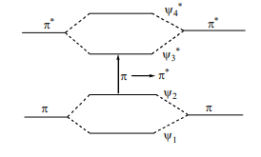
Figure 10: Effect of conjugation on orbitals’ energy and respective π-π* transition
The presence of alkyl substituents on double bond also produces bathochromic shift and hyperchromic effect. These effects are additive in dienes and up to some extent in trienes. The open chain dienes can achieve s-cis or s-trans conformations and similarly diene system can be homoannular or heteroannular in cyclic systems. In 1941, Woodward suggested empirical rules for predicting the absorption of open chain and six-membered ring dienes which have been later on extended to large number of dienes and trienes (Table 4 ).
Table 4:
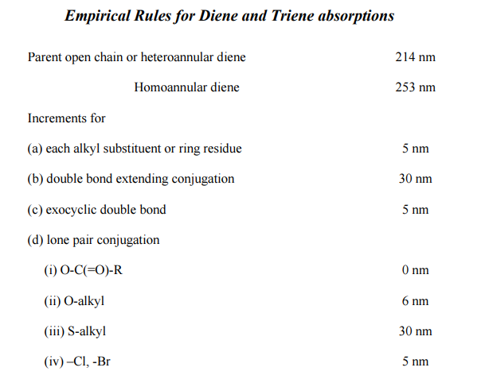
For example, here the absorption maxima for dienes 1 and 2 have been calculated according to Woodward rules. The comparison of calculated λmax values with observed λmax values highlights the importance of these rules.
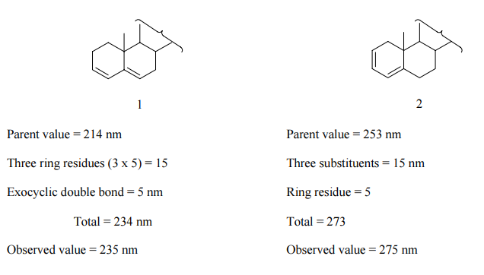
As the number of double bonds in conjugation increases, the bathochromic (towards longer wavelength) shift in lowest energy absorption maxima is observed. The increase in conjugation gradually shifts the maxima to visible region (> 400 nm) and imparts colour to the sample. Table 5 shows the λmax shift in Me(CH=CH)nMe with increasing number of conjugated double bonds. β - Carotene (figure 11) responsible for red color in carrots is a typical example of polyene with 11 conjugated double bonds and exhibits λmax at 445 nm.
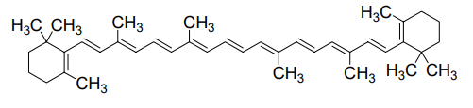
Figure 11: Structure of β-carotene
Table 5:
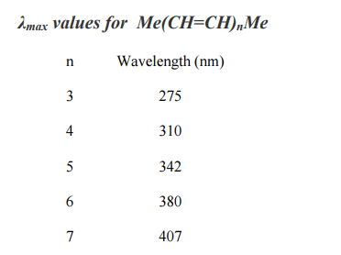
2: Carbonyl Compounds
Carbonyl compounds have two principal UV radiations, the allowed π →π* transitions and the forbidden n →π* transitions. In amides, acids, esters or acid halides, the substituents viz. NR₂, OH, OR, or –X on carbonyl group show pronounced hypsochromic effect on the n →π* transitions. The hypsochromic effect is due to inductive effect of nitrogen, oxygen or halogen atoms. The heteroatom withdraws electrons from carbonyl carbon and makes carbonyl oxygen lone pair of electrons more stabilized due to its involvement in increasing C=O bond order. As a result, the n → π* transition of these compounds is shifted to 200-215 nm range relative to 270 nm in aldehydes and ketones. Conjugation of the carbonyl group with double bond shifts both n →π* and π →π* transitions to longer wavelengths. The effect on π→ π* band is more pronounced. Woodward formulated rules to predict the position of an absorption maximum in an unknown enone. These rules have been summarized in table 6.
Table 6:
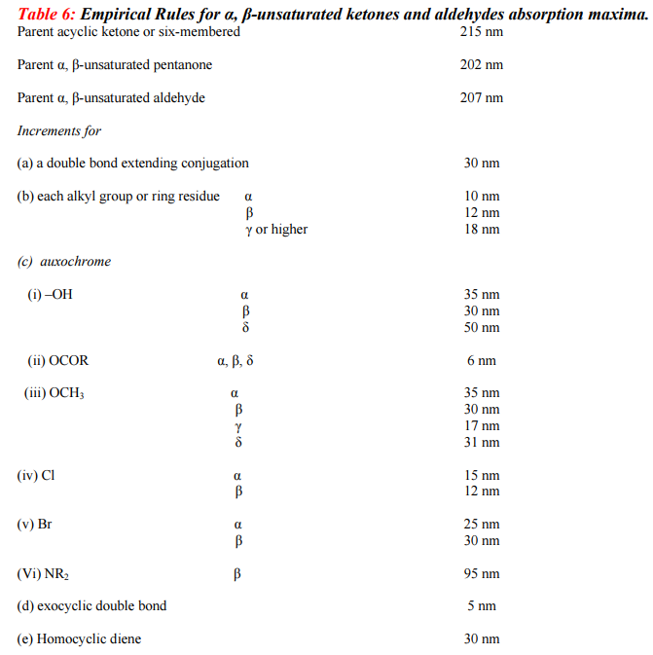

3. Aromatic Compounds
The simplest aromatic compound is benzene. It shows two primary bands at 184 (ε = 47,000) and 202 (ε = 7400) nm and a secondary fine structure band at 255 nm (ε = 230 in cyclohexane). Substituents on the benzene ring also cause bathochromic and hypsochromic shifts of various peaks. Unlike dienes and unsaturated ketones, the effects of various substituents on the benzene ring are not predictable. However, qualitative understanding of the effects of substituents on the characteristics of UV-Vis spectrum can be considered by classifying the substituents into electron-donating and electron-withdrawing groups. (i) Effect of Substituents with Unshared Electrons: The non-bonding electrons increase the length of π-system through resonance and shift the primary and secondary absorption bands to longer wavelength. More is the availability of these non-bonding electrons, greater the shift will be. In addition, the presence of non-bonding electrons introduces the possibility of n → π* transitions. If non-bonding electron is excited into the extended π*chromophore, the atom from which it is removed becomes electron-deficient and the π-system of aromatic ring becomes electron rich. This situation causes a separation of charge in the molecule and such excited state is called a charge-transfer or an electron-transfer excited state. In going from benzene to t-butylphenol, the primary absorption band at 203.5 nm shifts to 220 nm and secondary absorption band at 254 nm shifts to 275 nm. Further, the increased availability of n electrons in negatively charged t-butylphenoxide ion shifts the primary band from 203.5 to 236 nm (a 32.5 nm shift) and secondary band shifts from 254 nm to 290 nm (a 36 nm shift) (Figure 12 ). Both bands show hyperchromic effect. On the other hand, in the case of anilinium cation, there are no n electrons for interaction and absorption properties are quite close to benzene. But in aniline, the primary band is shifted to 232 nm from 204 nm in anilinium cation and the secondary band is shifted to 285 nm from 254 nm (Figure 13).
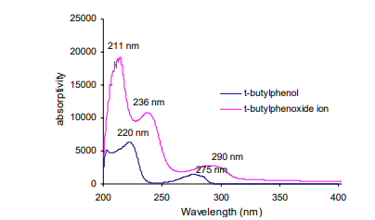
Figure 12 : UV-spectra of t-butyl phenol and t-buty phenoxide in methanol

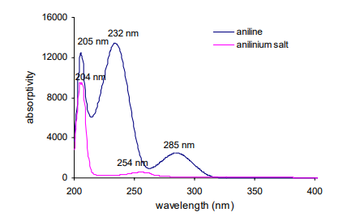
Figure 13 : UV-spectra of aniline and anilinium salt in methanol
(ii) Effect of π Conjugation: Conjugation of the benzene ring also shifts the primary band at 203.5 nm more effectively to longer wavelength and secondary band at 254 nm is shifted to longer wavelength to lesser extent. In some cases, the primary band overtakes the secondary band. For example, benzoic acid shows primary band at 250 nm and secondary band at 273 nm, but cinnamic acid that has longer chromophore exhibits primary band at 273 nm and secondary band remains merged with it. Similarly, in benzaldehyde, the secondary band appears at 282 nm and primary band at 242 nm but in case of cinnamaldehyde, primary band appears at 281 nm and remains merged with secondary band (figure 14). The hyperchromic effect arising due to extended conjugation is also visible.
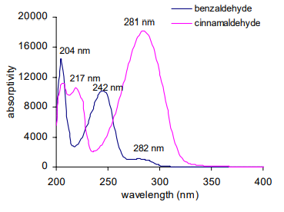
Figure 14 : UV-spectra of benzaldehyde and cinnamaldehyde in methanol
(iii) Effect of Electron-withdrawing and Electron-releasing Groups: Electron-withdrawing substituents viz. NH₃ ⁺ , SO₂NH₂, CN, COOH, COCH₃, CHO and NO₂ etc. have no effect on the position of secondary absorption band of benzene ring. But their conjugation effects with πelectrons of the aromatic ring are observed. Electron-donating groups such as -CH₃, -Cl, -Br, - OH, -OCH₃, -NH₂ etc increase both λ_{max} and ε_{max} values of the secondary band.
In case of disubstituted benzene derivatives, it is essential to consider the effect of both the substituents. In para-substituted benzenes, two possibilities exist. If both the groups are electron-donating then the observed spectrum is closer to monosubstituted benzene. The group with stronger effect determines the extent of shifting of primary band. If one group is electron-releasing and other is electron-withdrawing, the magnitude of red shift is grater compared to the effect of single substituent individually. This is attributed to the increased electron drift from electron-donating group to the electron-withdrawing group through π-bond of benzene ring. For example, aniline shows secondary band at 285 nm which due to presence of electron-withdrawing p-nitro substituent is shifted to 367 nm with a significant increase in absorptivit (figure 15).
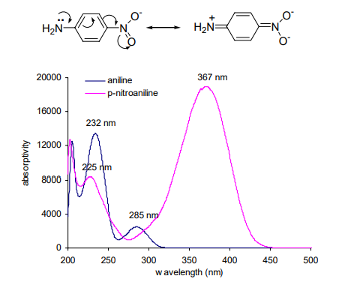
Figure 15: UV-spectra of aniline and p-nitroaniline in methanol
If two groups of a disubstituted benzene derivative are placed ortho- or meta- to each other, the combined effect of two substiuents is observed. In case of substituted benzoyl derivatives, an empirical correction of structure with observed position of the primary absorption band has been developed. In the absence of steric hindrance to co-planarity, the calculated values are within ± 5 nm of the observed value.
(iv) Polycyclic Aromatic Compounds: In case of polycyclic aromatic hydrocarbons, due to extended conjugation, both primary and secondary bands are shifted to longer wavelength. These spectra are usually complicated but are characteristic of parent compound. The primary band at 184 nm in benzene shifts to 220 nm in case of naphthalene and 260 nm in case of anthracene.
Similarly, the structured secondary band which appears as broad band around 255 nm in benzene is shifted to 270 nm and 340 nm respectively in case of naphthalene and anthracene molecules.
Commercial Applications of UV and Visible Spectroscopy
The UV-Vis spectroscopy has innumerable applications in the drugs and pharmaceutical industry. Beer-Lambert law offers a valuable and simple method for quantitative analysis. In practice, a calibration curve is constructed by plotting absorbance vs. molar concentration and the concentration of unknown with ‘X’ absorbance is determined by finding the concentration corresponding to the measured absorbance on the calibration curve. The UV spectroscopy is used extensively in determining rate constants, equilibrium constants, acid-base dissociation constants etc for chemical reactions. The use of UV spectrometry in evaluation of enzymatic assays has become very common e.g. the activity of enzyme dehydrase is assayed by measuring the formation of ergosterol at 282 nm.
Infrared Absorption Spectroscopy (Vibrational spectroscopy)
The two atoms joined together by a chemical bond (may be single, double or triple bond), macroscopically can be composed as two balls joined by a spring. The application of a force like (i) stretching of one or both the balls (atoms) away from each other or closer to each other (ii) bending of one of the atoms either vertically or horizontally and then release of the force results in the vibrations on the two balls (atoms). These vibrations depend on the strength of the spring and also the mode (stretching or bending) in which the force is being applied. Similarly, at ordinary temperatures, organic molecules are in a constant state of vibrations, each bond having its characteristic stretching and bending frequencies. When infrared light radiations between 4000-400 cm⁻¹ (the region most concerned to an organic chemist) are passed through a sample of an organic compound, some of these radiations are absorbed by the sample and are converted into energy of molecular vibrations. The other radiations which do not interact with the sample are transmitted through the sample without being absorbed. The plot of % transmittance against frequency is called the infrared spectrum of the sample or compound. This study of vibrations of bonds between different atoms and varied multiplicities which depending on the elctronegativity, masses of the atom and their geometry vibrate at different but specified frequencies; is called infrared spectroscopy. The presence of such characteristic vibrational bands in an infrared spectrum indicates the presence of these bonds in the sample under investigation.
Hooke’s law and Absorption of radiations The band positions in the IR spectrum are presented in wave numbers ( ν ) whose unit is the reciprocal centimeter (cm-1). ν is proportional to the energy of vibration. ∆E = hυ = hc / λ = hc ν Therefore, in principle, each absorption of radiation in the infrared region is quantized and should appear as sharp line. However, each vibrational transition within the molecule is associated with number of rotational energy changes and thus appears as combination of vibrational-rotational bands. The analogy of a chemical bond with two atoms linked through a spring can be used to rationalize several features of the infrared spectroscopy. The approximation to vibration frequency of a bond can be made by the application of Hooke’s law. In Hooke’s law, two atoms and their connecting bond are treated as a simple harmonic oscillator composed of two masses joined by a spring and frequency of vibration is stated as
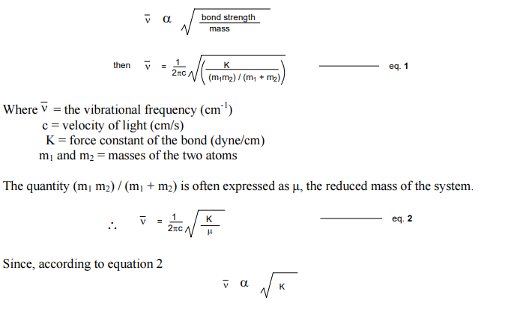
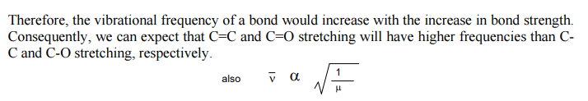
Therefore, the vibrational frequency of a bond would increase with the decrease in reduced mass of the system. It implies that C-H and O-H stretching absorptions should appear at higher frequencies than C-C and C-O stretching frequencies. Similarly, O-H stretching should appear at higher frequency than O-D stretching. Further, in parallel with the general knowledge that the stretching of the spring requires more energy than to bend it, the stretching absorption of a band always appear at higher energy than the bending absorption of the same band. The Hooke’s law can be used to theoretically calculate the approximate stretching frequency of a bond. The value of K is approximately 5x10⁵ dyne/cm for single bonds and approximately two and three times this value for the double and triple bonds, respectively.
Let us calculate the approximate frequency of the C-H starching vibration from the masses of carbon and hydrogen
m_{C} = mass of carbon atom = 20x10⁻²⁴ g
m_{H} = mass of hydrogen atom = 1.6x10⁻²⁴ g
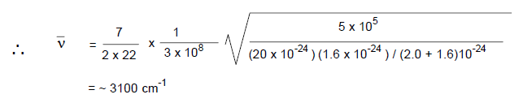
Let us consider how the radiations are being absorbed. We know that at ordinary temperature, molecules are in constant state of vibrations. The change in dipole moment during vibration of the molecule produces a stationary alternating electric field. When the frequency of incident electromagnetic radiations is equal to the alternating electric field produced by changes in the dipole moment, the radiation is absorbed and vibrational levels of the molecule are excited. Once in the vibrationally excited state, the molecules can loose the extra energy by rotational, collision or translational processes etc. and come back to ground state. Therefore, only those vibrations which result in a rhythmical change in the dipole moment of the molecule absorb infrared radiations and are defined as IR active. The others which do not undergo change in dipole moment of the molecule are IR inactive e.g. the stretching of a symmetrically substituted bond, viz ‘carbon triple bond carbon’ in acetylene and symmetrical stretching in carbon dioxide (figure 17) – a linear molecule, produce no change in the dipole moment of the system and these vibrations cannot interact with infrared light and are IR inactive. In general, the functional groups that have a strong dipole give rise to strong absorption bands in the IR.
Modes of molecular vibrations
Molecules with large number of atoms possess a large number of vibrational frequencies. For a non-linear molecule with n atoms, the number of fundamental vibrational modes is (3n-6); linear molecules have 3n-5 fundamental vibrational modes. Therefore, water - a non-linear molecule theoretically possesses 3 fudamental vibrations – two stretching and one bending (figure 16); whereas carbon dioxide - a linear molecule possess 4 fundamental absorption bands involving two stretching and two bending modes (figure 17). Amongst these theoretically possible vibrations, a stretching vibration is a rhythmical movement along the bond axis such that interatomic distance is increasing or decreasing. A bending vibration consists of a change in bond angle between bonds with a common atom or the movement of a group of atoms with respect to remaining part of the molecule without movement of the atoms in the group with respect to one another.
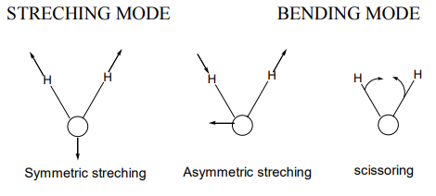
Figure 16: Vibrational modes for water molecule
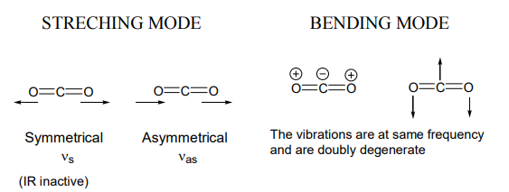
Figure 17: Vibrational modes for carbon dioxide molecule
The various stretching and bending modes can be represented by considering an AX₂ group appearing as a portion of molecule, for example, the CH₂ group in a hydrocarbon molecule (figure 18 ). Any atom joined to two other atoms will undergo comparable vibrations for example NH₂ or NO₂. Each of different vibration modes may give rise to a different absorption band so that CH2 groups give rise to two C-H stretching bands i.e. υsym and υantisym. Some of the vibrations may have the same frequency i.e. they are degenerate and their absorption bands will appear at same position (for CO₂, see figure 17).
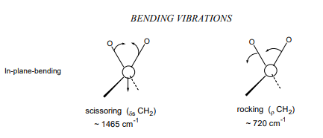

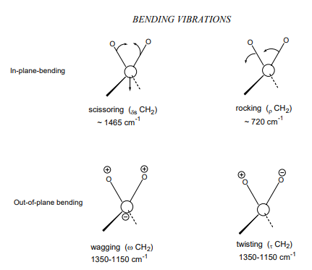
Figure 18: Vibrational modes of a CH₂ group. [ and indicate movement above and below the plane of page]
In addition to the fundamental vibrations, other frequencies can be generated by modulations of the fundamental bands. Overtone bands appear at integral multiples of fundamental vibrations. Therefore, the strong absorptions at say 800 cm⁻¹ and 1750 cm⁻¹ will also give rise to weaker absorptions at 1600 cm⁻¹ and 3500 cm⁻¹, respectively. In the IR spectra of benzaldehyde (figure 33) and acetophenone (figure 31), due to C=O stretching vibration a weak overtone can be seen at 3400 and 3365 cm⁻¹, respectively. Two frequencies may interact to give beats which are combination or difference frequencies. The absorptions at x cm⁻¹ and y cm⁻¹ interact to produce two weaker beat frequencies at x + y cm⁻¹ and x – y cm⁻¹. Therefore, whereas the factors like degeneracy of bands from several absorptions of the same frequency, lack of change in molecular dipole moment during vibration and fall of frequencies outside the 4000-400 cm⁻¹ region decrease the number of bands whereas the overtone and beats increase the number of bands actually appeared in IR spectrum. Therefore, theoretical numbers of fundamental frequencies are seldom observed. Other Factors Influencing Vibrational Frequencies The vibrational frequency of a bond, being part of a molecule, is significantly affected by the electronic and steric factors of the surroundings, in addition to the bond strength and atomic masses discussed above. When two bond oscillators share a common atom, they seldom behave as individual oscillators where the individual oscillation frequencies are widely different. The mechanical coupling interactions between two oscillators are responsible for these changes.
For example, the carbon dioxide molecule, which consists of two C=O bonds with a common carbon atom, has two fundamental stretching vibrations – an asymmetrical and a symmetrical stretching mode. The symmetrical stretching mode produces no change in dipole moment and is IR inactive. Asymmetric stretching mode is IR active and appears at a higher frequency (2350 cm⁻¹) than observed for a carbonyl group in aliphatic ketones (1715 cm⁻¹). The carbonyl stretching frequency in RCOCH3 (~1720 cm⁻¹) is lower than acid chloride RCOCl (1750-1820 cm⁻¹). This change in frequency of the C=O stretching may be arising due to (i) difference in mass between CH₃ and Cl (ii) the inductive or mesomeric influence of Cl on the C=O bond (iii) coupling interactions between C=O and C-Cl bonds (iv) change in bond angles arising due to steric factors etc. It is usually impossible to isolate one effect from the other. However, the appropriate emphasis can be placed on those features that seem to be most responsible in explaining the characteristic appearance and position of group frequencies.
Sample Preparation
For recording an IR spectrum, the sample may be gas, a liquid, a solid or a solution of any of these. The samples should be perfectly free of moisture, since cell materials (NaCl, KBr, CsBr etc.) are usually spoiled by the moisture. Liquids are studied neat or in solution. In case of neat liquid, a thin film of < 0.01 mm thickness is obtained by pressing the liquid between two sodium chloride plates and plates are subjected to IR beam. Spectra of solutions are obtained by taking 1-10 % solution of the sample in an appropriate solvent in cells of 0.1-1 mm thickness. A compensating cell, containing pure solvent is placed in the reference beam of the instrument. The choice of solvent depends on the solubility of the sample and its own minimal absorption in IR region. Carbon tetrachloride, chloroform and carbon disulfide are preferred solvents. The spectrum of a solid can be obtained either as a mull or as an alkali halide pellet. Mulls are obtained by thoroughly grinding 2-5 mg of a solid sample with a drop of mulling agent usually Nujol (mixture of parafinic hydrocarbons) or fluorolube (a completely fluorinate polymer). The suspended particles must be less than 2 µM to avoid excessive scattering of radiations. The mull is placed between two sodium chloride plates and plates are subjected to IR beam. For preparing, an alkali halide pellet, 1-2 mg of dry sample is grinded with ~ 100 mg of KBr powder. The mixture is then pressed into a transparent pellet with a special die under a pressure of 10,000-15,000 psi. KBr pellet is then mounted on holder and is placed in sample beam of IR spectrophotometer.
Characteristic Group Vibrations of Organic Molecules
An infrared spectrum of an organic compound comprises many bands and assigning each band to a particular mode of vibration is practically impossible but two non-identical molecules generally have different IR spectra. An IR spectrum, therefore, is a fingerprint of the molecule. The region most useful for the purpose of “fingerprinting” of the compound is 650-1350 cm⁻¹. This region comprises a large number of bands due to skeletal vibrations and when the spectrum we are studying coincides exactly with the spectrum of a known compound, it can be safely assumed that the two compounds are identical. The region above 1350 cm⁻¹ often provides easily recognizable bands of various functional groups and thus much valuable structural evidence from relatively few of theses bands is obtained and total interpretation of the complete spectrum is seldom required. In the following sections, the basic information about the vibrational modes in basic functional groups has been discussed.

1. Hydrocarbons C-H and C-C stretching and bending vibrations
(i) Alkanes: In simple hydrocarbons, only two types of atoms - C and H and only two types of bonds – C-C and C-H are present. The C-H starching vibrations usually occur in the general region between 3300 cm⁻¹ (in alkynes) and 2700 cm⁻¹ (in aldehydes).
A hydrocarbon containing a methyl group usually shows two distinct bands, one at 2960 cm⁻¹ due to asymmetric stretching and the other at 2870 cm⁻¹ due to symmetric stretching. The C-H bonds in methylene group undergo number of stretching and bending vibrations as shown in figure 18. The two stretching vibrations – asymmetrical and symmetrical occur at 2925 cm⁻¹ and appear in the spectrum within a range of ± 10 cm⁻¹.
The C-H bending vibrations of the methyl groups in the hydrocarbons normally occur at 1450 and 1375 cm⁻¹. The band at 1375 cm⁻¹ is due to methyl on the carbon atom and is quite sensitive to the electronegativity of the substituent present at the methyl group. It shifts from as high as 1475 cm⁻¹ in CH₃-F to as low as 1150 cm⁻¹ in CH₃-Br. However, this band is extremely useful in detecting the presence of methyl group in a compound because it is sharp and of medium intensity and is rarely overlapped by absorptions due to methylene or methine deformations. The intensity of this band usually increases with the number of methyl groups in the compound. However, the presence of two or more methyl groups on one aliphatic carbon atom (isopropyl or t-butyl groups) results in splitting of this band due to in-phase or out-of phase interactions of the two symmetrical methyl deformations.
In case of methylene group, C-H bending vibrations such as scissoring, twisting, wagging and rocking normally appear at fairly different frequencies. If two or more CH2 groups are present, the usually strong scissoring and rocking absorption bands appear at 1465 and 720 cm⁻¹, respectively. Whereas weak bands due to twisting and wagging vibrations appear at 1250 + 100 cm⁻¹. So, the scissoring absorption band of methylene around 1465 cm⁻¹ often overlaps with asymmetric bending vibration of methyl at 1450 cm⁻¹.
In cyclic aliphatic hydrocarbons, the C-H stretching frequencies are the same (2800 – 3000 cm⁻¹) as in the case of acyclic compounds, if the ring is unstrained. However, methylene scissoring bands shift slightly to smaller wavenumber (1470 cm⁻¹ in hexane and 1448 cm⁻¹ in cyclohexane, see figure 19). In sterically strained cyclic compounds, the C-H stretching normally occurs at slightly higher wavenumber e.g. 3080 -3040 cm⁻¹ in cyclopropane.
The C-C bond vibrations appear as weak bands in 1200-800 cm⁻¹ region and are seldom used for structural study. Whereas the C-C bending absorptions occur at < 500 cm⁻¹ and are usually below the range of IR – instrument.
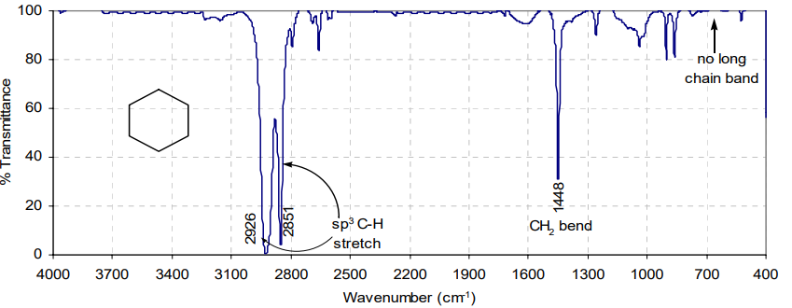
Figure 19: The infrared spectrum of cyclohexane (neat liquid)
(ii) Alkenes: The carbon-carbon double bond has a higher force constant than a C-C single bond and in a non-conjugated olefin, C=C stretching vibrations appear at higher frequency (1680-1620 cm⁻¹ ) than that of the C-C starching vibrations (1200-800 cm⁻¹).
In completely symmetrical alkenes, such as ethylene, tetrachloroethylene etc., C=C stretching band is absent, due to lack of change in dipole moment in completely symmetrical molecule. On the other hand, non-symmetrically substituted double bonds exhibit strong absorption bands. The absorption bands are more intense for cis isomers than for trans isomers; for mono or tri substituted olefins than for di and tetra substituted ones. Also, terminal olefins show stronger C=C double bond stretching vibrations than internal double bonds. Similarly C=C groups conjugated with certain unsaturated group show stronger band than for non-conjugated ones. In case of olefins, conjugated with an aromatic ring, the C=C stretching appears at 1625 cm⁻¹ (s) and an additional band at ~1600 cm⁻¹ is observed due to aromatic double bond. In compounds containing both olefinic and alkyl C-H bonds, the bands above 3000 cm⁻¹ are generally attributed to aromatic or aliphatic C-H stretching, whereas between 3000-2840 cm⁻¹ are generally assigned to the alkyl C-H stretching. The absorption frequency of a double bond in a cyclic ring is very sensitive to ring size (figure 20). The absorption frequency decreases as the internal angle decreases and is lowest in cyclobutene (90º angle). The frequency increases again for cyclopropane.
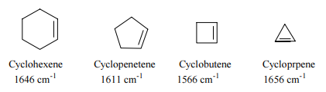
Figure 20: C=C vibration frequencies of cycloalkenes
The exocyclic double bonds exhibit an increase in frequency with decrease in ring size (figure 21). The exocyclic double bond on six-membered ring absorbs at 1651 cm⁻¹ and it is shifted to 1780 cm⁻¹ in case of exocyclic double bond on cyclopropane. The allenes show the highest double bond absorptions at 1940 cm⁻¹.
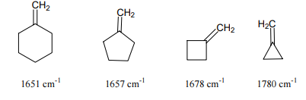
Figure 21: Exocyclic C=C double bond frequencies in various ring sizes

(iii) Alkynes : All alkynes both terminal (R.C≡CH ) or non-terminal (R.C≡CR ) contain carbon – carbon triple bond but the non-terminal alkynes also contain a ≡CH bond. The force constant for a triple bond is grater than that for a double bond. Consequently, whereas a C-C stretching vibrations occur between 1300-800 cm-1 and the C=C stretching vibration occur in the region 1700-1500 cm⁻¹, the C≡C vibrations are observed at significantly higher frequencies in the region of 2300 to 2050 cm-1. The terminal alkynes show weak triple bond stretching vibration at 2140-2050 cm⁻¹, whereas the unsymmetrically disubstituted alkynes show a triple bond absorption at 2260-2190 cm⁻¹. The acetylene C-H stretching vibrations are normally observed as a sharp characteristic band in the region 3310-3200 cm-1 and the acetylenic C-H bending vibrations occur in the region 600-650 cm⁻¹. Therefore the frequency of the absorption of C-H bond is a function of the type of hybridization of the carbon to which hydrogen atom is attached. While moving from sp³ to sp² and sp hybridized carbons, the s-character increases and so is the bond strength (force constant of C-H bond and the frequency of absorption (Table 7).
Table 7:
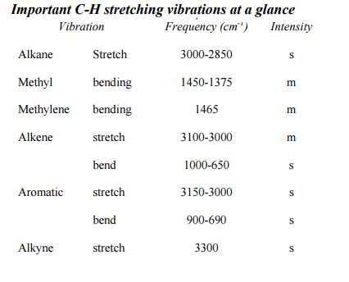
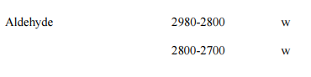
(iv) Aromatic Hydrocarbons: In the aromatic compounds, the most prominent bands are due to out-of-plane bending of ring C-H bonds in the region of 900-650 cm⁻¹. These bands can be used to assign the ring substitution pattern in mono substituted benzenes and 1,2-, 1,3-, and 1,4- substituted benzene derivatives. Mono substituted benzene derivatives exhibit strong absorption band near 690 cm-1 (see IR spectrum of toluene, figure 22). The absence of this band indicates the absence of mono substituted phenyl rings in the sample. A second strong band appears at ~750 cm⁻¹. 1,2-Disubstituted benzenes give one strong absorption band at ~ 750 cm⁻¹. 1,3- Disubstituted rings give three absorption bands at ~690, ~780 and ~ 880 cm⁻¹. 1,4-Disubstituted rings give one strong absorption band in the region 800-850 cm⁻¹ (strong absorption band at 831 cm⁻¹ is seen in IR spectrum of t-butylphenol, figure 26 ). The spectra of aromatic compounds typically exhibit many weak or medium intensity C-H stretching vibrations in the region 3100- 3030 cm⁻¹, the region of olefinic compounds.
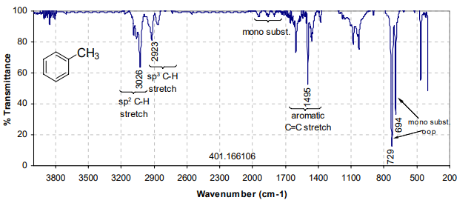
Figure 22: The infrared spectrum of toluene (neat liquid)
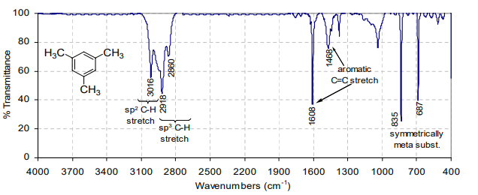
Figure 23: The infrared spectrum of mesitylene (neat liquid)
The bands considered to be of most help in diagnosing the aromatic character of the compound appear in the region 1650-1400 cm⁻¹. There are normally four bands in this region at about 1600, 1585, 1500 and 1450 cm⁻¹ and are due to C=C in-plane vibrations (see spectra in figures 22 and 23). The combination and overtone bands in 2000-1650 cm⁻¹ region are also characteristics of aromatic rings. Moreover, they are very weak and are observed only in the case of concentrated solutions of highly symmetric benzene derivatives.
2. Alcohols and Phenols
When a hydrogen atom from an aliphatic hydrocarbon is replaced by an OH group, new bands corresponding to new OH and C-O band absorption appear in the IR spectrum. A medium to strong absorption band from 3700 to 3400 cm⁻¹ ( see IR spectra of 1-butanol and t-butylphenol in figures 25 and 26) is a strong indication that the sample is an alcohol or phenol (The presence of NH or moisture causes similar results). The exact position and shape of this band depends largely on the degree of H-bonding. A strong, sharp peak in the region as higher 3700 cm⁻¹ in gaseous or extremely dilute solutions represents unbounded or free OH group(s). Alcohols and phenols in condensed phases (bulk liquid, KBr discs, concentrated solution etc.) are strongly hydrogen bonded, usually in the form of dynamic polymeric association; dimmers, trimers, tetramers etc. (Figure 24) and cause broadened bands at lower frequencies. The hydrogen bonding involves a lengthening of the original O-H bond. This bond is consequently weakened, force constant is reduced and so the stretching frequency is lowered.
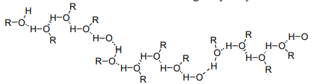
Figure 24: Polymeric association of ROH
The C-O stretching in phenols / alcohols occurs at a lower frequency range 1250-1000 cm⁻¹. The coupling of C-O absorption with adjacent C-C stretching mode, makes it possible to differentiates between primary (~1050 cm⁻¹), secondary (~1100 cm⁻¹) and tertiary ( ~1150 cm⁻¹) alcohols and phenols ( ~1220 cm⁻¹).
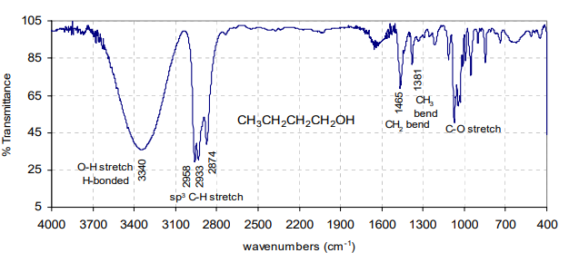
Figure 25: The infrared spectrum of 1-butanol (neat liquid)
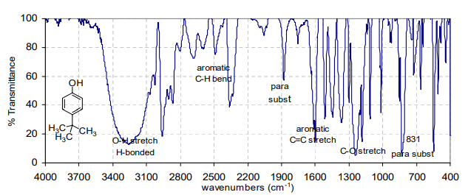
Figure 26: The infrared spectrum of t-butylphenol (nujol mull)
3. Carbonyl Compounds The absorption peak for C=O stretching in the region 1870 to 1600 cm⁻¹ is perhaps the easiest band to recognize in IR spectrum and is extremely useful in analysis of carbonyl compounds. The changes in C=O stretching frequency in various carbonyl compounds viz. aldehydes, ketones, acids, esters, amides, acid halides, anhydrides etc. can be explained by considering (i) electronic and mass effects of neighboring substituents (ii) resonance effects ( both C=C and heteroatom lone pair) (iii) hydrogen bonding (inter and intramolecular) (iv) ring strain etc. It is customary to refer to the absorption frequency of a saturated aliphatic ketone at 1715 cm⁻¹ as normal value and changes in the environment of the carbonyl group can either lower or raise the absorption frequency from the “normal” value.
(i) Inductive and Resonance Effects: The replacement of an alkyl group of the saturated aliphatic ketone by a heteroatom (O, N) shifts the C=O stretching frequencies due to inductive and resonance effects. In esters, the oxygen due to inductive effect withdraws the electrons from carbonyl group (figure 27) and increases the C=O bond strength and thus the frequency of absorption. In amides, due to the conjugation of lone pair of electrons on nitrogen atom, the resonance effect increases the C=O bond length and reduces the C=O absorption frequency. Therefore, C=O absorption frequencies due to resonance effects in amides are lowered but due to inductive effect in esters are increased than those observed in ketones.
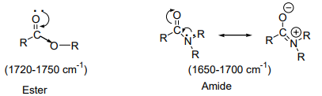
Figure 27: Inductive and resonance effects in ester and amide groups
In acid chlorides, the halogen atom strengthens the C=O bond through inductive effect and shifts the C=O stretching frequencies even higher than are found in esters. The acid anhydrides give two bands in C=O stretching frequency region due to symmetric (~1820 cm-1) and asymmetric (~1760 cm-1) stretching vibrations (figure 28).

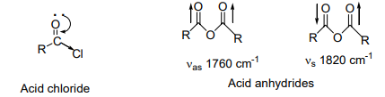
Figure 28: Inductive effect in acid chloride and C=O stretch in anhydride
(ii) Conjugation Effects: The C=O stretching frequencies for carbon-carbon double bond conjugated systems are generally lower by 25-45 cm⁻¹ than those of corresponding nonconjugated compounds. The delocalization of π-electrons in the C=O and C=C bonds lead to partial double bond character in C=O and C=C bonds and lowers the force constant (figure 30). Greater is the ability of delocalization of electrons, the more is lowering in C=O stretching frequency. In general s-cis conformations absorb at higher frequency than s-trans conformations. A similar lowering in C=O stretching frequency occurs when an aryl ring is conjugated with carbonyl compound.
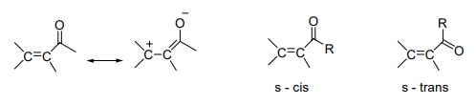
Figure 30: Resonance effects and s-cis and s-trans structures in enones
(iii) Ring Size Effects: Six-membered rings with carbonyl group e.g. cyclohexanone absorb at normal value i.e. 1715 cm⁻¹. Decrease in ring size increases the C=O stretching frequency. Smaller rings require the use of more p- character to make C-C bonds for the requisite small angles. This gives more s character to the C=O sigma bond and thus results in strengthening of C=O double bond. The comparison of C=O stretching frequencies of various compounds in figure 31 shows that in ketones and esters, ~ 30 cm⁻¹ increase in frequency occurs on moving to one carbon lower ring.
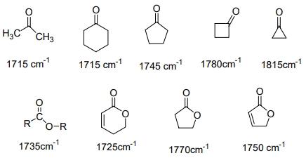
Figure 31: C=O stretching frequencies in various compounds
(iv) Hydrogen Bonding Effects: Hydrogen bonding to a C=O group withdraws electrons from oxygen and lowers the C=O double bond character. This results in lowering of C=O absorption frequency. More effective is the hydrogen bonding, higher will be the lowering in C=O absorption frequencies.
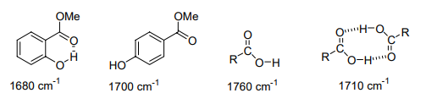
Figure 32: H-bonding effects on C=O stretch
The monomeric carboxylic acids (in very dilute solutions) absorb at ~1760 cm⁻¹. The dimerization of carboxylic acids in their concentrated solutions or in solid state lowers the carboxyl carbonyl frequency to 1710 cm⁻¹. The more effective intramolecular hydrogen bonding in methyl salicylate lowers the C=O stretching frequency to 1680 cm⁻¹ than observed at 1700 cm⁻¹ in case of methyl p-hydroxybenzoate.
- Aldehydes and Ketones
Aliphatic aldehydes show strong C=O stretching in the region of 1740 – 1725 cm⁻¹. The conjugation of an aldehyde to a C=C or a phenyl group lowers C=O stretching by ~ 30 cm⁻¹. This effect is seen in benzaldehyde in which aryl group is attached directly to the carbonyl group and shifts C=O stretch to 1701 cm⁻¹ (see IR spectrum of benzaldehyde, figure 33 ). Aldehyde C-H stretching vibrations appear as a pair of weak bands between 2860-2800 and 2760-2700 cm⁻¹. The higher C-H stretching band (2860-2800 cm⁻¹) of aldehyde is often buried under aliphatic CH band. But the lower C-H band at 2760-2700 cm⁻¹ is usually used to distinguish aldehydes from ketones. The C-H bending vibrations appear between 945-780 cm⁻¹.
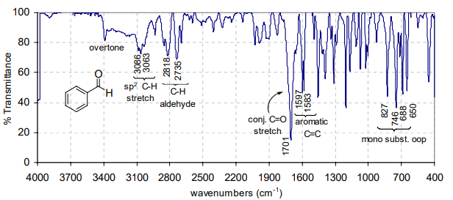
Figure 33: The infrared spectrum of benzaldehyde (neat liquid)
The aliphatic acyclic ketones show C=O stretching between 1720 to 1700 cm-1 which is shifted to lower frequencies by 20-30 cm-1 on conjugation with C=C or phenyl ring. The presence of two conjugated groups as in benzophenone further lowers the C=O stretching frequency to 1665 cm⁻¹ (figures 34 and 35 ).
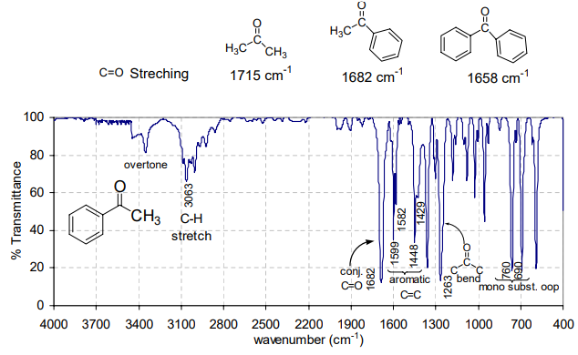
Figure 34: The infrared spectrum of acetophenone (neat liquid)
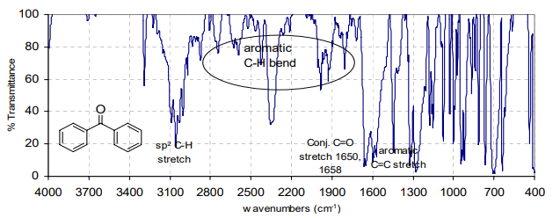
Figure 35: The infrared spectrum of benzophenone (nujol mull)
In case of cyclic ketones, the coupling between C=O stretching and C(=O)-C single bond causes increase in C=O stretching frequency as the C-C(=O) angle decreases (figure 31).
b. Carboxylic Acids, Esters and Carboxylates In case of carboxylic acids, in solid state or pure liquid state, the intermolecular hydrogen bonding weakens the C=O bond and thus lower the stretching frequency to ~1720 cm⁻¹. The O-H stretch appears as a very broad band between 3400 – 2500 cm⁻¹ (see IR spectrum of benzoic acid, figure 36). The appearance of strong C=O stretching along with broad hydroxyl peak centered at ~ 3000 cm⁻¹ in an IR spectrum certainly shows the presence of carboxylic acid. In addition a medium intensity C=O stretch appears between 1320 – 1260 cm⁻¹. In dilute solutions, the carboxylic acids attain monomeric structures and the inductive effect of oxygen shifts the C=O absorption band to higher values (1760 – 1730 cm⁻¹) than observed in ketones.
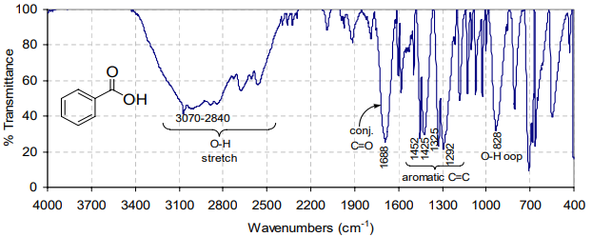
Figure 36: The infrared spectrum of benzoic acid (nujol mull)
In case of esters, the C=O stretching appears in the range 1750-1730 cm⁻¹ and strong C-O stretching absorption appears in the range 1300 -1000 cm⁻¹. The esters of α,β-unsaturated or aryl carboxylic acids due to conjugation absorb at lower frequency (figure 37).
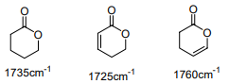
Figure 37: Effect of conjugation in cyclic esters

ROTATIONAL SPECTROSCOPY (MICROWAVE SPECTROSCOPY)
Introduction
Free atoms do not rotate or vibrate. For an oscillatory or a rotational motion of a pendulum, one end has to be tied or fixed to some point. In molecules such a fixed point is the center of mass. The atoms in a molecule are held together by chemical bonds. The rotational and vibrational energies are usually much smaller than the energies required to break chemical bonds. The rotational energies correspond to the microwave region of electromagnetic radiation (3x10¹⁰ to 3x10¹² Hz; energy range around 10 to 100 J/mol) and the vibrational energies are in the infrared region (3x10¹² to 3x10¹⁴ Hz; energy range around 10kJ/mol) of the electromagnetic radiation. For rigid rotors (no vibration during rotation) and harmonic oscillators (wherein there are equal displacements of atoms on either side of the center of mass) there are simple formulae characterizing the molecular energy levels. In real life, molecules rotate and vibrate simultaneously and high speed rotations affect vibrations and vice versa. However, in our introductory view of spectroscopy we will simplify the picture as much as possible. We will first take up rotational spectroscopy of diatomic molecules.
Rotational Spectra of diatomics
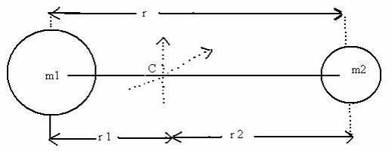
Figure 38: A rigid diatomic with masses m1 and m2 joined by a thin rod of length r = r₁ + r₂ .The centre of mass is at C.
The two independent rotations of this molecule (Figure 38) are with respect to the two axes which pass though C and are perpendicular to the “bond length” r. The rotation with respect to the bond axis is possible only for “classical” objects with large masses. For quantum objects, a “rotation” with respect to the molecular axis does not correspond to any change in the molecule as the new configuration is indistinguishable from the old one.
The center of mass is defined by equating the moments on both segments of the molecular axis.
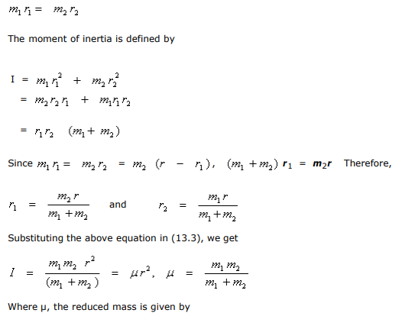
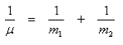
The quantized rotational energy levels for this diatomic are
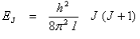
The energy differences between two rotational levels is usually expressed in cm-1. The wave number corresponding to a given ∆E is given by
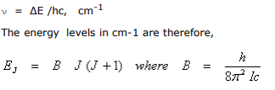
The rotational energy levels of a diatomic molecule are shown in Figure 39.
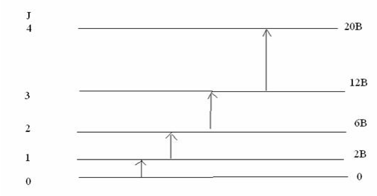
Figure 39: Rotational energy levels of a rigid diatomic molecule and the allowed transitions.
The selection rule for a rotational transition is,
In addition to this requirement, the molecule has to possess a dipole moment. As a dipolar molecule rotates, the rotating dipole constitutes the transition dipole operator μ. Molecules such as HCl and CO will show rotational spectra while H₂, Cl₂ and CO₂ will not. The rotational spectrum will appear as follows (Figure 40).
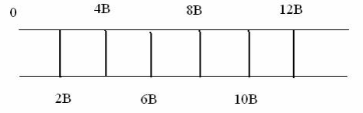
Figure 40: Rotational spectrum of a rigid diatomic. Values of B are in cm-1. Typical values of B in cm-1 are 1.92118 (CO), 10.593 (HCl), 20.956 (HF)
By using rotational or microwave spectroscopy, very accurate values of bond lengths can be obtained. For example, in HCN, the C-H length is 0.106317 ± 0.000005 nm and the CN bond length is 0.115535 ± 0.000006 nm. The principle of the microwave oven involves heating the molecules of water through high speed rotations induced by microwaves. The glass container containing water however remains cold since it does not contain rotating dipoles.
Module-IV NMR SPECTROSCOPY (TOOLS FOR STRUCTURE DETERMINATION)
The 1952 Nobel Prize in Physics was awarded to Felix Bloch (Stanford) and Edward M. Purcell (Harvard) for their discoveries relating to nuclear magnetic resonance.

I. INTRODUCTION: Nuclear magnetic resonance (NMR), a form of spectroscopy that is one of the most powerful tools for the identification of functional groups and for the determination of connections between the atoms in molecules, which requires for the structure determination of compounds. NMR spectroscopy is astudy for interaction of energy with matter where energy absorption by molecules will quantitate that have been placed in a strong magneticfield.
The nuclei of certain elements, including ¹H nuclei (protons) and ¹³C (carbon-13) nuclei, behave as though they were magnets spinning about an axis. When a compound containing protons or carbon-13 nuclei is placed in a very strong magnetic field and simultaneously irradiated with electromagnetic energy of the appropriate frequency, nuclei of the compound absorb energy through a process called magnetic resonance. The absorption of energy is quantized.

A graph that shows the characteristic energy absorption frequencies and intensities for a sample in a magnetic field is called a nuclear magnetic resonance (NMR) spectrum (Figure 1).

Example: The proton (¹H) NMR spectrum of bromoethane is shown below.
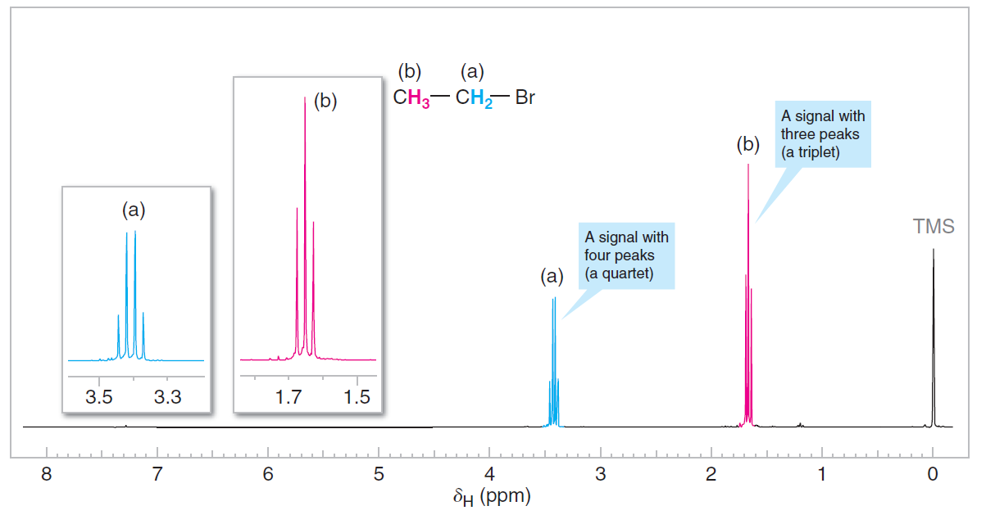
Figure 1 The 300-MHz ¹H NMR spectrum of bromoethane (ethyl bromide).

Figure 1 Explanation:
1. The number of signals in the spectrum tells us how many different sets of protonsthere are in the molecule. There are two signals arising from two different sets of protons. One signal (consisting of four peaks) is shown in blue and labeled (a). The other signal (consisting of three peaks) is in red and is labeled (b). These signals are shown twice in the figure, at a smaller scale on the baseline spectrum, and expanded and moved to the left above the base spectrum. the signal at the far right of the spectrum (labeled TMS); it comes from a compound (tetramethylsilane) that was added to the bromoethane to calibrate the positions of the other signals.
2. The position of the signals in the spectrum along the x-axis tells us about themagnetic environment of each set of protons arising largely from the electron densityin their environment.
3. The area under the signal tells us about how many protons there are in the setbeing measured.
4. The multiplicity (or splitting pattern) of each signal tells us about the number ofprotons on atoms adjacent to the one whose signal is being measured. In bromoethane,signal (a) is split into a quartet of peaks by the three protons of set (b), andsignal (b) is split into a triplet of peaks by the two protons of set (a).

II. BASIC PRINCIPLES:
1. Nuclear Spin: The Origin of the Signal
The nuclei of certain isotopes possess the quality of spin, and therefore these nuclei havespin quantum numbers, designated I. The nucleus of ordinary hydrogen, ¹H, has a spinquantum number of 1/2, and it can assume either of two spin states: +1/2or -1/2. Thesecorrespondto the magnetic moments (m) allowed for I = 1/2, which are m = +1/2orm = -1/2. . Other nuclei with spin quantum numbers I = 1/2are ¹³C, ¹⁹F, and ³¹P. Somenuclei, such as ¹²C, ¹⁶O, and ³²S, have no spin (I = 0), and these nuclei do not give anNMR spectrum. Other nuclei have spin quantum numbers greater than 1/2. In our treatmenthere, however, we are concerned primarily with the spectra that arise from ¹H andfrom ¹³C, both of which have I = 1/2.Since the proton is electrically charged, the spinning charge generates a tiny magneticmoment—one that coincides with the axis of spin. This tiny magnetic momentgives the spinning proton properties analogous to those of a tiny bar magnet.
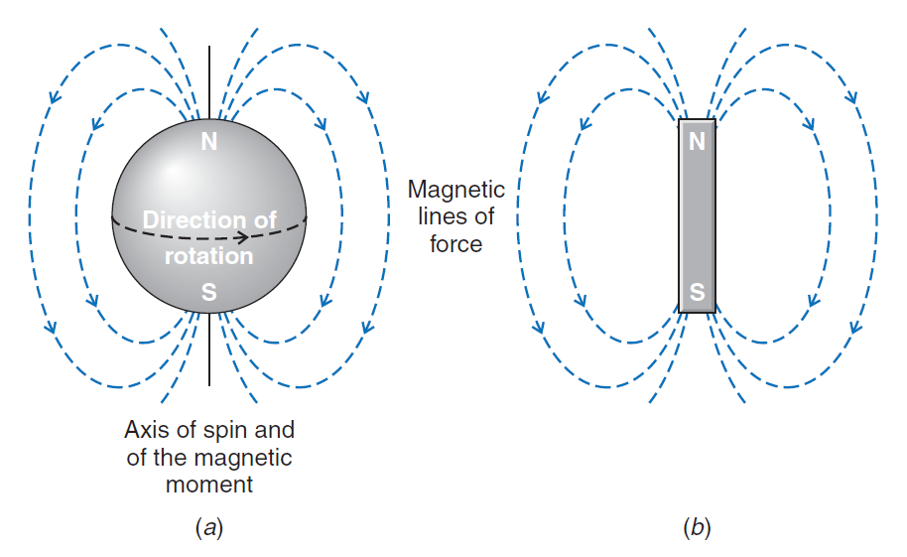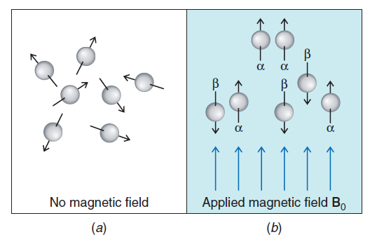
Figure 2 1(a) The magnetic fieldassociated with a spinning proton.1(b) The spinning proton resembles atiny bar magnet. 2(a) In the absence of a magnetic field the magnetic moments of protons (represented by arrows) are randomly oriented. (b) When an external magnetic field (B₀) is applied, the protons orient themselves. Some are aligned with the applied field (a spin state) and some against it (b spin state). The difference in the number of protons aligned with and against the applied field is very small, but is observable with an NMR spectrometer.

In the absence of a magnetic field (Fig. 2), the magnetic moments of the protons of a given sample are randomly oriented. When a compound containing hydrogen (and thus protons) is placed in an applied external magnetic field, however, the magnetic moment of the protons may assume one of two possible orientations with respect to the external magnetic field (other orientations are disallowed on the basis of quantum mechanics). The magnetic moment of the proton may be aligned “with” the external field or “against” it (Fig. 2). These alignments correspond to the two spin states mentionedearlier.
The two alignments of the proton’s magnetic moment in an external field are not of equal energy. When the proton’s magnetic moment is aligned with the magnetic field, its energy is lower than when it is aligned against the magnetic field. The lower energy state is slightly more populated in the ground state.
Energy is required to “flip” the proton’s magnetic moment from its lower energy state (with the field) to its higher energy state (against the field). In an NMR spectrometer this energy is supplied by electromagnetic radiation in the RF (radio frequency) region. When this energy absorption occurs, the nuclei are said to be in resonance with the electromagnetic radiation.
The energy required to excite the proton is proportional to the strength of the magnetic field (Fig. 3). One can show by relatively simple calculations that, in a magnetic field of approximately 7.04 tesla, for example, electromagnetic radiation of 300 x 10⁶ cycles per second (300 MHz) supplies the correct amount of energy for protons.

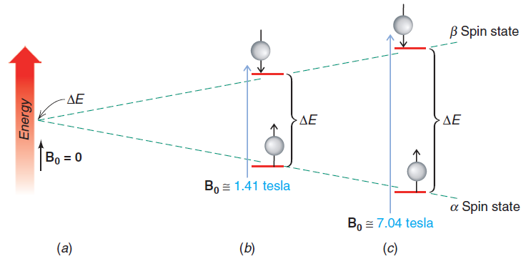

Figure 3 The energy difference between the two spin states of a proton depends on the strength of the applied external magneticfield, B₀. (a) If there is no applied field (B₀= 0), there is no energy difference between the two states. (b) If B₀1.41 tesla, the energy difference corresponds to that of electromagnetic radiation of 60 x 10⁶Hz (60 MHz). (c) In a magnetic field of approximately 7.04 tesla, the energy difference corresponds to electromagnetic radiation of 300 x 10⁶Hz(300 MHz).

The relationship between the frequency of the radiation (ν) and the strength of the magnetic field (B₀) is ν = γB₀ / 2π; where γ is the magnetogyric (or gyromagnetic) ratio. For a proton, γ = 26.753 rad s⁻¹ tesla⁻¹.

III. NMR Spectrometers:

Most NMR spectrometers use superconducting magnets that have very high magnetic field strengths. Superconducting magnets operate in a bath of liquid helium at -270 °C and they have magnetic field strengths more than 100,000 times as strong as Earth’s magnetic field.

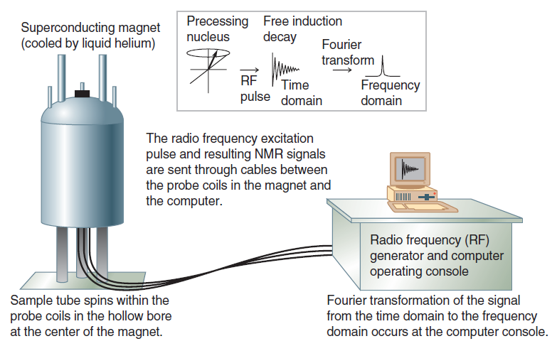 | 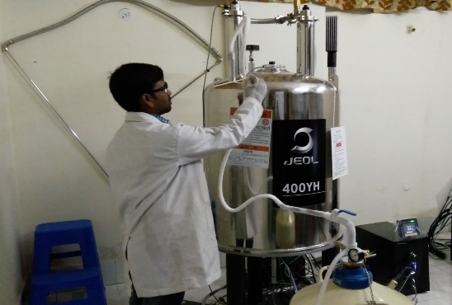  400 MHz Superconducting Magnet of an NMR Laboratory at Department of Chemistry, BIT Mesra, Ranchi
Figure 4 Principle & Diagram of a Fourier transform NMR spectrometer

Certain nuclei in the presence of a magneticfield behave as though they were tiny bar magnets that align themselves with or againstthe applied magnetic field. The nuclei spin (precess) about the spectrometer’s magneticfield axis (the “applied” magnetic field), much the same way that a spinning top gyratesaround the axis of gravity. The precessional frequency of each nucleus is directly related toits chemical shift. We can illustrate a nuclear magnetic moment precessing about the axisof an applied magnetic field (B0) using a vector representation, as shown in Fig. 5.Applying a pulse of radio frequency energy that matches the precessional frequencyof the nuclear magnetic moment causes the magnetic vector of the nucleus to tip awayfrom the applied magnetic field axis (the z-axis) toward the x–y plane (Fig. 5). Thenuclear magnetic vector still precesses about the z-axis, but it lies in the x–y plane. Fromthe perspective of a tiny coil of wire (called a receiver coil) situated next to the x–y plane,rotation of this vector around the z-axis but in the x–y plane presents an oscillatingmagnetic field to the receiver coil. And just as with large-scale electrical generators, thisoscillating magnetic field induces an oscillating electric current in the coil (Fig. 5).

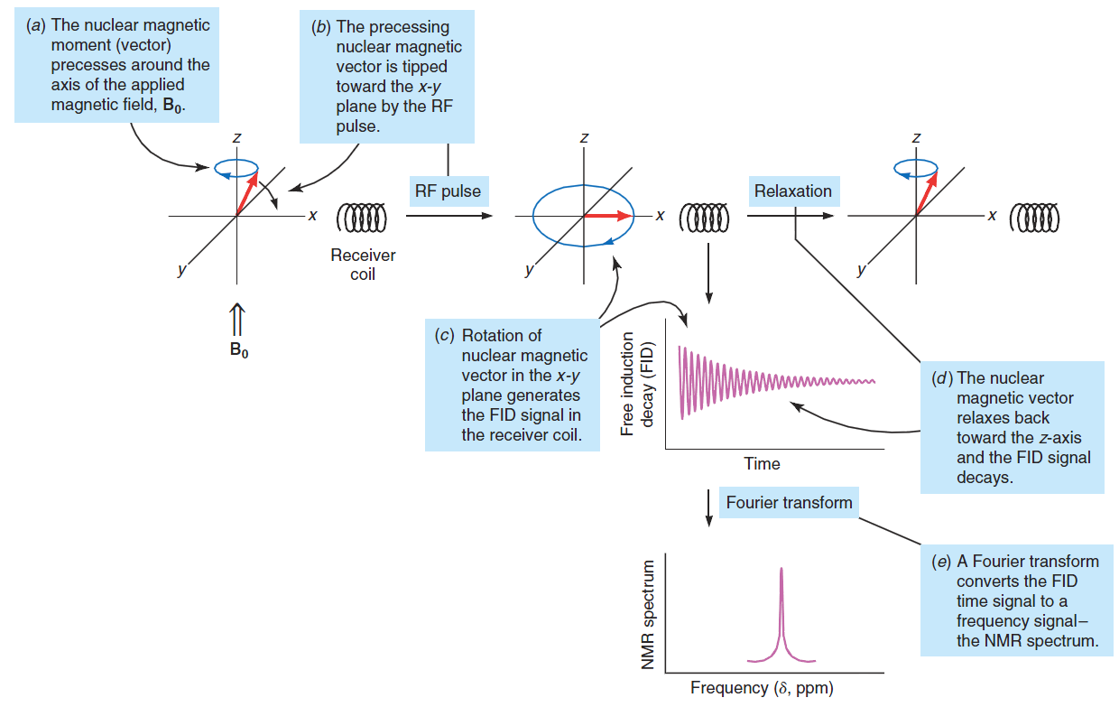

Figure 5. Origin of the Signal in FT NMR Spectroscopy.

This current is the signal detected by the NMR spectrometer.

This energy comes froma radio frequency pulse generated by the NMR spectrometer. In a matter of seconds orless, however, the nucleus releases the energy it absorbed back to the sample environment,returning the nucleus to its ground state energy as it moves back toward the z-axis. Asit does so, the vector component of magnetization in the x–y axis diminishes, and theobserved electrical signal decays (Fig. 5). The oscillating electrical signal produced bythe excited nucleus is therefore not a signal of steady amplitude, but one that dies awayexponentially. This signal is called a free induction decay (FID). The NMR computerapplies a mathematical operation called a Fourier transform to convert the signal from atime versus amplitude signal (the FID) to a frequency versus amplitude signal (the NMRspectrum that we interpret, Fig. 5).

As we mentioned, the chemical shift of an NMR signal is directly related to its precessionalfrequency. Since most compounds have nuclei in a variety of environments, theyhave nuclei that precess at a variety of frequencies, and therefore exhibit signals at a varietyof chemical shifts. The FID signal detected by the NMR spectrometer is an aggregate ofall of these frequencies. A powerful aspect of the Fourier transform (FT), as a mathematicalprocess, is that it extracts these combined frequencies from the FID and converts themto discrete signals that we can interpret in an NMR spectrum.
IV. The Chemical Shift, PPM and the δ-Scale
All protons do not absorb at the same chemical shift (δ) in an external magnetic field. Thechemical shift of a given proton is dependent on its chemical environment. The δ value that we report for a proton’s chemical shift is actually ameasure of its NMR absorption frequency, which is proportional to the external magneticfield strength. Smaller chemical shift (δ) values correspond with lower absorption frequency.Larger chemical shift (δ) values correspond with higher absorption frequency.Chemical shifts are most often reported in reference to the absorption of the protonsof TMS (tetramethylsilane), which is defined as zero on the δ scale. A small amount ofTMS is either included as an internal standard in the solvent for a sample, or the NMRspectrometer itself is calibrated electronically to a chemical shift standard.Si(CH3)4Tetramethylsilane (TMS)

The signal from TMS defines zero ppm on the chemical shift (δ) scale.

Tetramethylsilane was chosen as a reference compound for several reasons. It has12 equivalent hydrogen atoms, and, therefore, a very small amount of TMS gives arelatively large signal. Because the hydrogen atoms are all equivalent, they give a singlesignal. Since silicon is less electronegative than carbon, the protons of TMS are in regionsof high electron density. They are, as a result, highly shielded, and the signal from TMSoccurs in a region of the spectrum where few other hydrogen atoms absorb. Thus, theirsignal seldom interferes with the signals from other hydrogen atoms. Tetramethylsilane,like an alkane, is relatively inert. It is also volatile, having a boiling point of 27 8C. Afterthe spectrum has been determined, the TMS can be removed from the sample easily byevaporation.

The chemical shift of a proton, when expressed in hertz (Hz), is proportional to thestrength of the external magnetic field. Since spectrometers with different magnetic fieldstrengths are commonly used, it is desirable to express chemical shifts in a form that isindependent of the strength of the external field. This can be done easily by dividing thechemical shift by the frequency of the spectrometer, with both numerator and denominatorof the fraction expressed in frequency units (hertz). Since chemical shifts are alwaysvery small (typically <5000 Hz) compared with the total field strength (commonly theequivalent of 60, 300, or 600 million hertz), it is convenient to express these fractions inunits of parts per million (ppm). This is the origin of the delta scale for the expression ofchemical shifts relative to TMS:
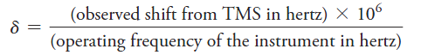
For example, the chemical shift for benzene protons is 2181 Hz when the instrument isoperating at 300 MHz. Therefore,
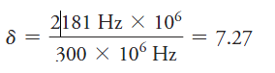

The chemical shift of benzene protons in a 60-MHz instrument is 436 Hz:
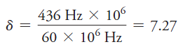
Thus, the chemical shift expressed in ppm is the same whether measured with an instrumentoperating at 300 or 60 MHz (or any other field strength).

V Examples of Structure Elucidation through 1H NMR Spectrum
Example 1:
The 300-MHz 1H NMR spectrum of a compound with the formula CH₃CH₂CH₂ Br. Expansions of the signals are shown in the offset plots.
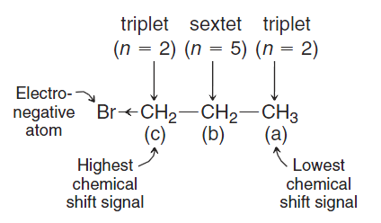
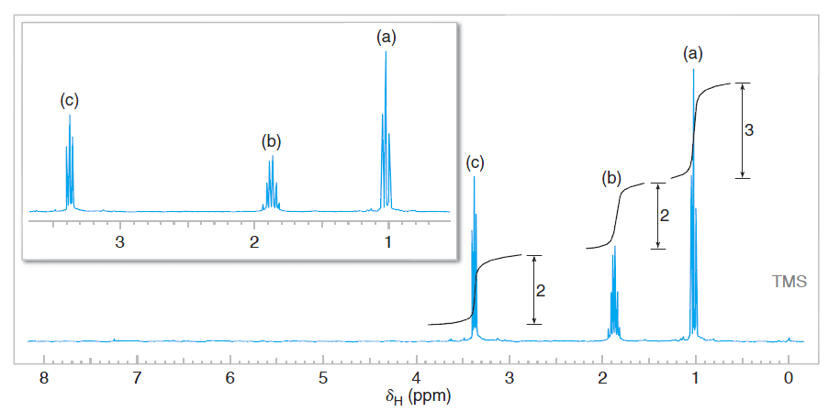

Example 2: Ethanol
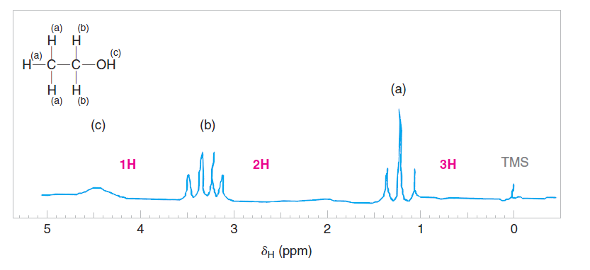
Example 3: 1,4-diemthylbenzene

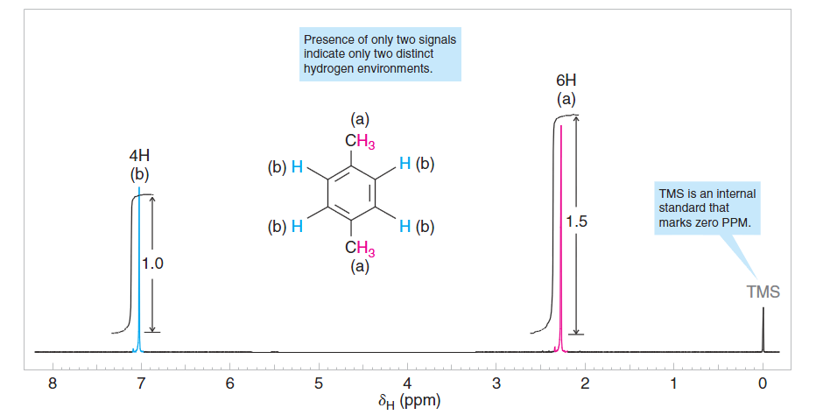

Reference Book: i) Organic Chemistry: Solomons, Fryhle, Snyder, 11e ii) Spectroscopy of Organic Compounds by P. S. Kalsi; 6th edition

